*Blake Waxley*

*Central record For School Staff*

*Centre Name: Highgate School*

*Centre Number: 12610*

*Candidate Number: 2800*

*Qualification Code: OCR H446*

Table of Contents

Analysis 3

Problem Identification 3

Stakeholders 3

Why is it suited to a computational solution? 3

Computational methods that the solution lends itself to 3

Interviews 5

Interview Questions 5

Interviews 6

Research 9

Existing similar solutions 9

Features of the proposed solution: 12

Further meeting with stakeholders: 12

Requirements 13

Stakeholder requirements 13

Hardware and software requirements 14

Success Criteria 14

Design 16

Database Design 16

Database Testing Design 17

Algorithm Design 18

Plotting Buttons 18

Moving Between Screens 18

Calculating Due Date For A Staff’s Given Training 19

Search Bar 20

Finding A Staff Member’s Incomplete Prerequisites 21

Finding Staff Members Who Have Missed The Due Date For A Given Training 22

Finding Staff Members Who Have An Upcoming Due Date For A Given Training 23

Inputs and Outputs 24

Key Variables 26

GUI Design 28

Staff Profiles Section 28

Training & Contacts Section 33

Notifications Section 39

Stakeholder Input 43

Validation 44

Buttons 44

Text Boxes 44

Sliders 44

Query Testing Design 45

GUI Testing Design 45

Testing Checklist 46

Development and Testing 47

Stage 1 - Database development 48

Stage 2 - Database Testing 51

Stage 3 & 4 - Query Development & Testing 54

Update on Testing Checklist 66

Stage 5 & 6 - GUI Development & Testing 67

Root and Menu 67

Staff Profiles Section 70

Trainings Section 92

Notifications Section 106

Final Update on Testing Checklist 124

Stage 7 - Stakeholder Testing 125

Questionnaire 125

Review 127

Evaluation 128

Success Criteria Met 128

Success Criteria Not Met 129

Evidence 130

Staff Profiles Video 130

Trainings Video 130

Notifications Video 130

Limitations 131

Maintenance 132

# Analysis

## Problem Identification

Educational Institutions across the planet require their faculty to have undergone security checks and periodic training in various areas, and for all this information to be stored. Typical methods such as spreadsheets and paper records are difficult to design, navigate and update. In fact, some schools keep no record of any of this, which can have catastrophic consequences since the school will not know if their staff are fit for their positions as protectors and educators of young, vulnerable children and adults. I plan to create a system that will allow for the easy storing and navigation of this information.

### Stakeholders

The primary demographic for this software will be schools and other educational institutes. However, with some adjustments, this system could be useful to any Human Resources department.

I am creating this software with guidance from an international safeguarding company.

I have been communicating with this company about what functionality they believe should exist in the software, as well as what information needs to be stored.

### Why is it suited to a computational solution?

This problem lends itself to computational methods of finding and implementing a solution for multiple reasons:

* Storing this information on analogue files, and even spreadsheets, can be difficult to set up, tedious to navigate, and messy to update. A specialized application would mean that time, space, and energy would be saved.
* Automated processes: using a computer means that information can be sorted and used without requiring someone to do it manually. For example, a computer can automatically sort dates and trainings into a calendar and make the user aware when things are overdue or missing.

### Computational methods that the solution lends itself to

#### Problem recognition:

There are three main problems:

* Firstly, we have many objects with many relationships between each other, staff members have relationships with prerequisites depending on the type of staff they are, staff members also have relationships with trainings, etc.
* Secondly, we have many processes that need to be automated using the aforementioned objects. For example, I need to have the system work out deadlines for having training redone by a staff member and if that is overdue/ upcoming etc.
* Lastly, I need to have all of the above represented/ displayed in a way that is easy to understand, navigate, and update.

#### Abstraction

Abstraction will need to be used, particularly for staff members. Staff members need to have only the most relevant information stored, displayed, and considered when working out deadlines etc. Consequently, I must abstract to define the most important aspects of a staff member e.g. name, type of staff, email, etc.

#### Problem decomposition

This problem can be decomposed into a set of much smaller steps. This is an initial idea of what these steps are:

* Design and create a database to store all this data neatly
* Create a user interface (UI) to navigate the database
* Create a means for communication/ interaction between the UI and the database so that queries and updates can be made

#### Thinking ahead

Due to requiring various different functionality, I will need to be constantly thinking ahead during the design and development of my objects/ database tables in order to ensure that all relevant attributes are there when I need them. E.g. training will need a timeperiod attribute in order to calculate staff members’ deadlines for recompleting the training.

## Interviews

### Interview Questions

Here, I will outline some of the key questions I will ask my stakeholders. During the interview, I may ask follow-up questions or ask them to elaborate on answers. My hope is that these questions will help me to understand how to make my software as useful and easy to use as possible.

Questions for Emily (CEO of a safeguarding company) and Alice (A member of the Human Resources department at my school):

1. From your experience, do schools generally keep sufficient records on their staff regarding training, checks, and general information?
2. If no, what do you think are the main issues with these records?
3. What are the main difficulties that exist with storing this amount and type of information?
4. What sort of functionality would you like to see with this sort of record system?
5. Do you have anything else to add or things you think I should know about before designing this system?

Question 1 aims to clarify whether there does truly exist a need for my software.

Questions 2 and 3 aim to help me understand the main difficulties that exist within schools’ current record systems so that I can keep this in mind when designing the database and try to account for them for easier use of the system.

Question 4 aims to clarify how I can provide the maximum utility with a system like this outside of just storing pieces of information.

Questions for Jonathan (informs staff at my school when they must attend training sessions):

1. How does the HR department let you know what training is coming up and who must attend?
2. How far in advance do you receive this information?
3. How do you inform staff members of training sessions they must attend?
4. How far in advance do you provide staff with this information?
5. What is the most difficult or tedious part of this process?
6. What sort of features of a software would help to eliminate this problem?
7. Do you have anything else to add or things you think I should know about before designing this system?

Questions 1 to 4 aim to clarify how the information is passed to each department/ staff member and what time scale this is on.

Questions 5 and 6 aim to help me understand how I can provide maximum utility and make efficient the most inefficient processes with my software.

### Interviews

#### Emily

1. **From your experience, do schools generally keep sufficient records on their staff regarding training, checks, and general information?**

“While many schools do sufficiently manage the storing of this information, less developed or funded schools, unfortunately, sometimes struggle to do so. This often mean that their records are incomplete, difficult to use, or practically non-existent. “

1. **If no, what do you think are the main issues with these records?**

“Because there is so much information to be stored on each person and training, and a need to be able to see which staff members need to take what trainings at what time, these systems just become so overly complicated. Particularly when schools try to do this with paper of word documents, it becomes so messy and confusing to use and update.”

1. **What are the main difficulties that exist with storing this amount and type of information?**

“First of all, as I said, there is just so much information to be stored on each staff member: personal info, employment info, information about checks, what trainings they must undergo, a record of each time they have completed this training, etc etc. As well as this, finding an easy way to represent all of this is just impossible. For example, if each staff member is stored on their own page, finding which people need to take some particular training means moving through every staff member’s profile and updating them one by one.”

1. **What sort of functionality would you like to see with this sort of record system?**

“Obviously, the most important thing is just having a way to clearly store all of the information. Ideally, there would be something which could automatically let the administrator know which trainings they would need to book for which people, and which people were missing training requirements or prerequisite checks.”

1. **Do you have anything else to add or things you think I should know about before designing this system?**

“I believe I have touched on the most important things. I think that the biggest issue you will face will be making the information clearly represented and ensuring that everything is clear for the administrator.”

#### Alice

1. **From your experience, do schools generally keep sufficient records on their staff regarding training, checks, and general information?**

“To be honest, this is the only school I have worked at so I can only speak in reference to *My School*. I would say we do manage to keep on top of all of this, but the issue is just how time consuming it is because our system is not the best.”

1. **If no, what do you think are the main issues with these records?**

*I didn’t ask this question because she had said yes to the previous question*

1. **What are the main difficulties that exist with storing this amount and type of information?**

**“**It’s trying to keep track of when people need to do the training again. When staff members are first employed, we send them all of the training they need to do, and this is quite easy, but it’s when it expires, so usually after around 2 or 3 years, we do not get, like, any automatic notifications so we have to pull the information into an excel spreadsheet and literally go line by line to see whose training has expired, and so who we have to book onto another course. Although we have all the information, it’s just so time consuming. And, of course, there is always the risk of human error.”

1. **What sort of functionality would you like to see with this sort of record system?**

“One issue I often have is that adding training to a profile often has to be typed (The training name and information) by hand. It would be much easier if I could just select a training to add from a dropdown. Another thing that may be useful would be graphical representations of the data. So, for example, if there was a bar chart to show how many people have and have not completed a given training.”

1. **Do you have anything else to add?**

“I don’t think so, I’ve talked about most of the important things for this and I can imagine you have your work cut out for you as it stands.”

#### Jonathan

1. **How does the HR department let you know what training is coming up and who must attend?**

“Whenever a training session is scheduled, I’ll get an email from either the Head of Safeguarding or the HR department with an excel spreadsheet telling me who needs to attend.”

1. **How far in advance do you receive this information?**

“It’s not really set in stone. They usually let me know around a month in advance but it can range from about 2 to 6 weeks.”

1. **How do you inform staff members of training sessions they must attend?**

“Usually, I will just forward the spreadsheet I am sent to all staff with a message that basically says, “Check if you need to attend this”. It would be nice if I could send the message to just the relevant staff members but it takes too long to write out every email address every time a training occurs so that makes it a bit easier. Also, some staff request to be a part of a training session so this allows everyone to know what is coming up.”

1. **How far in advance do you provide staff with this information?**

“Essentially around the time I’m sent it, I try not to leave it too late because no one likes to receive an email saying “You must attend this tomorrow” so I do my best to give some notice.”

1. **What is the most difficult or tedious part of this process?**

“Oftentimes, people have to follow up with things like completing a survey. When some forget to do this though, I have to sort through everyone to figure out whom I need to send a reminder to. This can obviously be quite time-consuming.”

1. **What sort of features of a software would help to eliminate this problem?**

“Maybe some sort of system that staff could just click confirm on once they’ve completed the task. Then after a week or so it could send a reminder email to all those who have yet to confirm.”

1. **Do you have anything else to add or things you think I should know about before designing this system?**

“I don’t think so. I think the most important thing would just be to have some sort of way to check what training needs to be organised over the next month or two months or whatever and who’s training is expiring and so needs to attend this.”

## Research

### Existing similar solutions

#### The Safeguarding Alliance Model Single Central Record

Overview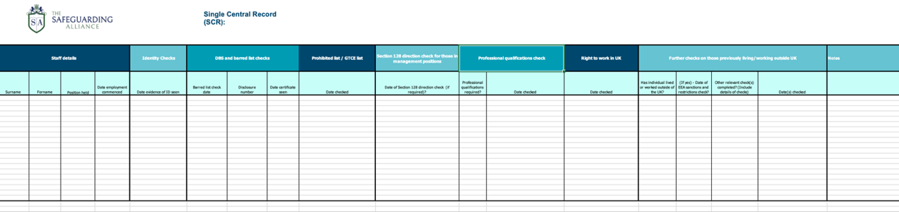

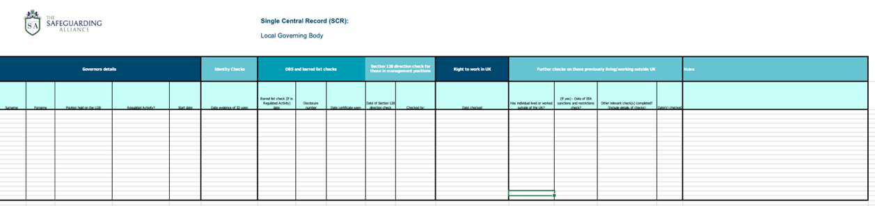

This Excel Spreadsheet is provided to UK schools by The Safeguarding Alliance for their record keeping needs. This does clearly show all the necessary information that needs to be stored on all the different staff types and provides a way of storing it. As it stands, this solution is very unidimensional as its only function is storing information. In addition, it provides no way of keeping a record of which trainings a staff must undergo or any dates for when these training requirements were fulfilled.

##### Parts that I can apply to my solution:

As aforementioned, while this does not have much functionality, it does provide me with all the information that needs to be stored on each staff type. Where this spreadsheet has rows, my software will have staff profiles.

#### School Information Management System (SIMS)

##### Overview



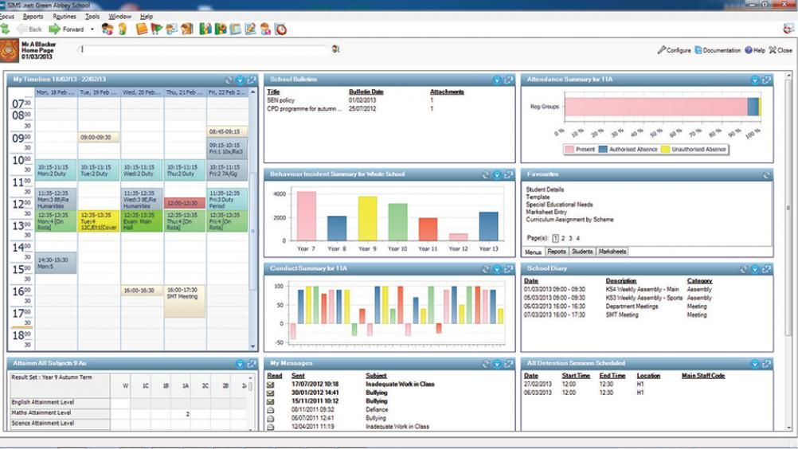

##### SIMS has many features and functions ranging across all departments of a school. It has individual teacher’s timetables, class registers, and student profiles including personal information, attendance records, and disciplinary information. There is a means of storing training information for teachers however this element of SIMS is lacklustre and is missing much functionality/ automation. Furthermore, SIMS is programmed in a way that makes it incompatible with Mac OS.

##### Parts that I can apply to my solution:

While this is better than the previous solution (a spreadsheet), it is still missing much functionality in the area I hope to address. I’m planning to use the concept of a calendar that automatically adds training deadlines etc., similar to the timetable that can be seen above. Additionally, I will use the concept of profiles to keep the information on each staff member well ordered, as SIMS does.

#### Highgate Hero

##### Overview

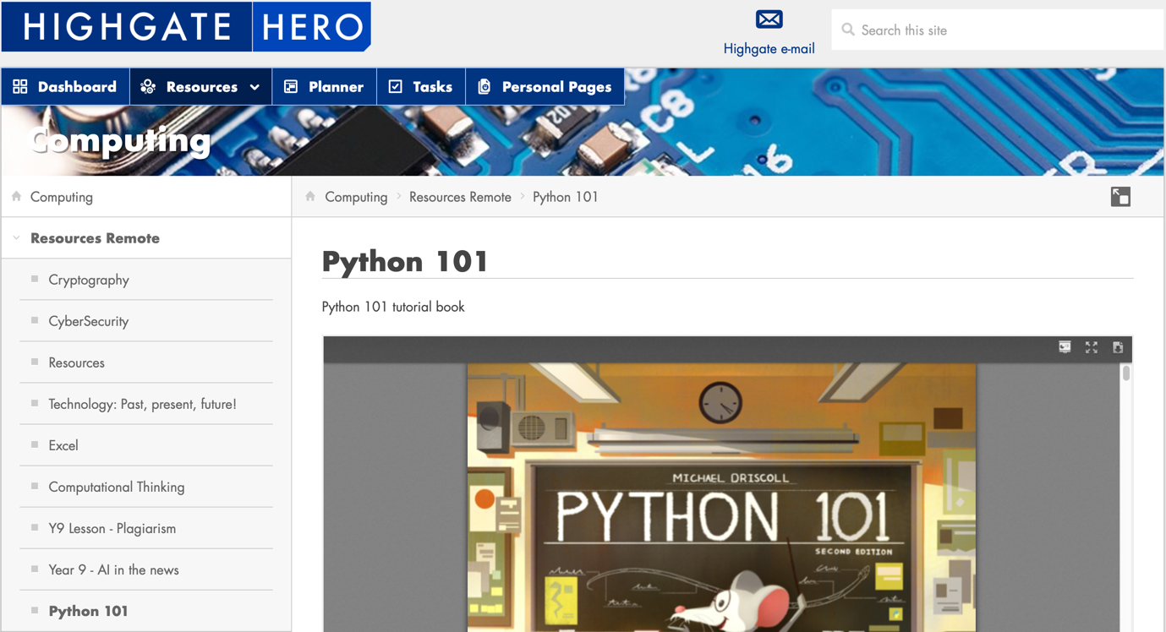

This is the school’s system which is used to provide information for students, including timetables, tasks, messages, resources etc. This does not do the same job as my intended software, but I thought it would be good to examine because it, like my software, is many layers deep. To deal with this, it has a series of tabs up the left side so that users can access previous pages.

##### Parts that I can apply to my solution:

This is a very different kind of system but still relies on a database and goes many layers deep, like my proposed software. I like how it helps with navigation by providing a series of tabs up the left-hand side so that users can go back to previous screens easily. This is something I believe will be useful in my software.

### Features of the proposed solution:

#### Initial concept of my solution considering this research:

My solution will be a local application that has clearly set out profiles for both staff members of various types and trainings. The staff profiles will have several sections, such as one for personal information, training, and a space to keep track of prerequisites/ checks. The training profiles will have information such as who requires it, contacts to book it through, and space for any other relevant information. There will also be a sort of notification centre that will show when people have upcoming deadlines to get their training renewed, which people are missing relevant information etc. While it will be possible to create profiles from the application, I would like to be able to read in either an excel or csv file so that mass profile creation is not so time consuming.

#### Limitations of my solution:

While there will be some automation, it will still require a lot of manual work. For example, someone still needs to contact each staff member to let them know when they need to complete training.

Another limitation of this is that, because it will be local and not on a network, the administrator will only be able to gain access to the information from the computer they set up the application on.

### Further meeting with stakeholders:

#### This is a message I sent to all my stakeholders (Emily, Alice, Jonathan):

“Hi,

From your input, I have come up with some specific ideas of what I could include in the system. I would really appreciate if you could let me know what you think of the ideas. My solution will be a local application that has clearly set out profiles for both staff members of various types and trainings. The staff profiles will have several sections, such as one for personal information, training information, and training. The training profiles will have information such as who requires it, contacts to book it through, and space for any other relevant information. There will also be a sort of notification centre that will show when people have upcoming deadlines to get their training renewed, which people are missing relevant information etc. While it will be possible to create profiles from the application, I would like to be able to read in either an excel or csv file so that mass profile creation is not so time consuming. It seems that the code will be able to run on almost any operating system and should not require too much computing power, and so should be able to be used by anyone.”

#### These are the responses I received:

##### Emily

“That sounds great! It appears that there is a lot of moving parts so just be careful about making sure that it is clear for the user. Apart from that, I’m very excited about it and look forward to seeing the project further developed.”

##### Amy

“I like it! I especially like the idea about having contacts who the trainings can be booked through and the thing about mass creating profiles since I know how time consuming that can be.”

##### Jonathan

“Very cool. I think that’s going to be a great help in keeping Human Resources on top of everyone’s trainings and requirements. Good Job!”

## 

## Requirements

### Stakeholder requirements

#### Design

|  |  |
| --- | --- |
| **Requirement** | **Explanation** |
| Lightweight designed interface | The design needs to be simple to use and easily understood. |
| Clearly labelled buttons and widgets | This will allow the user to see what they are doing and how they will be able to do what they want to do/ go where they want to go. |
| Well-connected and normalised database. | This will allow for connected relevant information and will also mean that connecting the information to the interface will be much easier as queries will be easier. |

#### Functionality

|  |  |
| --- | --- |
| **Requirement** | **Explanation** |
| Batch creating profiles from a spreadsheet/ csv file | Profile creation is tedious, allowing for batch creation will massively increase efficiency. |
| Training/ Staff profiles | Profiles will be required to store information on individual staff members or trainings, especially so that this can be stored and found in an orderly way. |
| Attach Training requirements to teacher profiles and vice-versa | Should be able to add all teachers, for example, to a training. Alternatively, a new teacher needs to have various trainings added to their profile at the same time. |
| Calendar/ notification centre | Administrators need to be able to see who has information missing from their profile and who needs training so that it can be organised. This will mean that training statuses do not need to be checked by moving through every profile. |
| Search bar for profiles | This will allow profiles to be easily found for when information on a staff member is needed/ needs to be updated. |

### Hardware and software requirements

|  |  |
| --- | --- |
| **Requirement** | **Explanation** |
| A computer capable of running and using the software | the software will not be particularly sophisticated or large so essentially any computer with a mouse and keyboard will suffice. |
| Windows, Linux or Mac operating system | These are the operating systems supported by Python, SQLalchemy (The library used for the creation of the database and the storage of the Information), and Tkinter (the library used for the GUI). |
| Python with SQLalchemy (1.4.7) and Tkinter | This programme will run on Python with SQLalchemy (to create the database) and Tkinter (to create the GUI) |

## Success Criteria

|  |  |
| --- | --- |
| **Criteria** | **How to evidence** |
| Main Window that links to different sections | Screen recording of me using the software |
| Window to access each staff type | Screen recording |
| Search bar to locate profiles/ trainings | Screen recording |
| Adding training requirements to staff profiles | Screen recording |
| Saving information on staff that can be viewed in a profile, including personal info and existing training requirements | Screen recording |
| Saving information on training that can be viewed, including how frequently it must be renewed | Screen recording |
| Adding one or many staff to a training at the same time | Screen recording |
| Adding a date of completed training to one or many staff profiles at the same time | Screen recording |
| Prerequisites section for staff | Screen recording |
| Profile/ training/ contact creation | Screen recording |
| Batch creation of profiles | Screen recording |
| Path down the side that allows you to go back to previous windows | Screen recording |
| Store Contacts who training can be booked through | Screen recording |
| Section to see who has incomplete prerequisites and what they are | Screen recording |
| Section to see who has incomplete training requirements and what they are | Screen recording |
| Section to see what trainings need to be organised over the next 6 months | Screen recording |
| Simple, lightweight design | Screen recording of me navigating the software with no screens to clustered. |

# Design

## Diagram, schematic Description automatically generatedDatabase Design

This is the database I will be creating with SQLalchemy to enable the program to store and save all the necessary information and data. Fields such as staff.name, staff.phonenum, training.name etc., will only be stored; fields such as training.timeperiod and staff_prerequisites.completed will be used to facilitate the programme’s functionality. For example, a prerequisite will only appear in a staff member’s incomplete prerequisites section (within notifications) if staff_prerequisites.completed is False for a given prerequisite.

## Database Testing Design

Thankfully, PyCharm has a variety of in-built features that will allow me to test the database once it has been created. Included in this are some graphs. For example, a visualisation of the database can be created, which I can compare with my above drawing to ensure that it has been correctly established and has the correct relationships.

Once I have ensured that the database is ready to be used and structured as it is meant to be, I will test it further by creating a record in each of the tables through the command line.

While this may seem somewhat rudimentary, this will be further tested during the unit tests for the queries, as the database must be working for the setup and unit tests to run.

## Algorithm Design

### Plotting Buttons

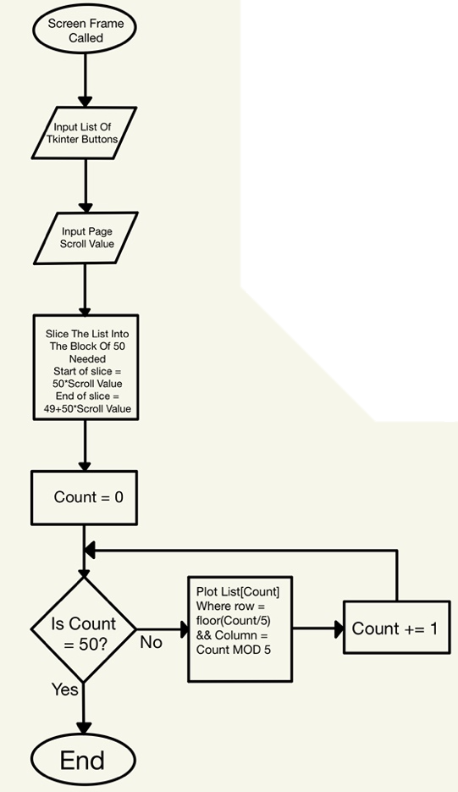Some of the screens will need to display an undefined number of buttons. In some cases, there may be too many buttons to fit on a screen and so will require the ability to scroll.

In this example, I am plotting the buttons in a grid of 10 rows by 5 columns.

Inputs the list of buttons and slices it into the 50 (rows*columns) buttons that will be plotted on the screen (depending on the scroll value). Plots it on the screen with the calculated row and column (shown in the diagram).

### Moving Between Screens

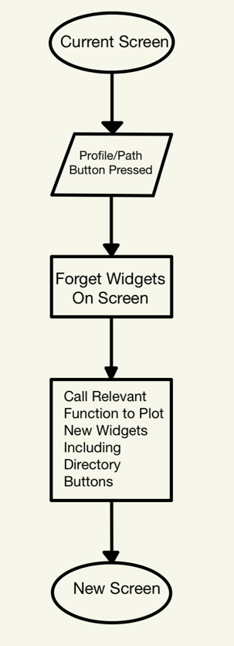

This is how I will move between screens. The profile/ path button pressed will call two methods: one to delete all widgets currently on screen and another for the new screen. The one for the new screen will plot all the necessary widgets, including the relevant directory buttons on the side.

This will be used between every screen.

### Calculating Due Date For A Staff’s Given Training

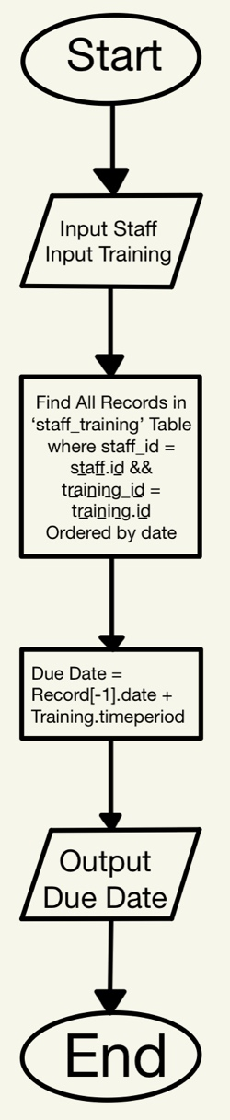

Takes an input of Staff and Training. Finds all records in the database where this staff has taken the training. Finds the most recent date of this and adds the Training.timeperiod to see when this needs to next be done. It then outputs this due date.

### Diagram Description automatically generatedSearch Bar

To search for a specific profile or training, type the name in the search bar and press the enter button. This will search through all the profiles and add all similar names to a new list. It will delete current widgets and replot with only the buttons in the new list (using the Plotting Buttons algorithm above).

### Diagram Description automatically generatedFinding A Staff Member’s Incomplete Prerequisites

Takes an input of Staff. Queries from the ‘staff_prerequisites’ table in the database all the records where staff.id = staff_id and ‘completed’ = False. Outputs all these records.

### Diagram Description automatically generatedFinding Staff Members Who Have Missed The Due Date For A Given Training

Input Training. Creates a list of staff members who require the training. Finds the most recent record of the staff completing the training and checks, and so calculates the due date for it. If this due date has passed, it adds the staff member to the overdue list. Once all records have been checked, it outputs the overdue list.

### Finding Staff Members Who Have An Upcoming Due Date For A Given Training

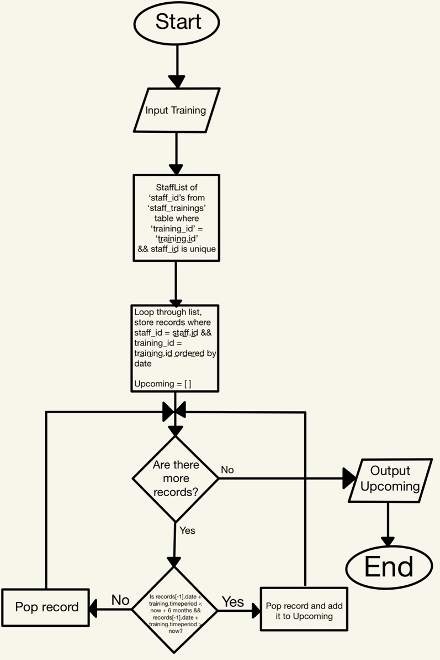

Input Training. Creates a list of staff members who require the training. Finds the most recent record of the staff completing the training and checks, and so calculates the due date for it. If this due date is within, for example, 6 months, it adds the staff member to the Upcoming list. Once all records have been checked, it outputs the Upcoming list.

## Inputs and Outputs

|  |  |  |
| --- | --- | --- |
| **Input** | **Process** | **Output** |
| StaffType_id | Find all records in the staff table of the database with correct stafftype id | Records from the database as a list ‘Staff’ |
| Staff | Create a tkinter button for each element with text = staff name, with a lambda function for the staff profile screen (passing the record as an attribute). Add each button to a list ‘StaffButtons’ | Output ‘StaffButtons’ |
| StaffButtons, StaffScroll | Slice StaffButtons depending on the value of StaffScroll. Save this new list as ‘StaffButtonsOnScreen’ | Output ‘StaffButtonsOnScreen’ |
| Training | Create a tkinter button for each element with text = training name, with a lambda function for the training profile screen (passing the record as an attribute). Add each button to a list ‘TrainingButtonList’ | Output ‘TrainingButtons’ |
| TrainingButtons,  TrainingScroll | Slice TrainingButtons depending on the value of TrainingScroll. Save this new list as ‘SmallTrainingButtonsList’ | Output ‘SmallTrainingButtonsList’ |
| Staff.id | Find Trainings belonging to that staff member | Output  Training |
| Training.id | Find all staff members who require this training. | Output ‘Staff’ |
| Training.id | Find all Contacts who offer this Training. Save them in a list, ‘Contacts’ | Output ‘Contacts’ |
| Contact.id | Find all Trainings offered by Contact. Save in list, ‘TrainingOffered’ | Output ‘TrainingOffered’ |
| Training.id | Find all staff members who have not completed this Training. Save them to a list, ‘Overdue’ | Output ‘Overdue’ |
| Training.id  Time_frame | Find all staff members who have this training upcoming within given time frame. Save them to a list, ‘Upcoming’ | Output ‘Upcoming’ |
| Path Buttons, Profile Buttons, Directory Buttons etc. | Trigger two functions:   * Forget_frame * Show_frame | The new screen/ frame will be displayed |

## Key Variables

|  |  |  |
| --- | --- | --- |
| **Name** | **Data Type** | **How it is used** |
| Stafftype_id | Integer | Changes depending on staff type selected, tells the software which staff profiles section to display e.g. teachers, volunteers etc. |
| Staffmember_id | Integer | Changed depending on profile button clicked, passed through to the profiles screen so it knows which information to display. |
| ProfilesScroll | Integer | Splits the staff list up into a smaller list of 70 so that the buttons do not grid over the page. E.g. ProfilesScroll 0 will create a list with the first 70, 1 will create a list with 71-140 etc. |
| New_staff_info | List | Temporarily stores new staff’s personal info while the other info is being filled in. eventually used when new profile is being created as a record. |
| New_employ_info | List | Temporarily stores new staff’s employment info while the rest of the info is filled in. used when new profile is being creates as a record. |
| Staff_Prerequisites.Completed | Boolean | If True, it will be displayed under staff’s incomplete prerequisites |
| Staff.Country_StaffType_id | Integer | Will determine the prerequisites a staff member must have, and so will store these as records in the Staff_Prerequisites Table |
| Staff_Training.date | Date | Will be used to calculate the date by which the staff member must redo the training by (due date) |
| Training_interval | Integer | Also used to determine the due date |
| Time_frame | Integer | Determines how long in the future to check for upcoming training |

## GUI Design

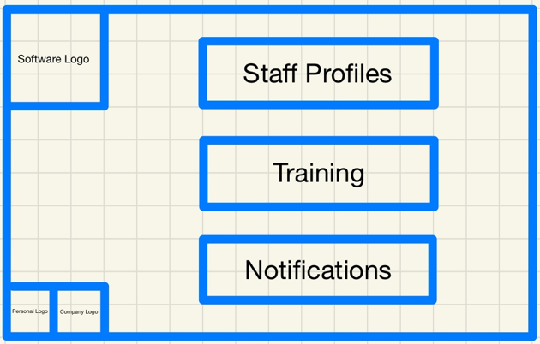Here is the Home Screen of the program. This allows the user to decide whether they want to access/ change information on training, staff, or when staff needed to/ will need to have their training redone. I also added logos to bring some colour to the page.

Links to the success criteria:

* Main Window that links to the different sections
* Simple, lightweight design

### Table Description automatically generatedStaff Profiles Section

This window allows you to access staff members of the different staff types. They are separated as different staff types hold different information. This will also help to faster navigate to a profile as it whittles down the profiles displayed.

Links to the success criteria:

* Window to access each staff type
* Path down the side that allows you to return to previous windows
* Simple, lightweight design

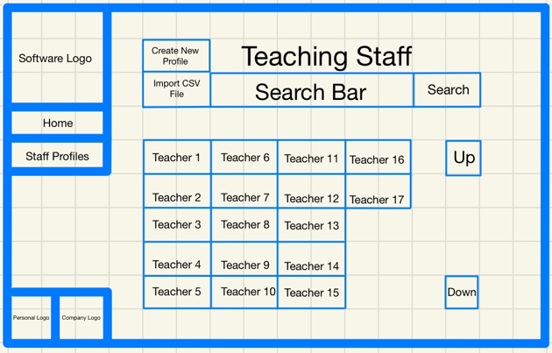This window displays all the teaching staff profiles. There is a search bar to search for profiles. The Up and Down buttons will appear and scroll if there are too many profiles to fit on one screen. There is a button to create another profile of the same staff type, and another button to upload a CSV for batch profile creation (again, of the same staff type). The other staff type screens will be almost identical to this. I will need an algorithm to plot the undefined amount of teacher profile buttons onto the screen with the ability to scroll through them using the up and down buttons.

Queries:

* Store all the teacher records from the ‘staff’ table in a list that the algorithm will then use to plot the profile buttons onto the screen with, using staff.name as the text.

Algorithms:

* Plotting Buttons
* Search Bar

Links to the success criteria:

* Search bar to locate profiles
* Profile creation
* Batch profile creation
* Path down the side that allows you to return to previous windows
* Simple, lightweight design

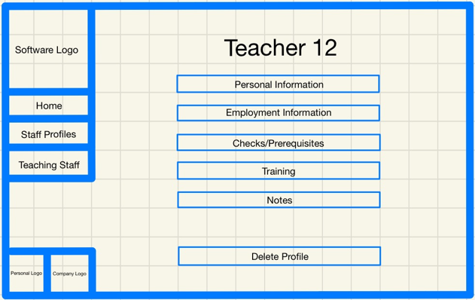Here is a Teacher Profile (other profiles will have the same sections but with different information within some of them).

I will need to pass the selected record through to this screen to display the name at the top.

Links to the success criteria:

* Saving information on staff that can be viewed in a profile, including personal info and existing training requirements
* Path down the side that allows you to return to previous windows
* Simple, lightweight design

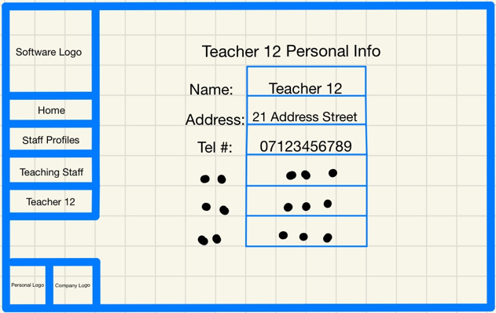

An example profile info section. This is the personal info but there will also be an employment info section etc.

The selected records name, address, phone number etc. will be displayed here.

Links to the success criteria:

* Saving information on staff that can be viewed in a profile, including personal info and existing training requirements
* Path down the side that allows you to return to previous windows
* 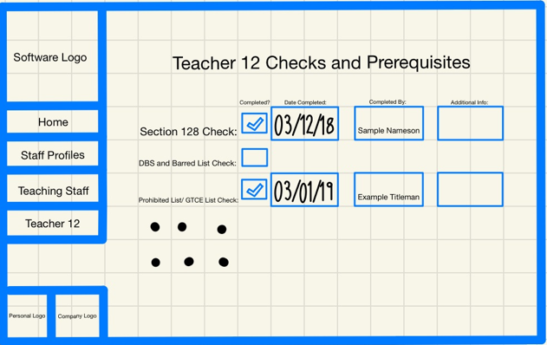Simple, lightweight design

This will be the screen for prerequisites which, when a prerequisite is ticked, will offer the ability to store the date of the check/ assurance of completion, the name of the staff member responsible for the check, and any additional info such as a reference number.

Queries:

* All records from the ‘ staff_prerequisites’ table with a staff_id matching that of the selected staff member will be stored in a list that will then be displayed on this page
* A query will be needed to update a prerequisite’s completed state from False to True, and to add the ‘completed by’ and ‘additional info’

Links to the success criteria:

* Saving information on staff that can be viewed in a profile, including personal info and existing training requirements
* Prerequisites section for staff
* Path down the side that allows you to return to previous windows
* Simple, lightweight design

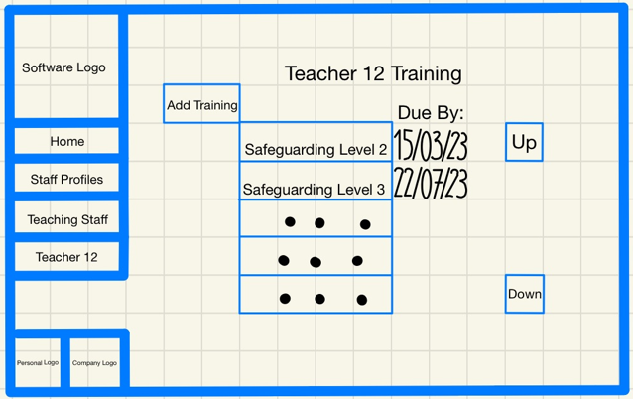This screen will display a staff member’s various required trainings, as well as when they must be redone by.

Queries:

* A query to store in a list all of the unique staff_trainings records from the ‘staff training’ table with staff_id of the selected staff member
* Access the most recent date for these records, adding the timeperiod of the training_id to find the due by dates

Algorithms:

* Calculating Due Date For A Staff’s Given Training

Links to the success criteria:

* Saving information on staff that can be viewed in a profile, including personal info and existing training requirements
* Adding training requirements to staff profiles
* Path down the side that allows you to return to previous windows
* Simple, lightweight design

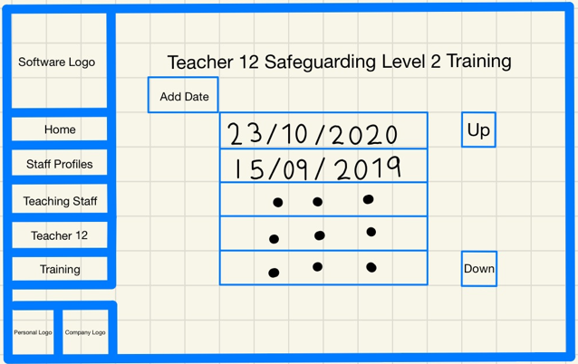

This screen displays all of the dates a staff member completed a given training, and will allow new dates to be added.

Queries:

* All of the dates from staff_trainings records with the staff_id of the staff member and the training_id of the training will need to be put into a list so that they can be displayed

Links to the success criteria:

* Saving information on staff that can be viewed in a profile, including personal info and existing training requirements
* Path down the side that allows you to return to previous windows
* Simple, lightweight design

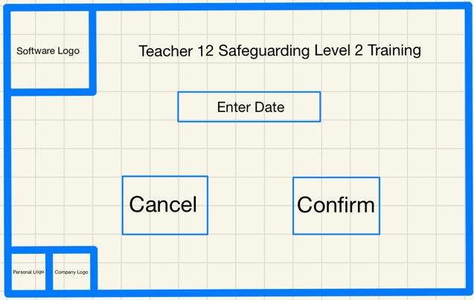This screen will allow you to input a new date for when a staff member completes a training.

The cancel button will take you back to the previous screen, the confirm button will commit the new staff_trainings record with the inputted date.

Queries:

* A query to create and commit a new record to ‘staff_trainings’

Links to the success criteria:

* Adding a date to one or many staff profiles at the same time
* Simple, lightweight design

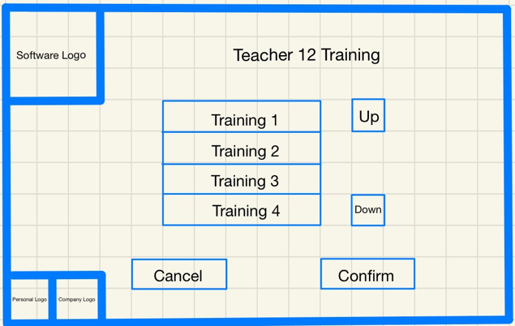

This screen allows one or many training requirements to be added to a staff member’s profile.

Cancel will take you back to the previous screen. Confirm will add the selected trainings to the profile.

Queries:

* A query to create and commit new records to ‘staff_trainings’

Links to the success criteria:

* Adding training requirements to staff profiles
* Simple, lightweight design

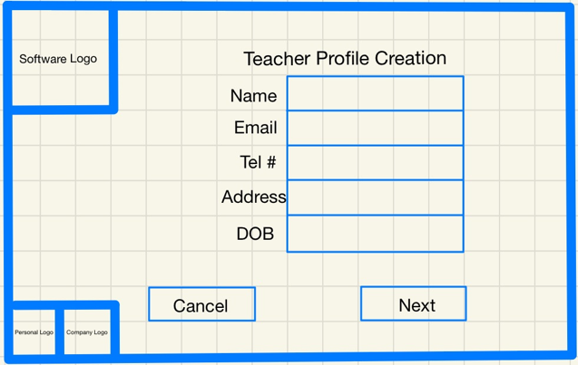This screen will create a temporary profile that will then be committed once all information has been added.

Cancel will take you back to the teacher profiles screen. Next will take you to the next screen that will require employment information for the profile.

Links to the success criteria:

* Profile creation
* Saving information on staff that can be viewed in a profile, including personal info and existing training requirements
* Simple, lightweight design

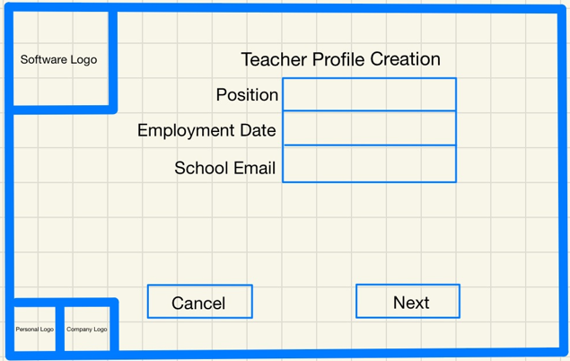This screen will add to the temporary profile.

Cancel will take you back to the teacher profiles screen. Next will take you to the next screen that will show you the prerequisites a staff member like this will need, as well as allowing you to mark them as completed.

Links to the success criteria:

* Profile creation
* Saving information on staff that can be viewed in a profile, including personal info and existing training requirements
* Simple, lightweight design

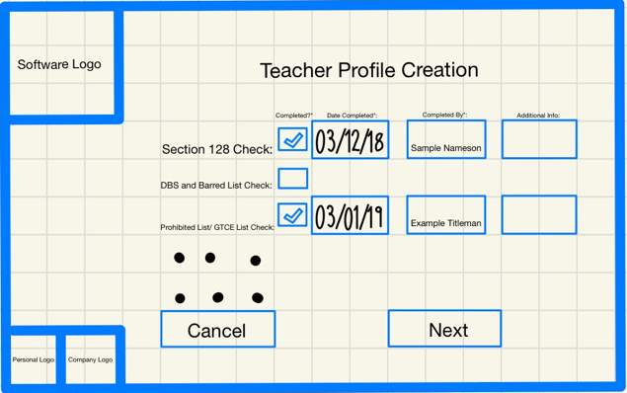

This screen displays the checks/ prerequisites that need to be completed on/by the new staff member. It will also allow you to add the information about completion.

Cancel will take you back to the teacher profiles screen. Next will take you to the next screen that will allow you to add training requirements to the new profile.

Queries:

* A query will be needed to see which prerequisites will be needed for the given country_stafftype of the new profile

Links to the success criteria:

* Profile creation
* Saving information on staff that can be viewed in a profile, including personal info and existing training requirements
* Prerequisites section for staff
* Simple, lightweight design

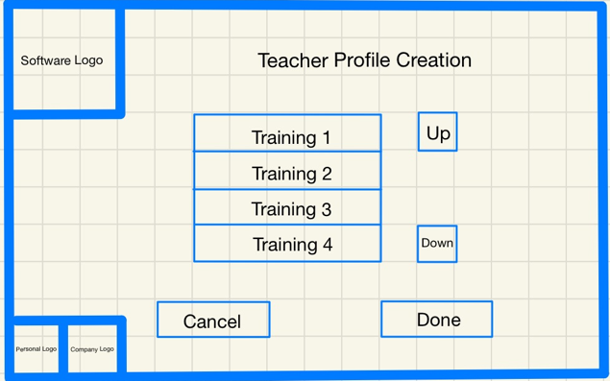

This screen allows you to add one or many training requirements to the new profile.

Cancel will take you back to the teacher profiles screen. Done will also take you back to the teacher screen after committing the information that was stored during the profile creation process.

Queries:

* Add and commit a record in ‘staff’ table with all info added
* Add and commit records to ‘staff_prerequisites’
* Add and commit records to ‘staff_trainings’

Links to the success criteria:

* Profile creation
* Saving information on staff that can be viewed in a profile, including personal info and existing training requirements
* Adding training requirements to staff profiles
* Simple, lightweight design

### Training & Contacts Section

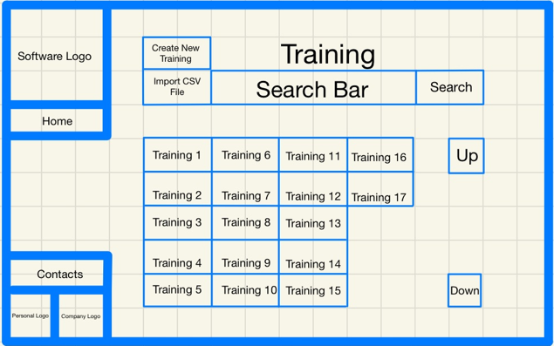

This is the screen that displays all the trainings, a button to display all contacts who can be contacted to schedule trainings with, a search bar to search through the trainings, and up and down buttons to scroll through the trainings when they do not all fit on the screen.

There is also buttons for training creation and batch training creation. Algorithm needed to

Queries:

* Store all the training records from the ‘training’ table in a list that the algorithm will then use to plot the buttons onto the screen with, using training.name as the text

Algorithms:

* Plotting Buttons
* Search Bar

Links to the success criteria:

* Search bar to locate trainings
* training creation
* Batch profile creation
* Path down the side that allows you to return to previous windows
* Simple, lightweight design

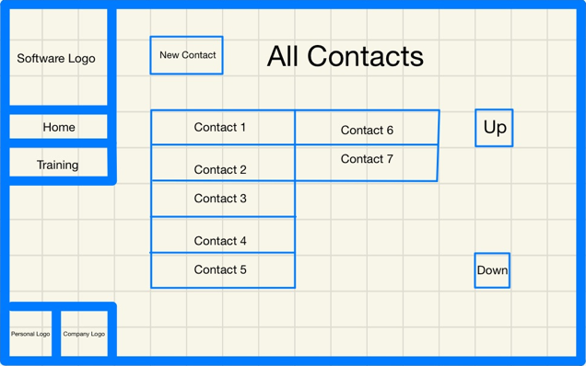This screen displays all contacts through which Training can be booked. It also allows new contacts to be added.

Queries:

* Store all Contacts from the contacts table of the database

Algorithms:

* Plotting Buttons

Links to the success criteria:

* Store Contacts who training can be booked through
* Contact creation
* Path down the side that allows you to return to previous windows
* Simple, lightweight design

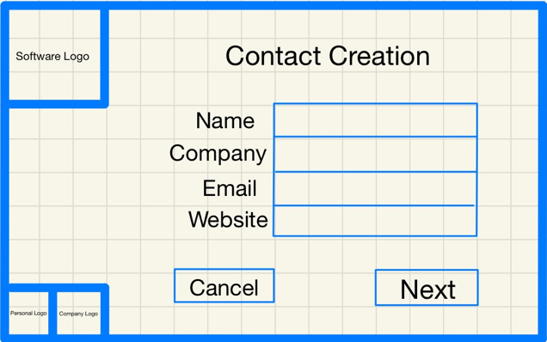This screen allows a contact to be created. The Cancel button will take you back to the contacts screen. Next will take you to the next scree, which will allow you to specify which training is offered by the contact.

Links to the success criteria:

* Store Contacts who training can be booked through
* Contact creation
* Simple, lightweight design

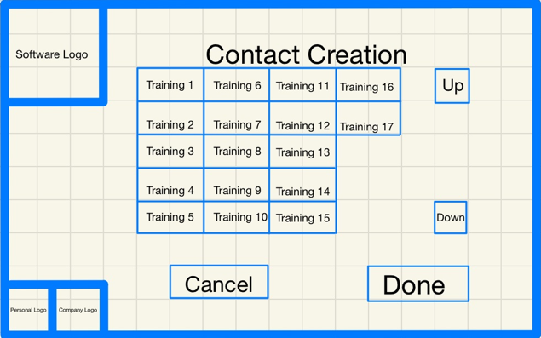This screen will allow you to specify which trainings are offered by the contact made on the last page. The Cancel button will take you back to the contact screen. The Done button will create the contact as a record in the contacts table of the database. It will then take you back to the contacts screen with the new contact.

Queries:

* Add a record to contacts
* Add records to training_contacts for which trainings are offered by this contact

Algorithms:

* Plotting Buttons

Links to the success criteria:

* Store Contacts who training can be booked through
* Contact creation
* Simple, lightweight design

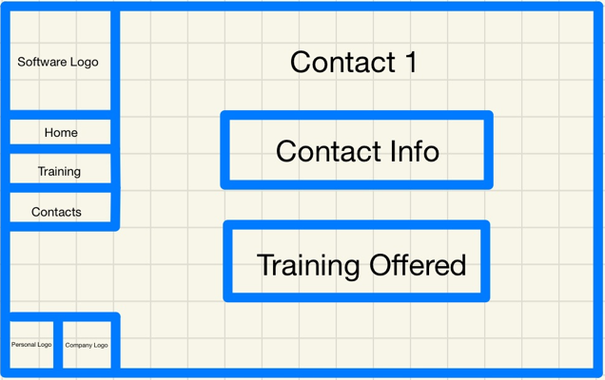

This is a contact profile and will be seen when a contact button is clicked.

Contact Info will show you the contacts email, website etc.

Training Offered will display trainings offered by the contact.

Links to the success criteria:

* Store Contacts who training can be booked through
* Path down the side that allows you to return to previous windows
* Simple, lightweight design

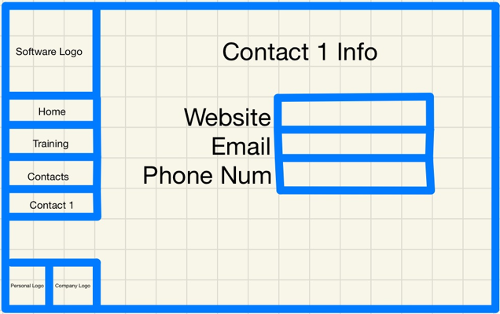

This is the Info page for a contact.

Queries:

* Store information on a given contact

Links to the success criteria:

* Store Contacts who training can be booked through
* Path down the side that allows you to return to previous windows
* Simple, lightweight design

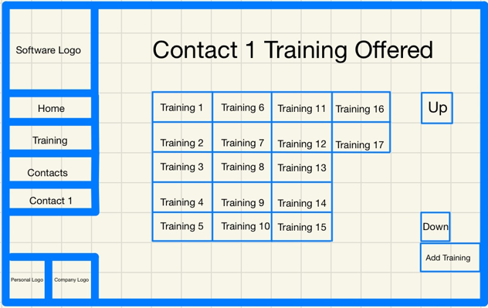

This page shows the trainings offered by a contact, and will allow you to add trainings if they now offer them. Clicking on a training button will show you the information about the training.

Queries:

* Store all trainings where there is a record with contact_id = contact.id in the training_contacts table

Algorithms:

* Plotting Buttons

Links to the success criteria:

* Store Contacts who training can be booked through
* Path down the side that allows you to return to previous windows
* Simple, lightweight design

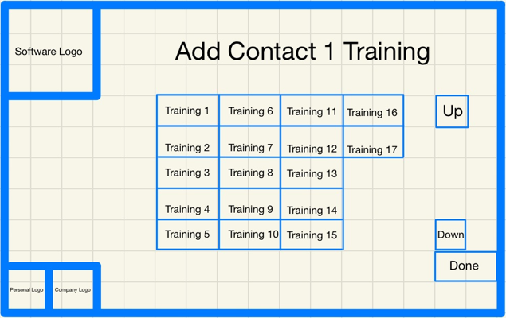This page will allow you to add trainings now offered by a contact. Clicking Done with nothing selected with essentially cancel and take you back to the trainings offered screen. All selected trainings will be added to the training_contacts table once done is clicked.

Queries:

* Store trainings not offered by contact
* Add records to training_contacts table

Algorithms:

* Plotting Buttons

Links to the success criteria:

* Store Contacts who training can be booked through
* Simple, lightweight design

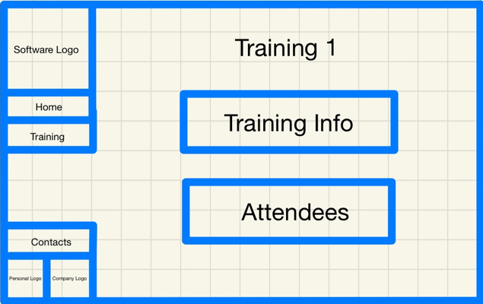This is the page that displays the Training ‘profile’.

Training Info will display the training info.

Attendees will display all Staff who require this training.

Contacts will display all contacts who offer this training.

Links to the success criteria:

* Saving information on training that can be viewed, including how frequently it must be renewed
* Path down the side that allows you to return to previous windows
* Simple, lightweight design

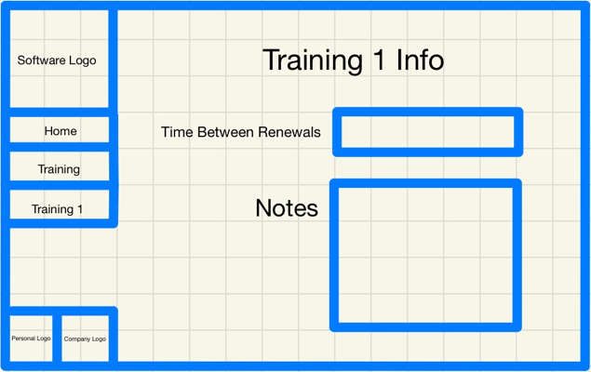

This page displays the information about the training

Links to the success criteria:

* Saving information on training that can be viewed, including how frequently it must be renewed
* Path down the side that allows you to return to previous windows
* Simple, lightweight design

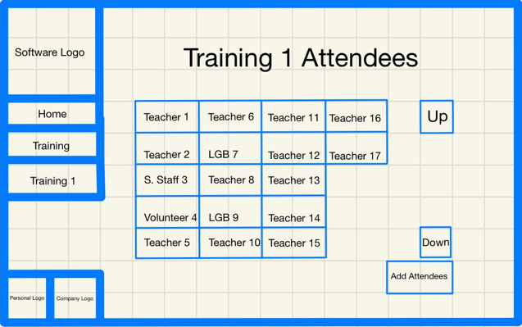

This page displays all staff members who require this training. Add Attendee will allow you to add more staff members to this.

Queries:

* Store all staff records who require this training

Algorithms:

* Plotting Buttons

Links to the success criteria:

* Saving information on training that can be viewed, including how frequently it must be renewed
* Adding training requirements to staff profiles
* Path down the side that allows you to return to previous windows
* Simple, lightweight design

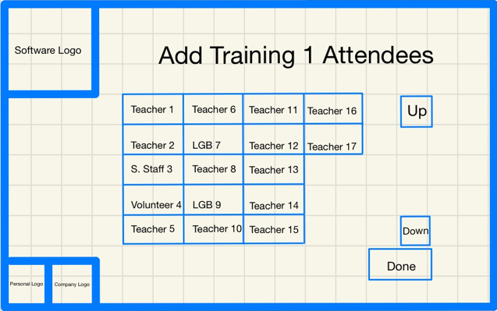

This screen allows you to add this training requirement to staff profiles.

With nothing selected, Done will act as a cancel button.

With profiles selected, Done will add the requirement to the profiles and go back to the Attendees screen with the new Attendees.

Queries:

* Store all staff records who don’t require this training
* Add relevant records to staff_trainings

Algorithms:

* Plotting Buttons

Links to the success criteria:

* Saving information on training that can be viewed, including how frequently it must be renewed
* Adding training requirements to staff profiles
* Simple, lightweight design

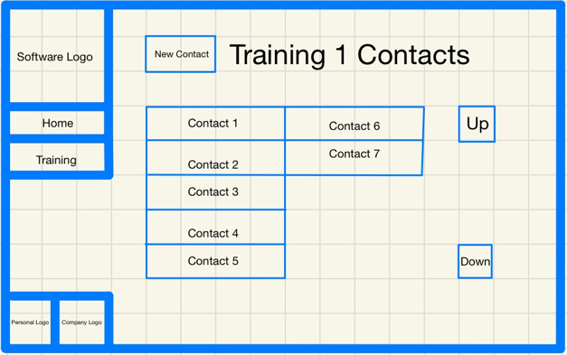

This screen displays the contacts who offer the training. Contacts can be added to this.

Queries:

* Store all contacts who offer the training

Algorithms:

* Plotting Buttons

Links to the success criteria:

* Saving information on training that can be viewed, including how frequently it must be renewed
* Store Contacts who training can be booked through
* Path down the side that allows you to return to previous windows
* Simple, lightweight design

### Notifications Section

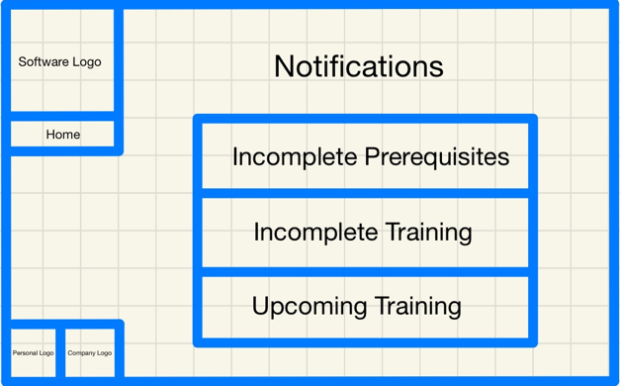

This is the notifications section of my system. This allows you to view Incomplete Prerequisites, Incomplete Training, and Upcoming Training.

Links to the success criteria:

* Section to see who has incomplete prerequisites and what they are
* Section to see who has incomplete training requirements and what they are
* Section to see what trainings need to be organised over the next 6 months
* Path down the side that allows you to return to previous windows
* Simple, lightweight design

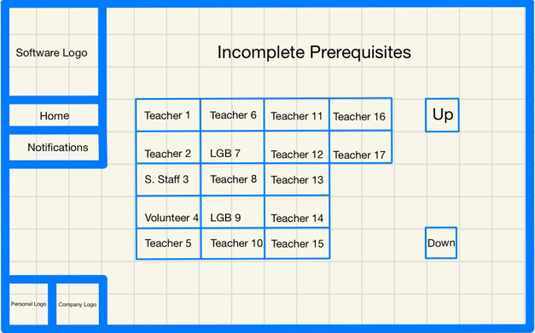This screen displays all staff with incomplete prerequisites. Clicking the button of a staff member will display all incomplete prerequisites

Queries:

* Store all Staff who have prerequisites where completed = False

Algorithms:

* Plotting Buttons

Links to the success criteria:

* Section to see who has incomplete prerequisites and what they are
* Path down the side that allows you to return to previous windows
* Simple, lightweight design

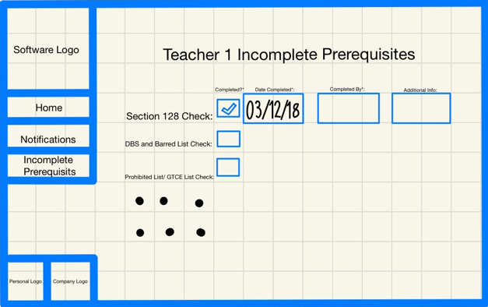This section displays all incomplete prerequisites of a staff member. They can be marked as completed and have the relevant information filled in from here.

Queries:

* Store all incomplete prerequisites of a given staff member

Algorithm:

* Finding A Staff’s Incomplete Prerequisites

Links to the success criteria:

* Saving information on staff that can be viewed in a profile, including personal info and existing training requirements
* Prerequisites section for staff
* Path down the side that allows you to return to previous windows
* Simple, lightweight design

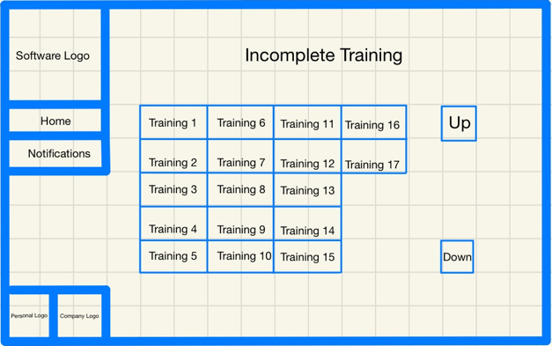

This screen shows you which trainings have staff members that have missed the due date of the training. Clicking on a training button will display all the staff members that need to complete it.

Queries:

* Store all trainings where at least one staff member has missed the deadline for it

Algorithms:

* Plotting Buttons

Links to the success criteria:

* Section to see who has incomplete training requirements and what they are
* Path down the side that allows you to return to previous windows
* Simple, lightweight design

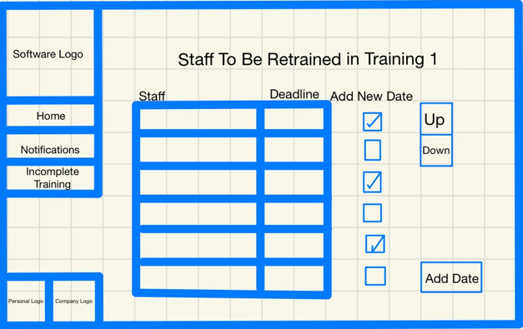This screen displays all staff who need to redo the training and the deadline that has passed.

Selecting Add New Date on one or multiple staff and clicking Add Date will allow a new record for every member to be added to staff_trainings with a date that will be given on the next screen.

Queries:

* Store all staff members who have missed the due date for the training

Algorithms:

* Calculating Due Date For A Staff’s Given Training
* Finding Staff Members Who Have Missed The Due Date For A Given Training

Links to the success criteria:

* Section to see who has incomplete training requirements and what they are
* Adding a date of completed training to one or many staff profiles at the same time
* Path down the side that allows you to return to previous windows
* Simple, lightweight design

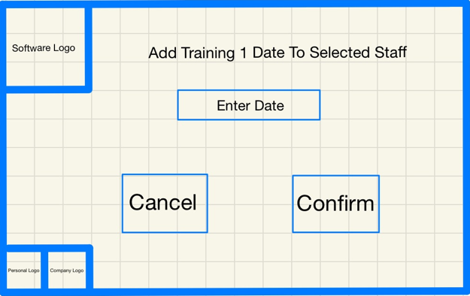

This screen is where the date for the records for the staff will be inputted.

Cancel goes back to the screen with the listed staff members who need to redo their training.

Confirm will store the records.

Queries:

* Add records for all selected staff members where training_id = training.id with the inputted date

Links to the success criteria:

* Adding a date of completed training to one or many staff profiles at the same time
* Simple, lightweight design

This screen shows you which trainings have staff members that need to have their training redone within the next 6 months. Clicking on a training button will display all the staff members that need to complete it.

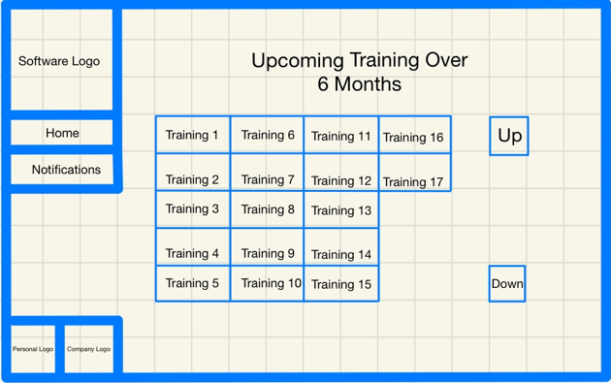

Queries:

* Store all trainings where at least one staff member has upcoming training

Algorithms:

* Plotting Buttons

Links to the success criteria:

* Section to see who has upcoming training requirements and what they are
* Path down the side that allows you to return to previous windows
* Simple, lightweight design

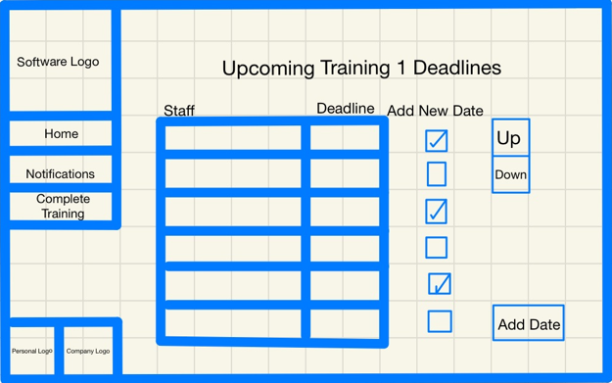

This screen displays all staff who need to redo the training and the upcoming deadline.

Selecting Add New Date on one or multiple staff and clicking Add Date will allow a new record for every member to be added to staff_trainings with a date that will be given on the next screen.

Queries:

* Store all staff members who have an upcoming due date for the training

Algorithms:

* Calculating Due Date For A Staff’s Given Training
* Finding Staff Members Who Have An Upcoming Due Date For A Given Training

Links to the success criteria:

* Section to see what trainings need to be organised over the next 6 months
* Adding a date of completed training to one or many staff profiles at the same time
* Path down the side that allows you to return to previous windows
* Simple, lightweight design

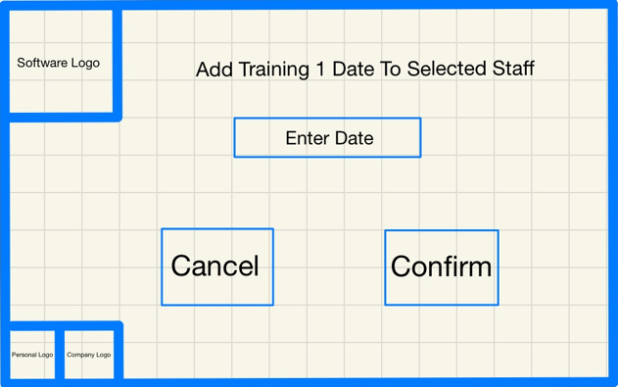This screen is where the date for the records for the staff will be inputted.

Cancel goes back to the screen with the listed staff members who have an upcoming training deadline.

Confirm will store the records.

Queries:

* Add records for all selected staff members where training_id = training.id with the inputted date

Links to the success criteria:

* Adding a date of completed training to one or many staff profiles at the same time
* Simple, lightweight design

### Stakeholder Input

The main problem to be solved by this software is displaying lots of intertwining data in a way that can easily be dealt with and understood. This is why I have reached out to my stakeholders to see what they think about my current designs for the GUI. Here is what they had to say:

#### Emily

“I like these designs. Everything on each page is so clear as to what it does and where the buttons lead to. I especially like the buttons on the left that allow you to go back to previous pages. It’s a bit difficult to imagine the software as a whole because there are so many screens but I’m sure it will be great.”

#### Alice

“These look great. I particularly like the notifications section, it’s going to speed up the process so much. I like how simple it is and I’m sure the logos will bring some colour to the page and make it look nice. It would be nice though to select a time frame for upcoming training because 6 months is a bit too long.”

#### Jonathan

“This looks good. I like how everything links together. I think that it would be good though to have the notifications outputted in an excel document but apart from that I’m impressed.”

## Validation

### Buttons

The Buttons I am using are part of Tkinter, so they are already robust. By their nature, they will carry out the necessary operation only when they are pressed, and if the operation is not yet ready to occur then they will not be on screen. They do not pass variables when they are pressed and so there is no risk of sending incorrect data.

### Text Boxes

These are different as the user can type anything into them. Text boxes in this program will be used for writing notes, inputting dates, inputting names, etc. and so validation will be different for each of these. For example, names will only be able to be inputted if all characters are between a-z or A-Z, but notes will take any characters.

I will make it clear how everything should be formatted so when incorrect data is inputted, users will be able to easily be able to rectify mistakes when they are unable to continue.

### Sliders

This is also a part of Tkinter and so is already robust. By their nature, they can only be in a state which is predefined, and all its states will be valid for the program. Therefore, there is no need for any additional validation.

## Query Testing Design

To test my queries, I will be using unit tests. There are five main reasons for me doing this:

1. These will allow me to test that my queries are giving expected outputs based on the arguments that are passed to them.
2. If a query does not pass the test, I will be able to easily see the actual value that was returned aside the expected value. This will allow me to easily analyse any errors and implement a solution.
3. Using each of the queries in a variety of ways will allow me to learn the format they use and the best way to use them.
4. Setting up some sample data and accessing, updating, and querying this will allow me to test that the database works in the first place.
5. Unit tests will allow me to physically demonstrate amd document the testing of my queries, as well as any errors and/or successful tests that occur.

## GUI Testing Design

There are a variety of ways that I will be testing my Interface.

Before I run my code, I will create several profiles for each of the staff types and some test trainings. This will allow me to use my interface to ensure that the correct information comes up for each staff profile/ training, as well as allowing me to carry out tasks on the profiles to ensure that the entries and buttons are working e.g. adding trainings to profiles, updating prerequisite information, testing my notifications section etc.

First and most obviously, I will be testing my interface by running the code and navigating to the screen I am currently working on.

Next, I will make sure that all my widgets are accurate and gridded in the correct locations. E.g. profile buttons and individual profiles’ prerequisite/ personal/ employment information.

Lastly, I will test functionality such as adding/ updating information by attempting this on the interface and checking back on my database tables that this has been correctly added and committed.

## Testing Checklist

|  |  |
| --- | --- |
| **Action to test** | **Working?** |
| Buttons on the Home screen take you to the relevant page |  |
| Buttons on the Staff Profiles screen take you to the relevant staff type section, and the Home takes you to the home screen |  |
| Profile (and training) buttons can be scrolled through and pressing one takes you to the correct profile. Directory buttons work |  |
| Create [staff type] button takes you to the relevant staff creation screen |  |
| Profiles only created when inputted data passes validation |  |
| Creating a staff profile (or training) will add all necessary records to the database |  |
| Search Bar works by showing only profiles (or training) with a name similar to the input |  |
| Buttons on a profile page bring you to the correct page for the correct staff member. Directory buttons work |  |
| Information displayed on profile (and training) info pages are correct |  |
| Prerequisites can be marked as done and have the information stored on them |  |
| Training can be added to a staff profile from the profile’s training screen |  |
| Dates can be added for when staff complete a training |  |
| Staff can be added to a training from the training attendees page |  |
| Dates for one or many staff can be added via the training profile |  |
| Contacts can be created |  |
| Contacts can be added to training |  |
| Training can be added to contacts |  |
| Contact creation works and creates correct records in the database |  |
| Upcoming training can have time frame changed |  |
| Query finds all profiles with incomplete prerequisites |  |
| Query finds all incomplete prerequisites given the profile |  |
| Query finds all trainings with staff members who have missed their deadline for it |  |
| Query finds all staff members who have missed the training deadline given the training |  |
| Query finds all trainings with staff members who need to have it done within the time frame selected |  |
| Query finds all the staff members who need to have training redone within the time frame given the training |  |

# Development and Testing

There are several stages that will need to occur during this section. I will outline these below with an explanation as to why they are necessary:

**Stage 1 - Database Development:**

Here, I will be using my design to code the structure of the database/ object tables and relationship tables. This is the first thing I will be doing as the database is the foundation of my software and so it is important that this works before I am able to proceed.

**Stage 2 - Database Testing:**

Here, I will be testing to see that the database tables have been correctly established by generating diagrams using PyCharm. This is important as, as mentioned previously, the database is the foundation for the rest of the software.

**Stage 3 - Query Development:**

Here, I will be developing the queries I decided would be needed whilst designing each of the different screens. This includes creating profiles/ training, updating information, and checking which staff have incomplete prerequisites, overdue training etc. This is important as this is what will allow the information in the database to be viewed and updated through the interface.

**Stage 4 - Query Testing:**

Here, I will be using unit tests to ensure that the queries work, including adding records to tables, updating information and displaying correct information. This is important as it will allow me to both ensure the database is working as it is meant to and that the interface can correctly communicate with the database once it has been created.

**Stage 5 - Interface Development:**

Here, I will be using TkInter to create all the screens. This is arguably the most vital part of the software as this is what the user will be directly interacting with.

**Stage 6 - Interface Testing:**

Here, I will be testing each of the screens to ensure that they look as they are meant to, they display the correct information, and communicate correctly with the database, including updates and queries.

**Stage 7 - Stakeholder Testing:**

Here, I will be sending the prototype to each of my stakeholders, along with a questionnaire so that I can gauge their opinions and become better informed on the limitations of the software and what features to add in the future (its limitations and need for maintenance). If I have any bugs, this may potentially be found and highlighted by them also, which will allow me to rectify any mistakes.

## Stage 1 - Database development

The database is the foundation of this software, where all the information that will be stored or queried will come from. With my database design, I created a ‘models’ file that will establish the tables and relationships for my database. These are the models for my tables.

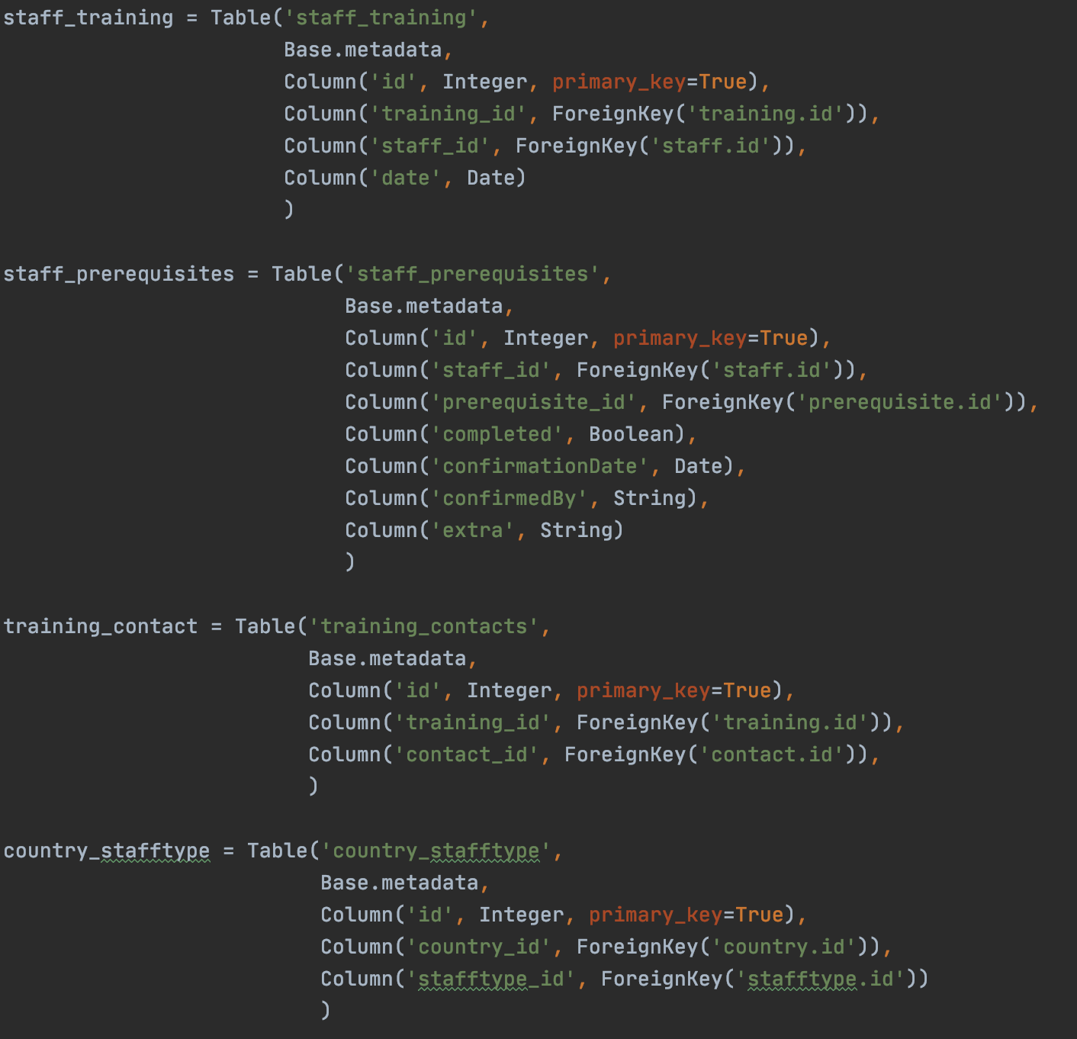

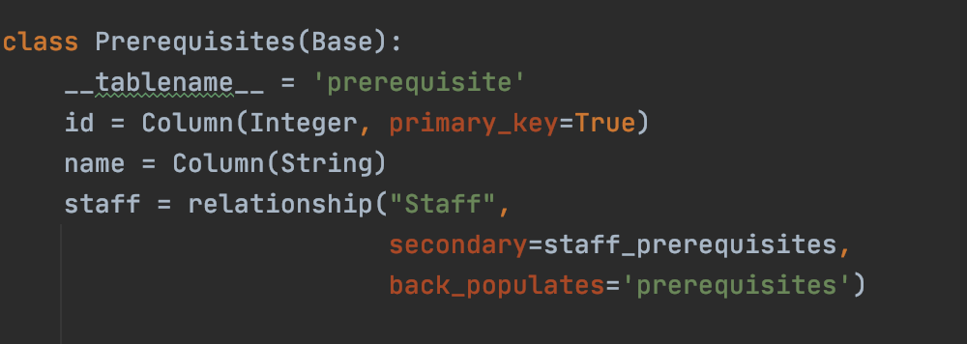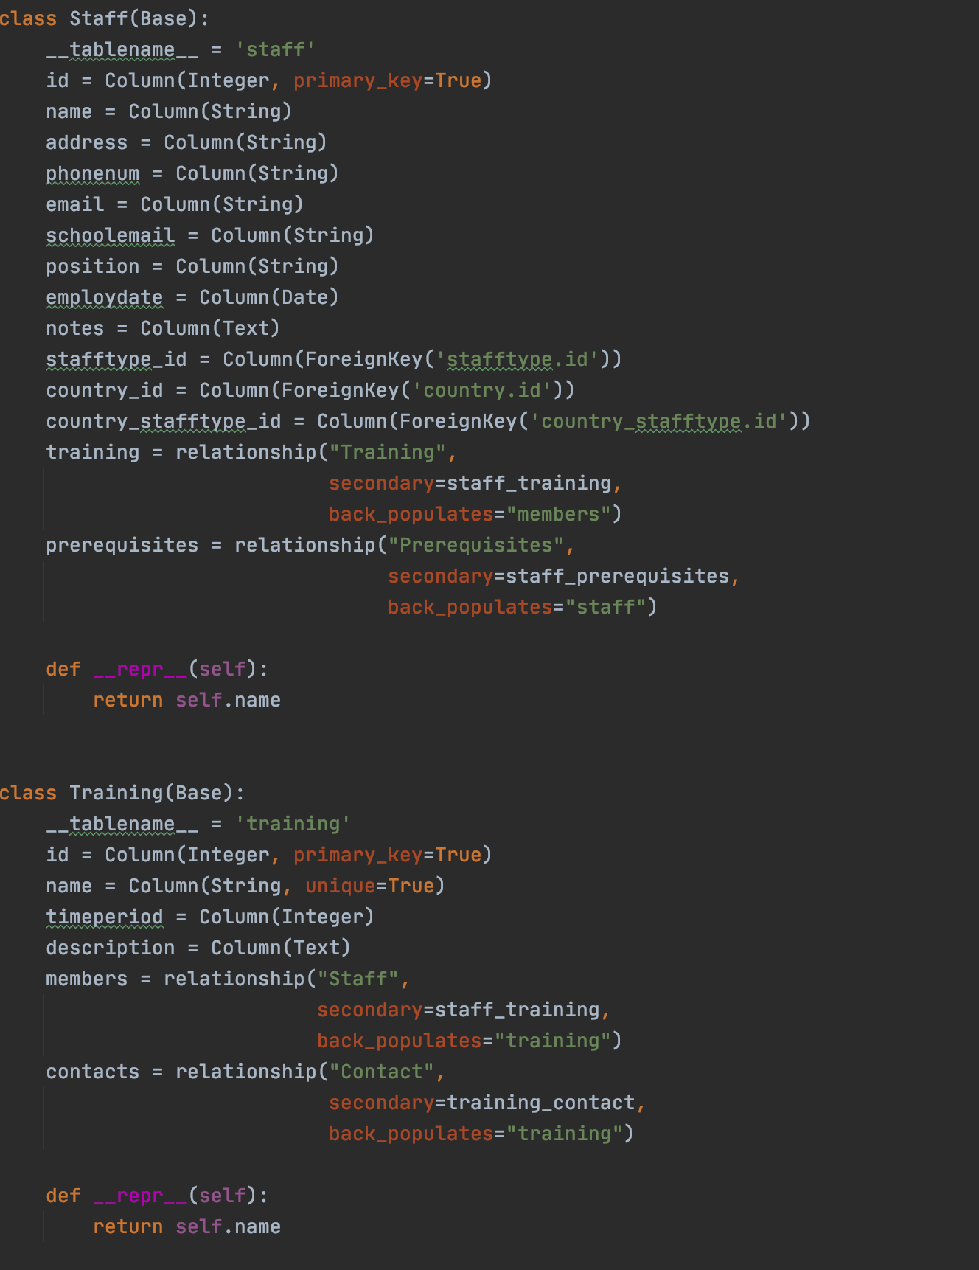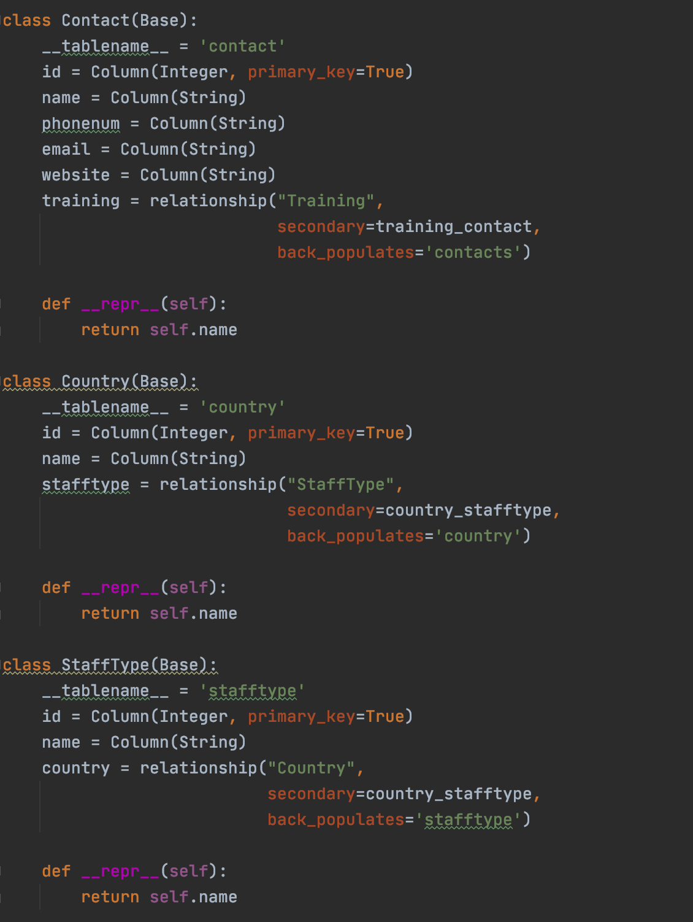

Now, I will make a ‘queries’ file for my queries. First, though, I must add a function called ‘establish_path’ that will create a session with my database, or create a new database if one is not already established. This function can be seen below.

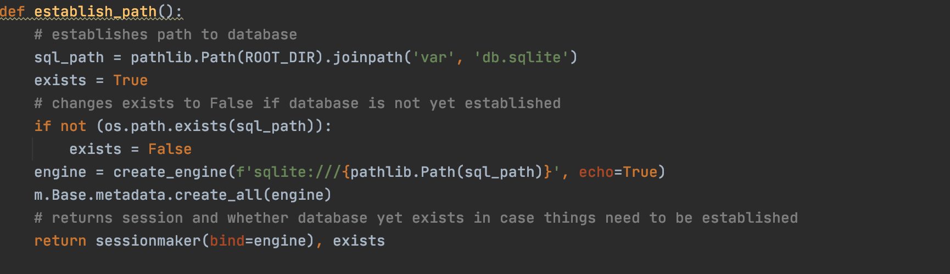

If this is the first time the database is being accessed, it will pass this information to another file which will populate the database with all the records it needs. For example, the countries, the staff types, and the prerequisites. I will come back to this once I have created the functions that will allow me to easily do this.

To call this function, I have created a ‘create_and_access_db’ file which will create the session. This is also where the ‘populate_database’ function will be created.

This is the code that creates a session (and populates the database if ‘exists’ == False):

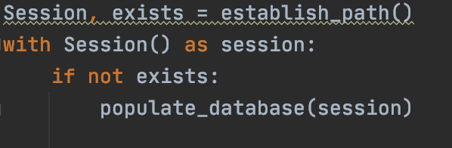

This will allow me to create the database, view the tables, and create diagrams to illustrate the structure of the database.

## Stage 2 - Database Testing

I needed to make sure that all of the tables were properly created and connected, and the database had the same structure that was outlined in my design.

Thankfully, PyCharm allowed me to do this through the Database functionality, as well as the creation of different diagrams to ensure that everything was connected correctly and looked like my design.

Here is the database as displayed by PyCharm:

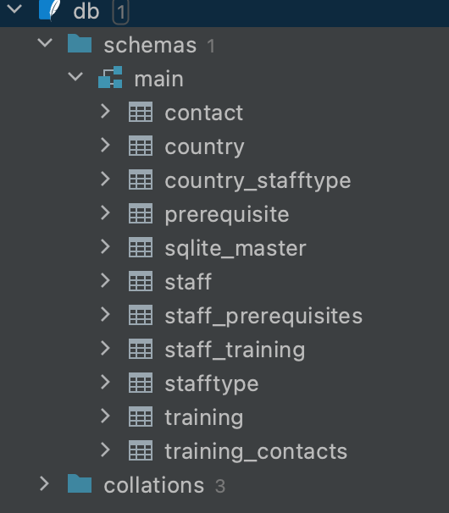

Here, I can see that my database and all my tables were created.

This is what the SQLalchemy Model Dependency Diagram looked like.

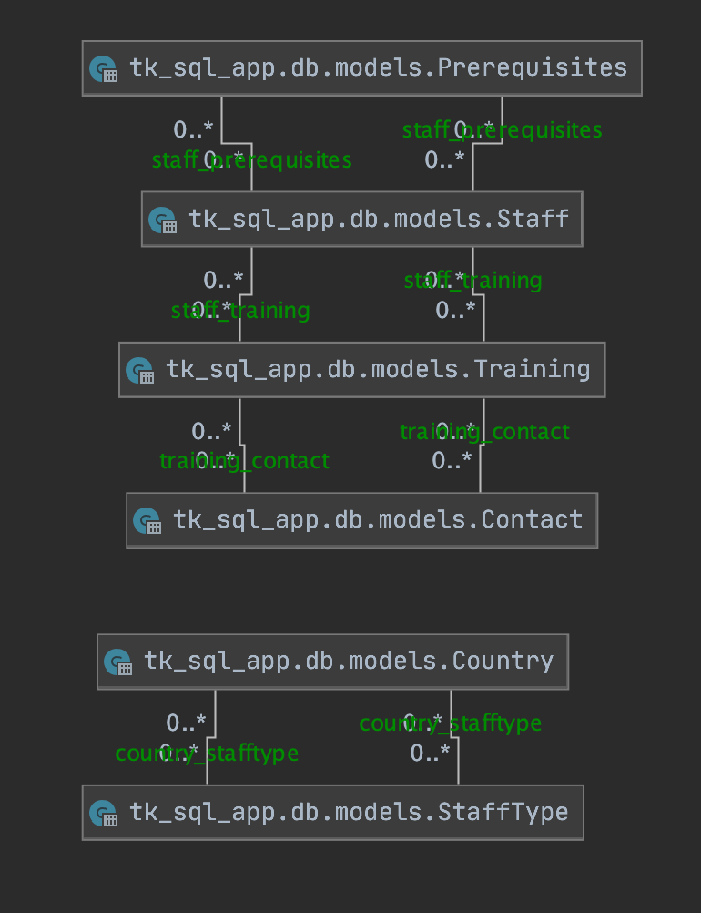

And this is what the visualisation looked like.

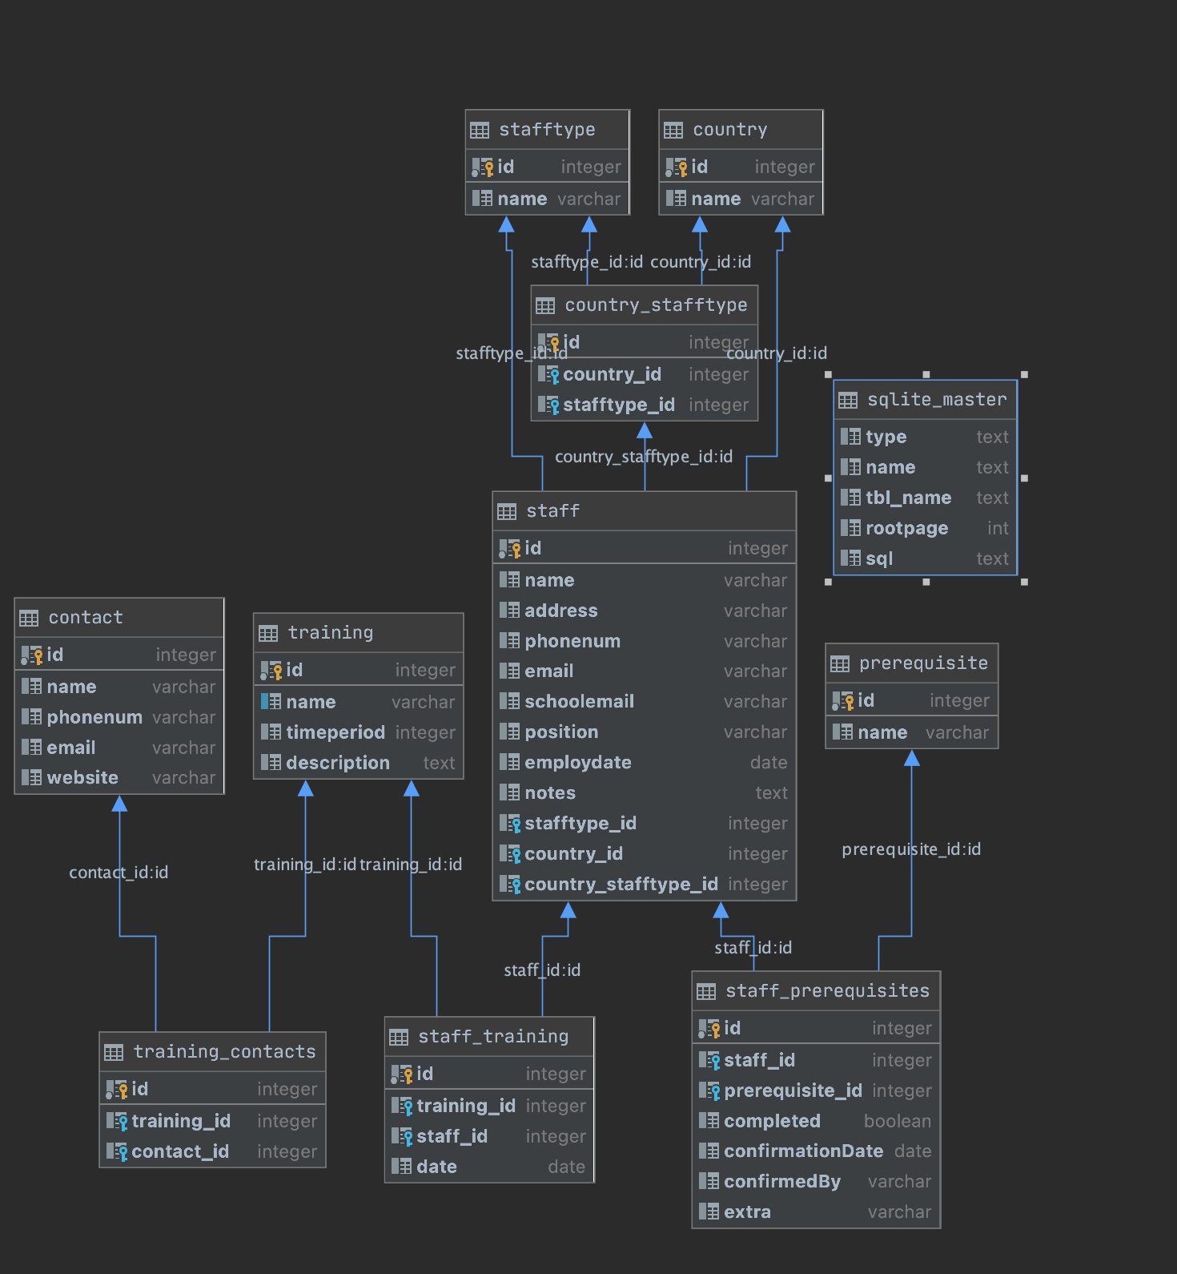

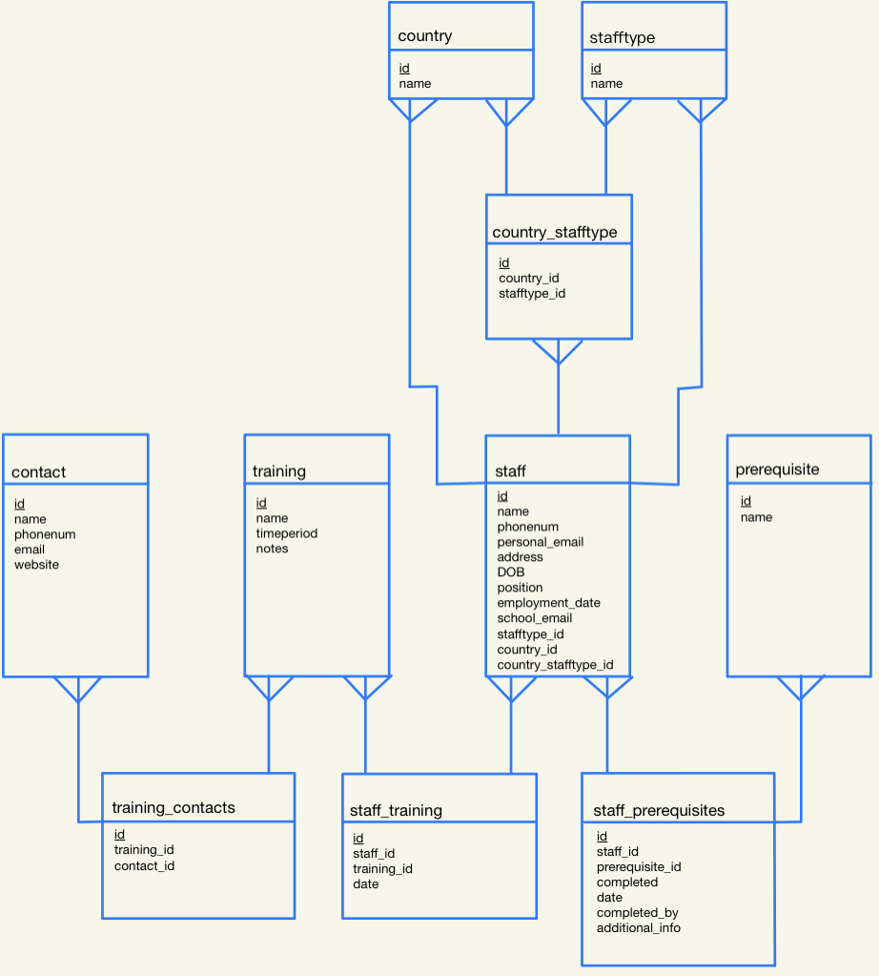

Placed side by side with my design, it can be seen that the database is correct and ready to go.

On reflection, whilst testing the ability to add and query records, it has become clear that using the table structure of my relationship tables will not be sufficient for accessing and updating records with relationship tables that have more than just two foreign keys. Here, this means that the staff_training and staff_prerequisites tables will need to be created in the way that the other tables were created. These updated models can be seen below, all changes surrounding this have been dealt with and I have tested the functionality of the database to ensure everything still works in the way that it is supposed to.

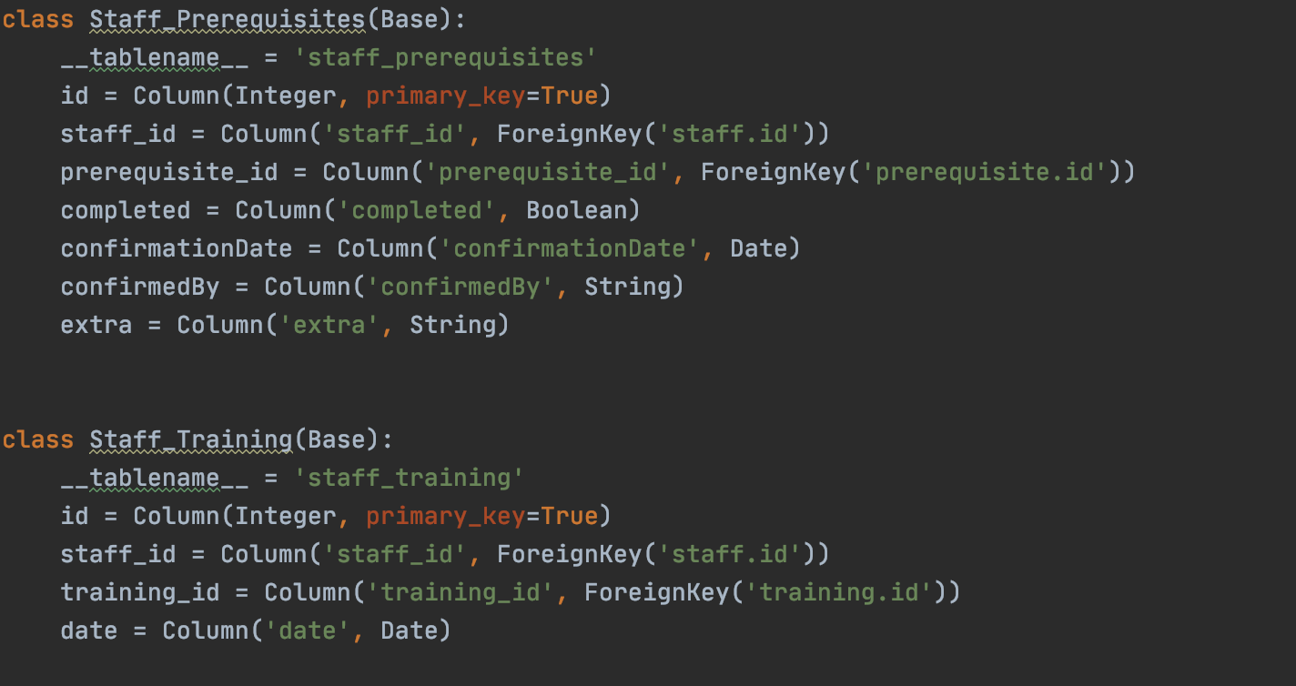

Now, I must create all of the functions that will allow me to create records, add records to link tables, update records, and query the database.

## Stage 3 & 4 - Query Development & Testing

With my ‘queries’ file, I must now add all the functions that will allow me to add records to the main tables. These ‘Create’ functions can be seen below.

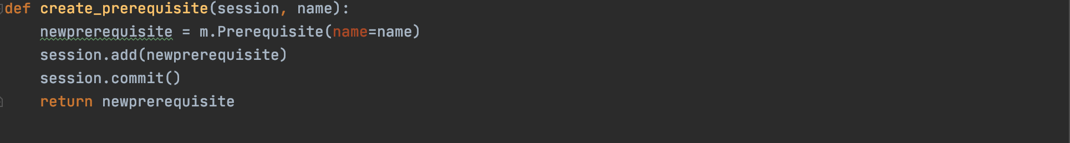

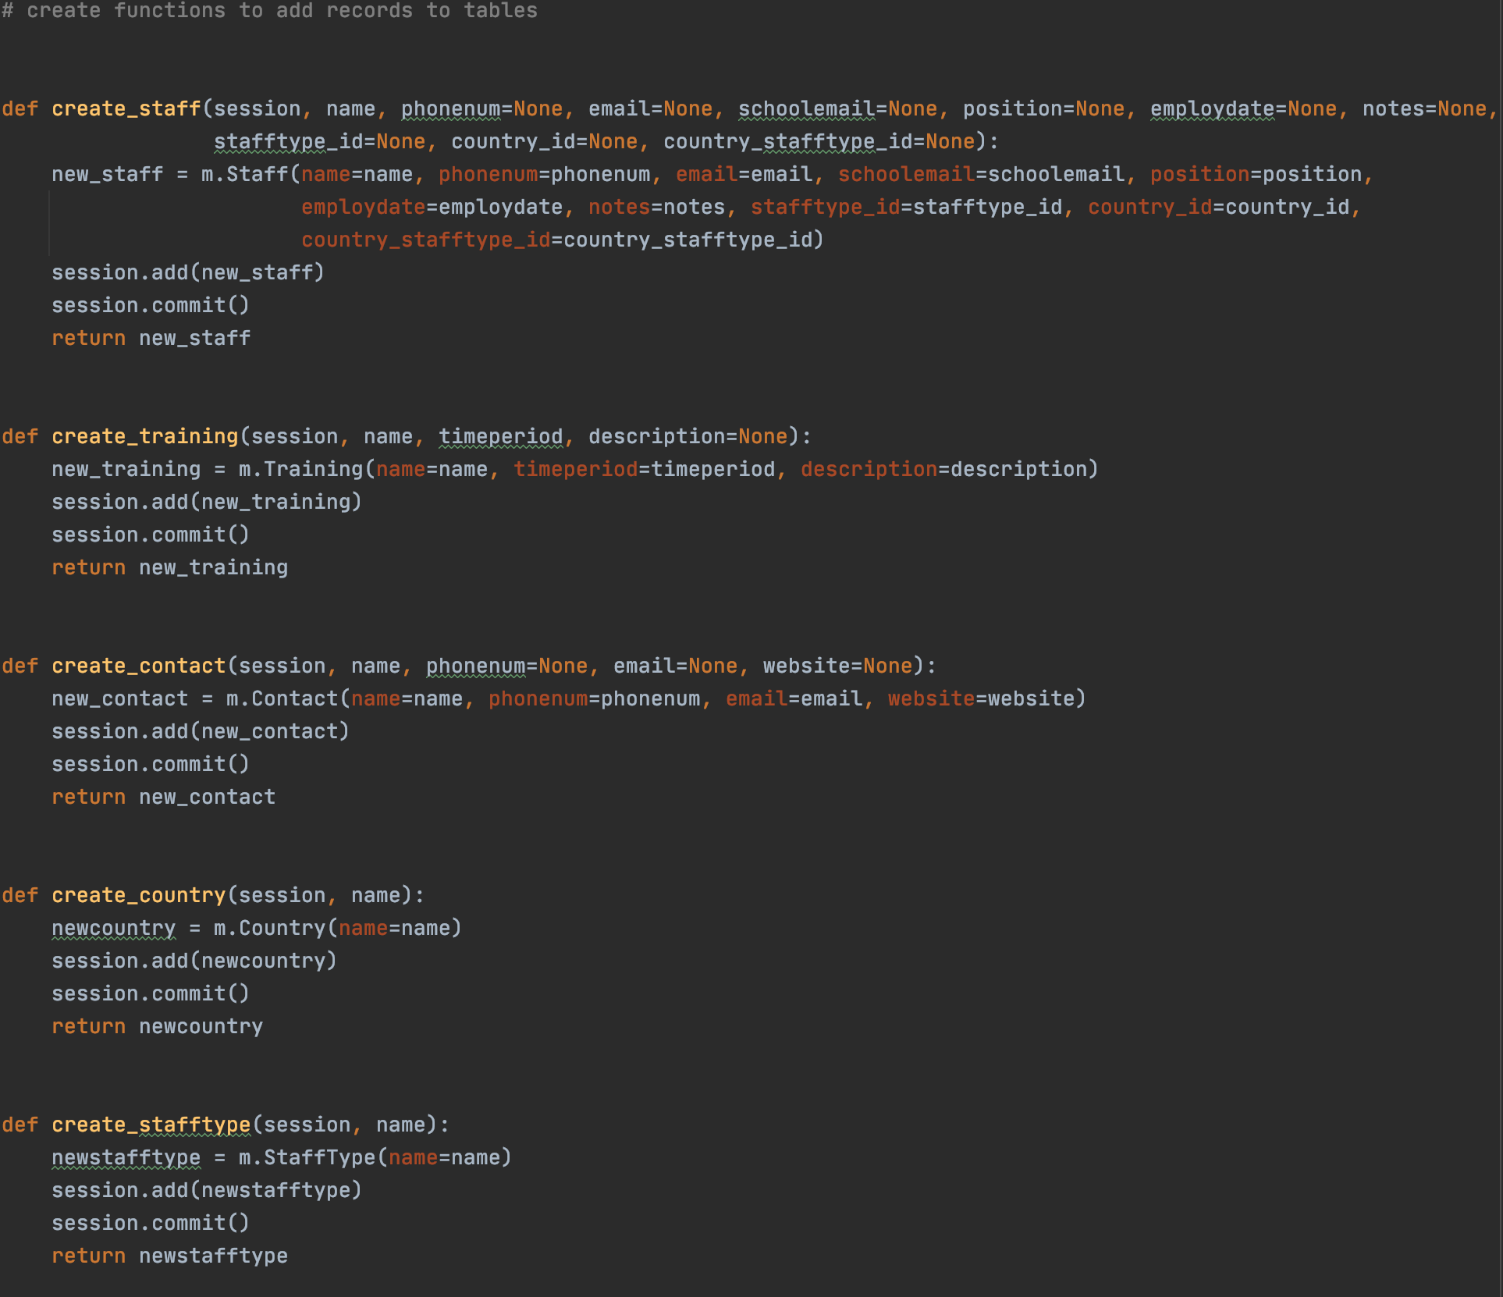

Next, I need to create all my ‘add’ functions to allow me to add records to my link/ relationship tables. These can be seen below.

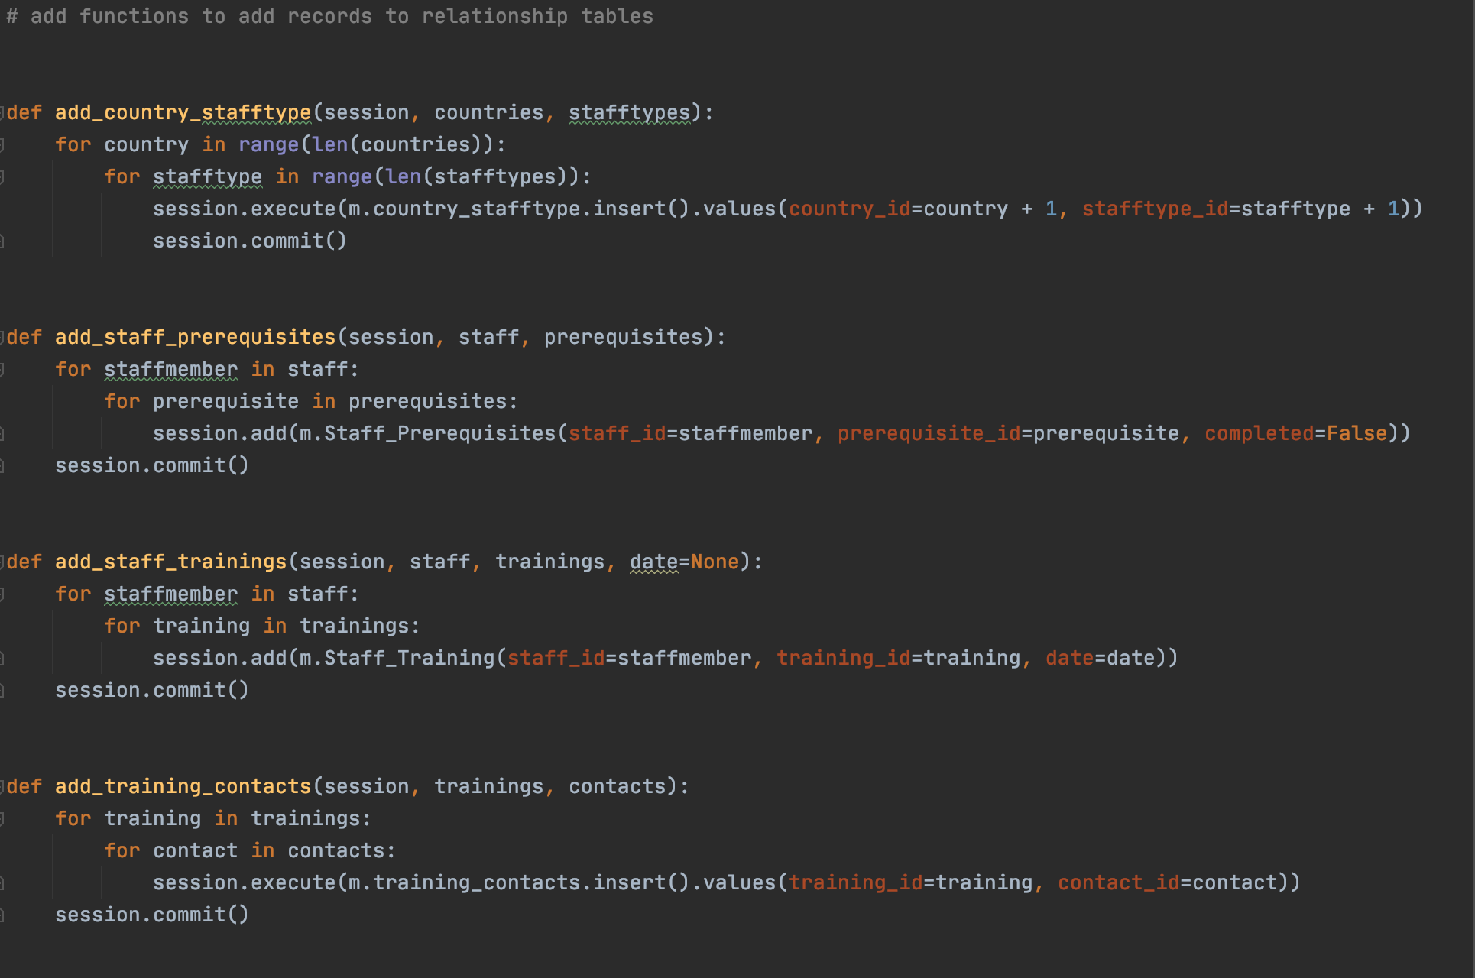

To test my ‘create’ and ‘add’ functions, I used each of them to create records in my tables and used the database functionality of PyCharm to ensure that all records were successfully added.

Next, I must create the functions that will allow me to update my table’s records. Presently, I am only going to do this for my staff’s prerequisites but in the future I will add more so that I will be able to edit staff profiles, training profiles, and contact information.

Here is the update function for staff prerequisites:

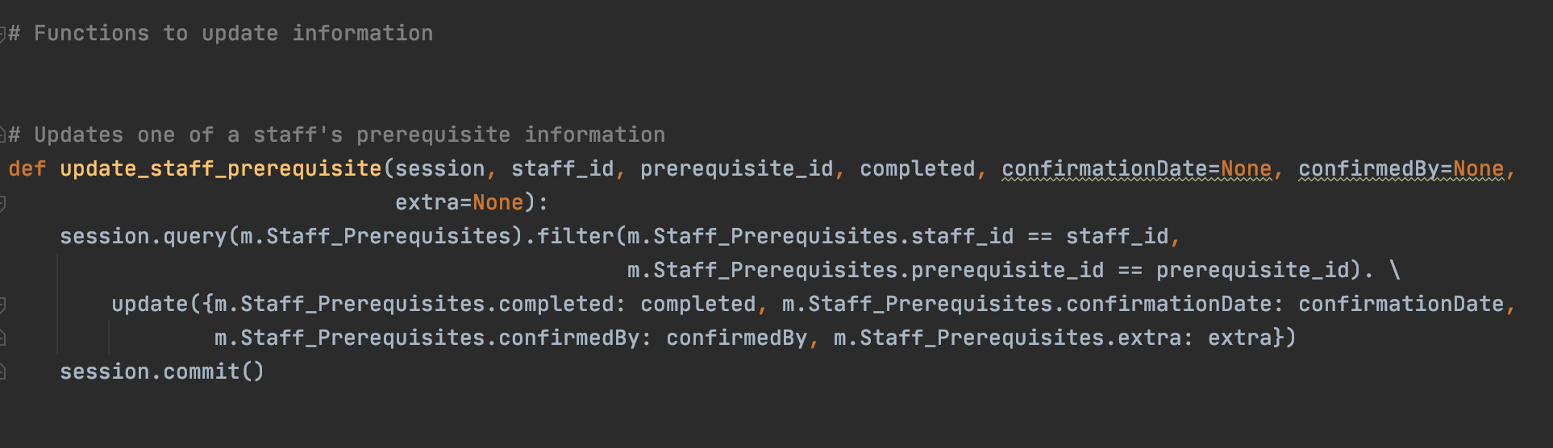

While testing my queries with unit tests, I will update some staff’s prerequisites so that the queries must be able to account for this. Here, I will be able to test this as well, as the tests will only succeed if the update has successfully worked. I know that this works currently though as I have tested it in the command line to make sure that the updates were correctly made to the staff_prerequisite records.

Before I create my queries, I now have the ability to add records to tables and so will deal with the ‘populate_database’ function aforementioned. This will populate the database with these records on first use.

Here is how that looks:

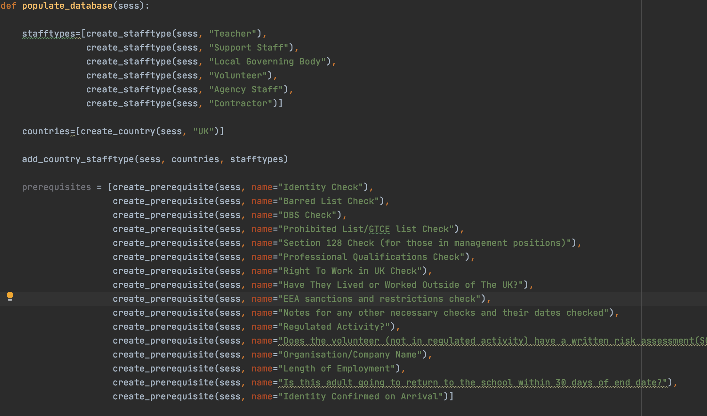

To show that this has worked I will screenshot the stafftype and prerequisites tables with these new records.

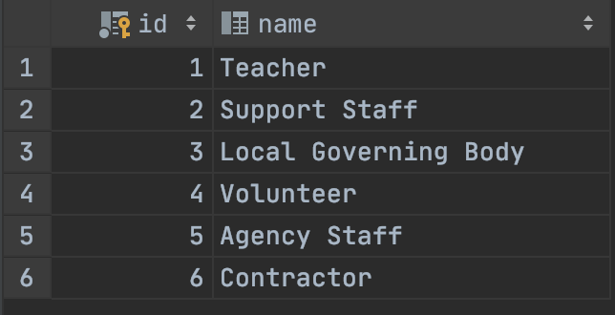stafftype Table:

prerequisite table:

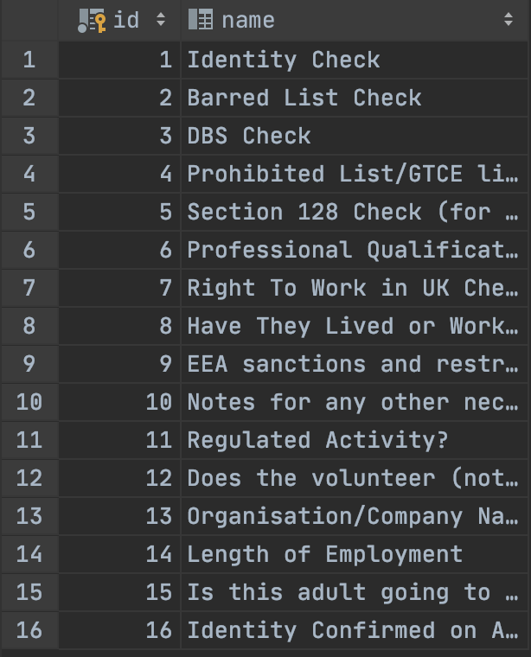

Now, I need to create and test my query functions using unit tests. To do this, I will first create a ‘test_db’ file so that I can test the queries as I go along.

I have created a test class and a setup method.

The setup method established the following:

* Creates a database and a path to it/ session with it
* Adds the records shown in the ‘populate_database’ function seen previously
* Creates various staff members and training
* Adds prerequisites to the relevant stafftypes
* Adds training to the relevant stafftypes
* Updates the prerequisites of one of the staff members so that I can make sure the update function has worked
* Adds a new date to one of the trainings for all staff members so that the training will not appear in ‘upcoming due dates’
* Adds a date to one staff member for another training so that the staff member does not appear as someone who has a duedate approaching for that training

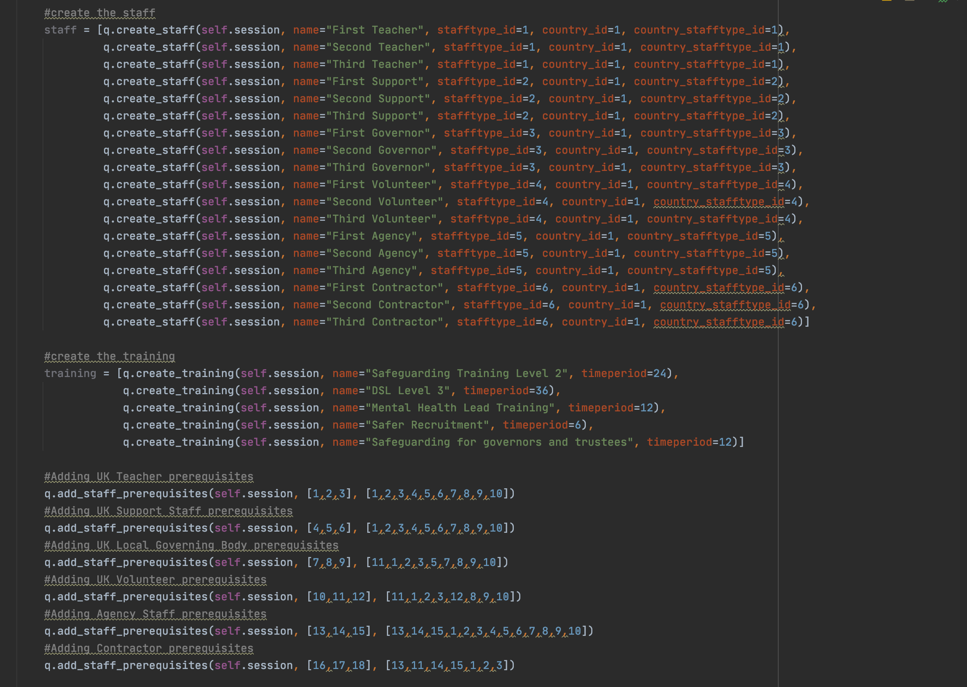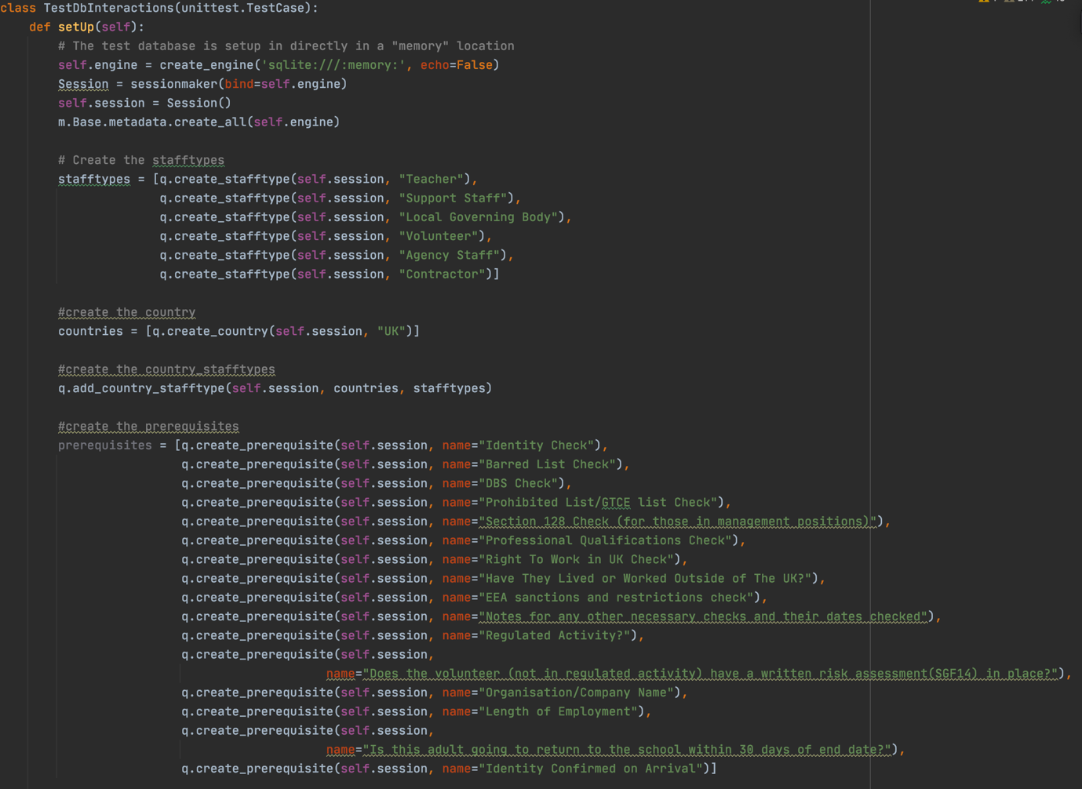Here is the class declaration and setup method:

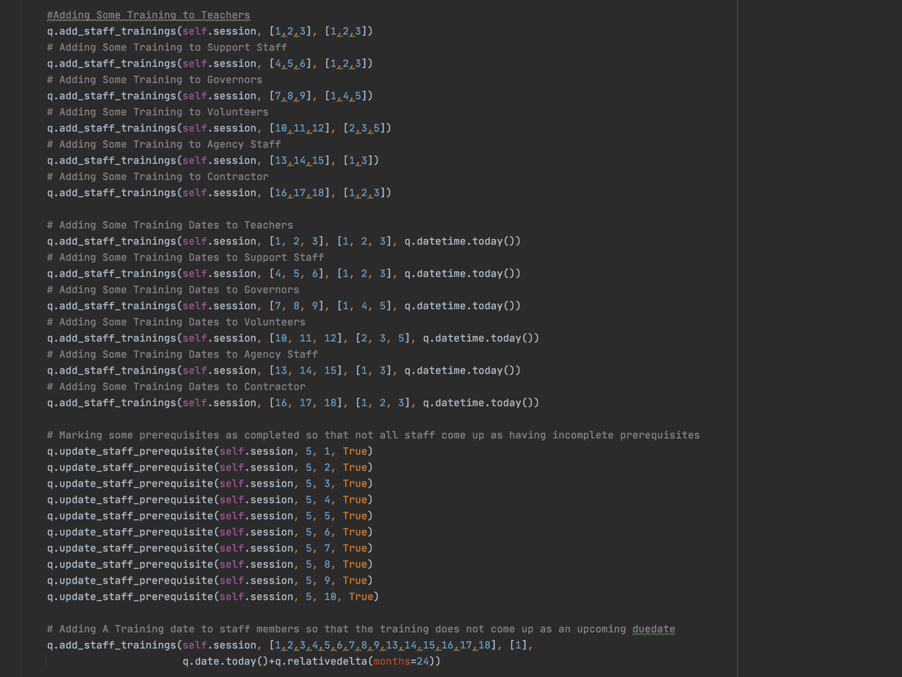

Now I will create and test my queries.

Query

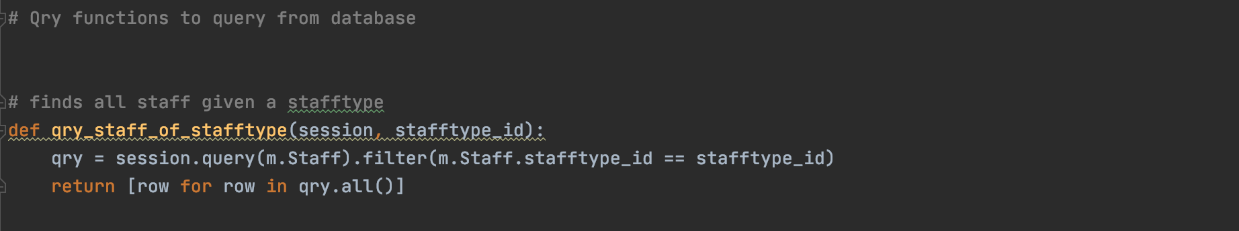

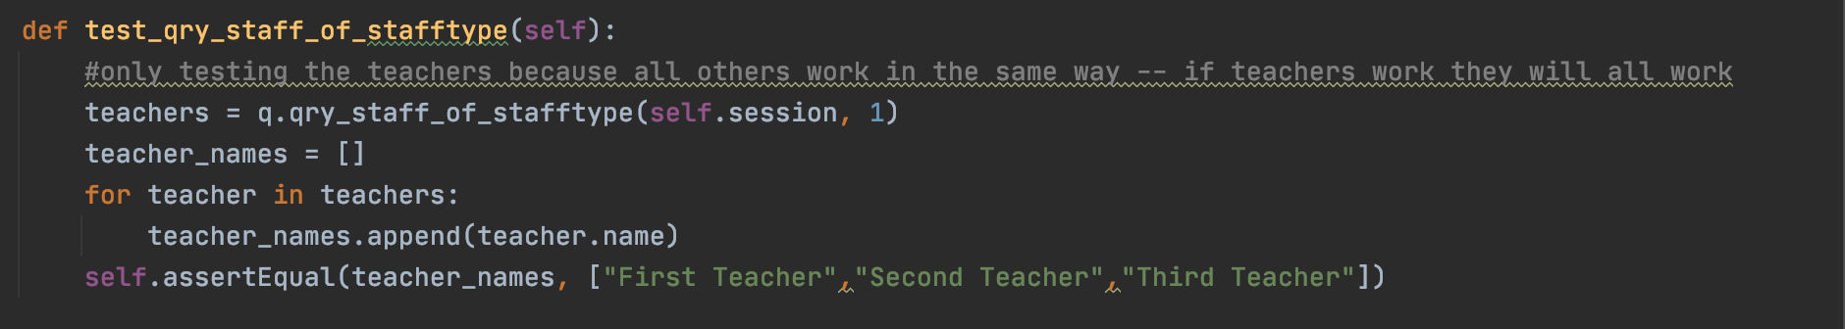Test

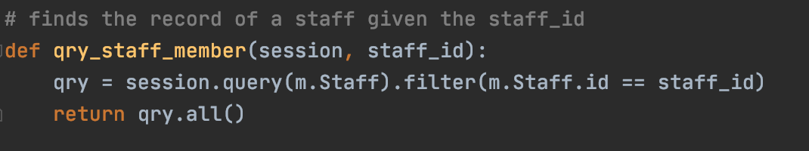Query

Test

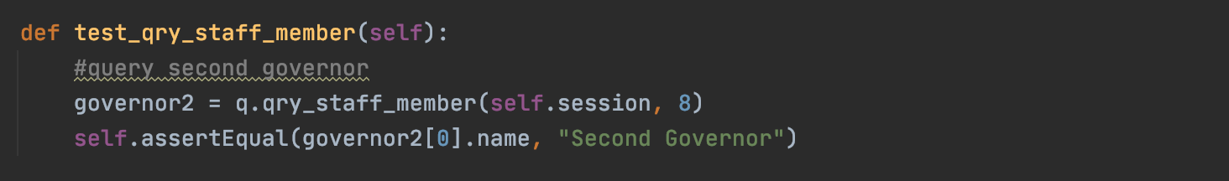

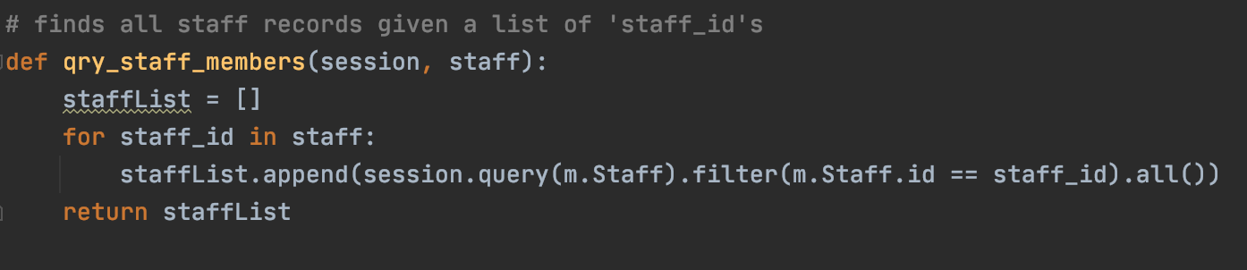Query

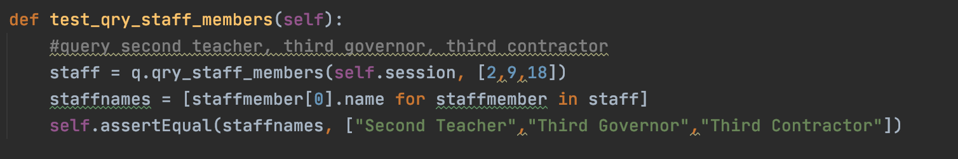Test

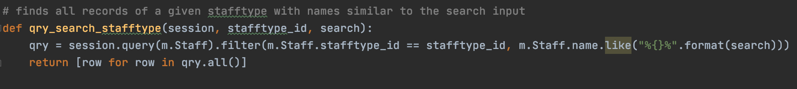Query

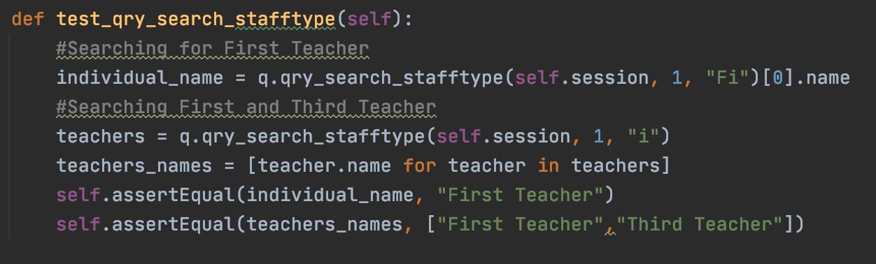Test

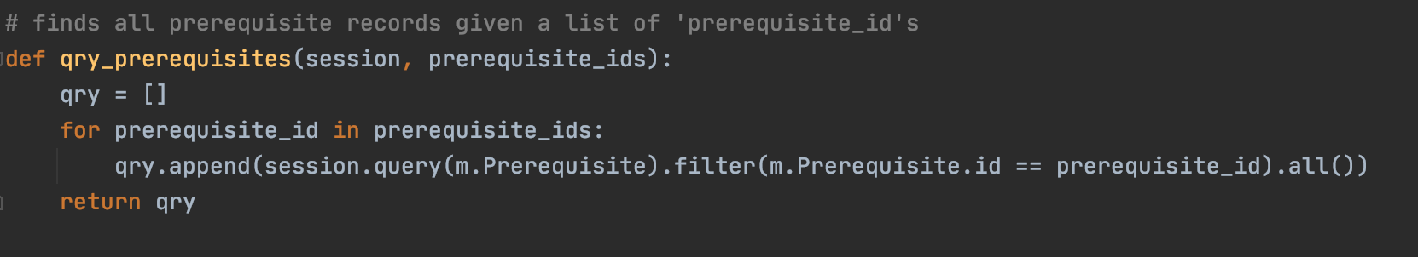Query

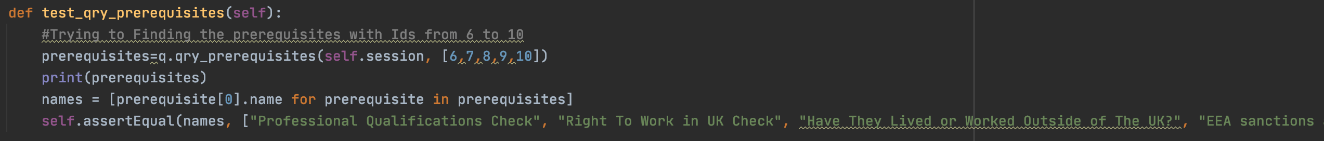Test

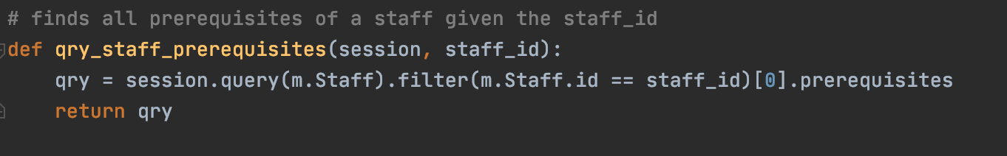Query

Test

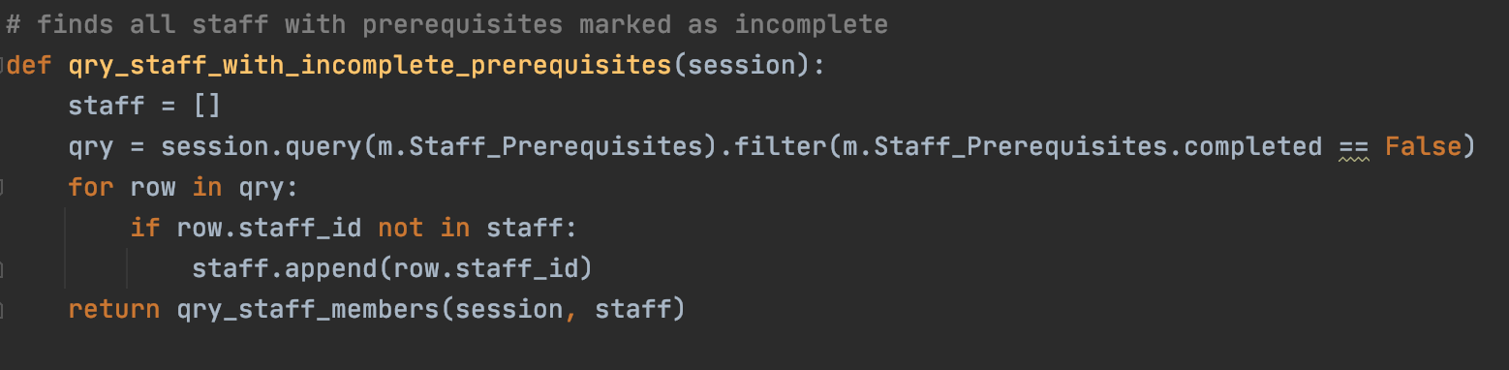Query

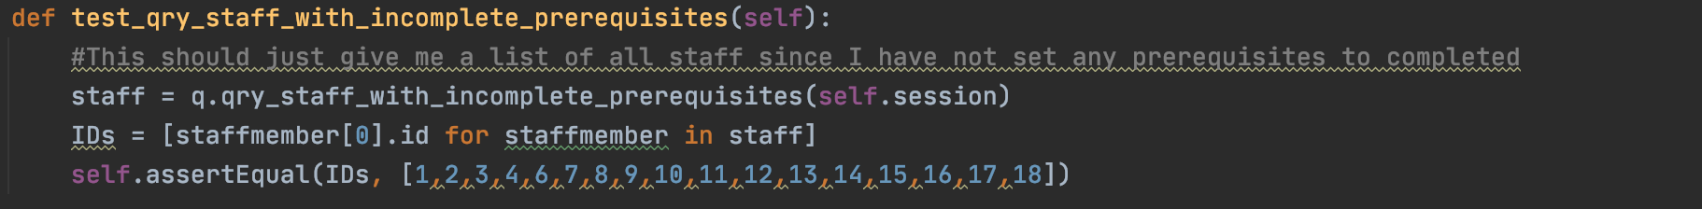Test

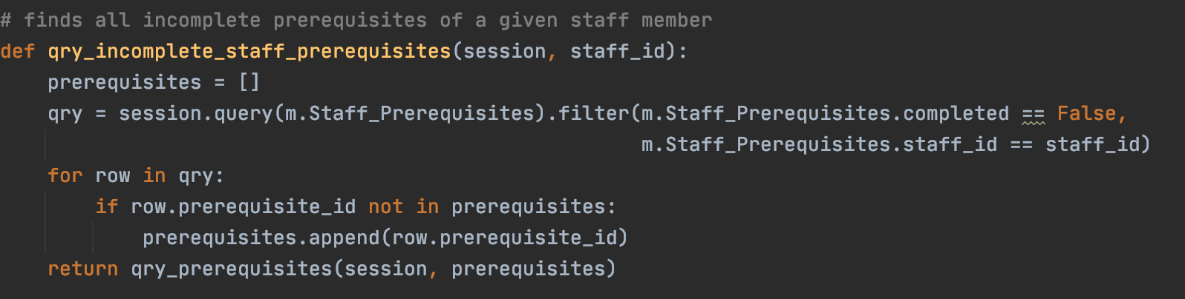Query

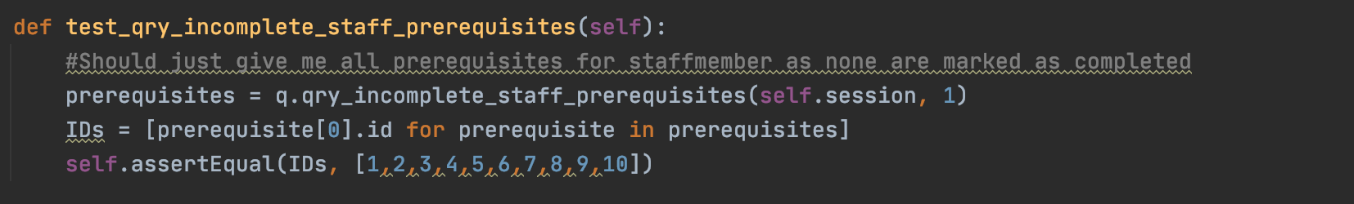Test

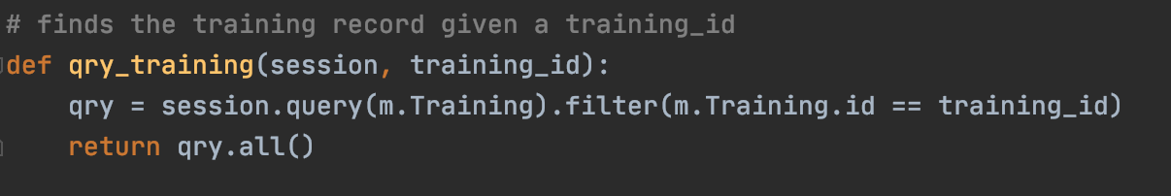Query

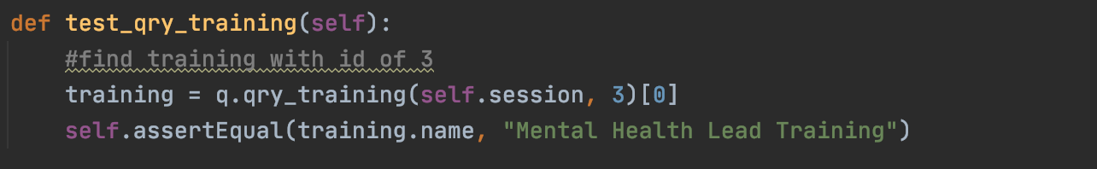Test

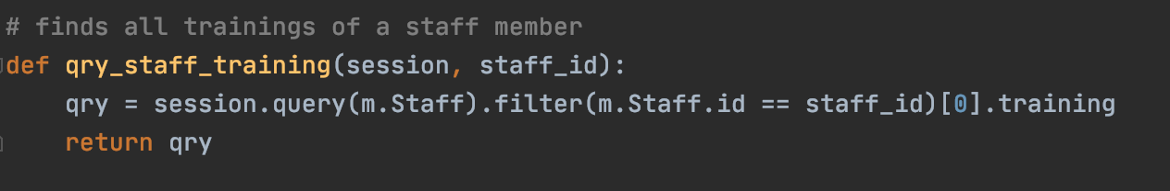Query

Test

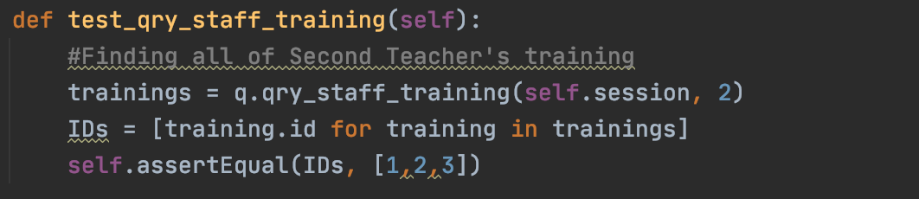

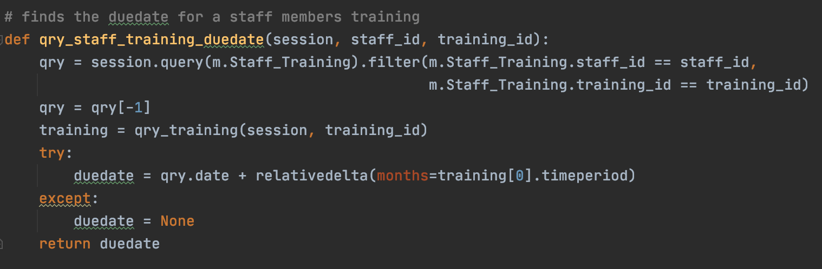Query

Test

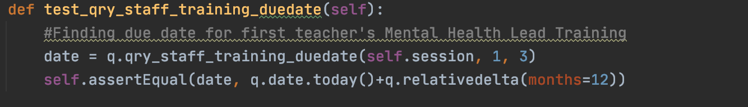

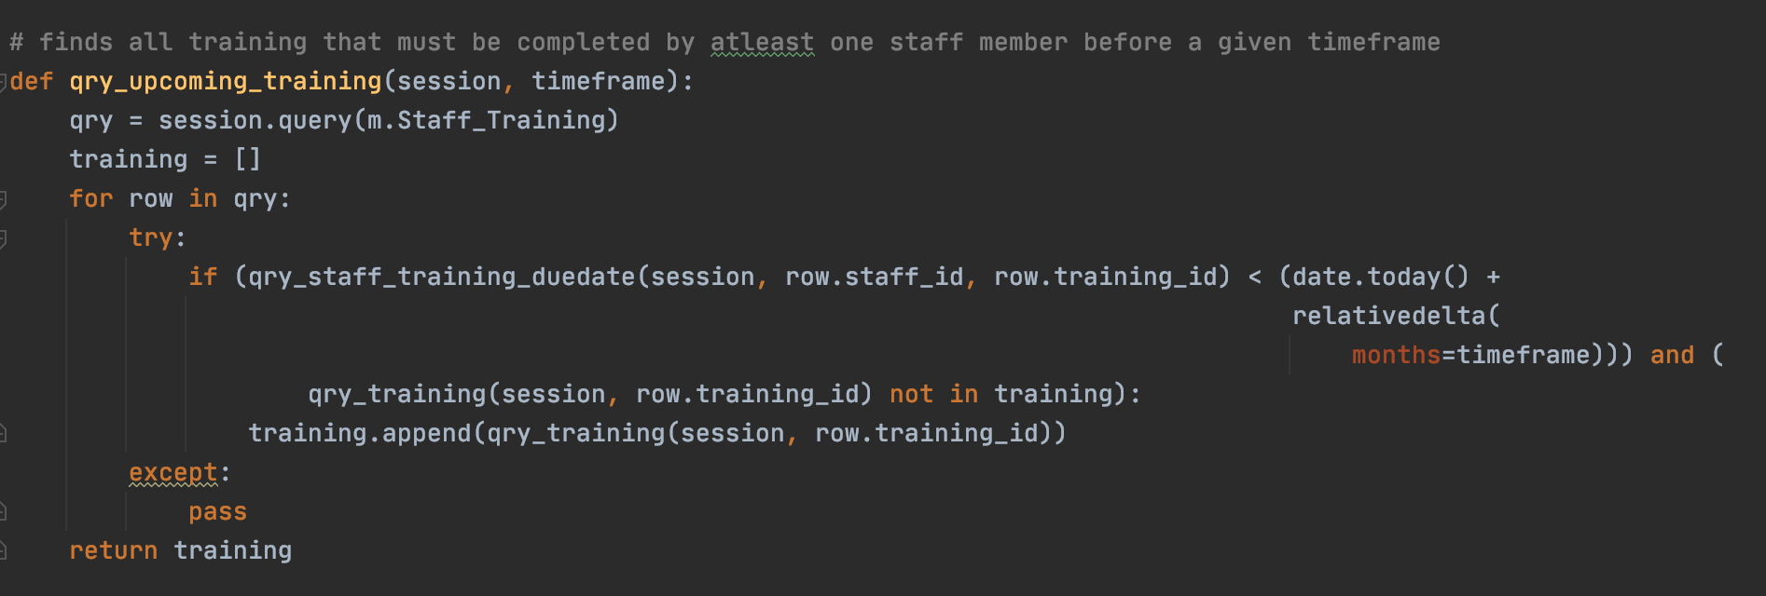Query

Test

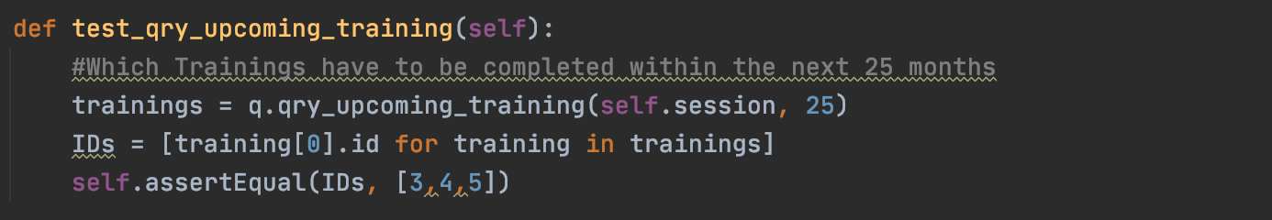

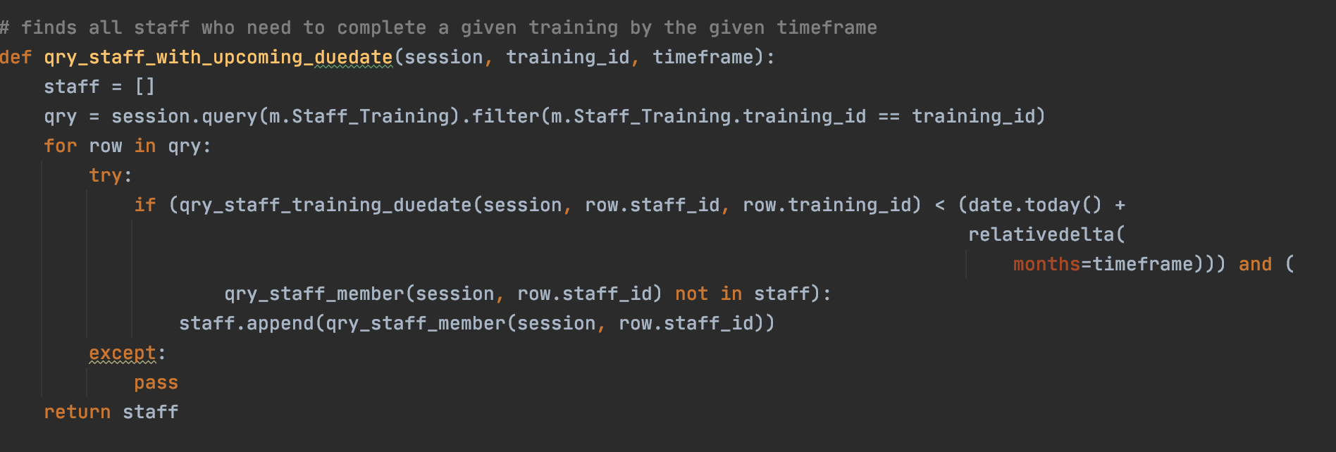Query

Test

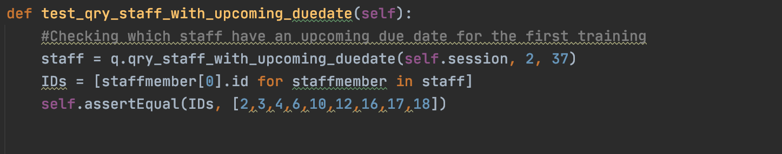

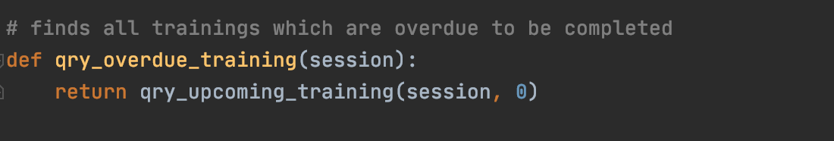Query

Test

This is covered by the test for the qry_upcoming_training function

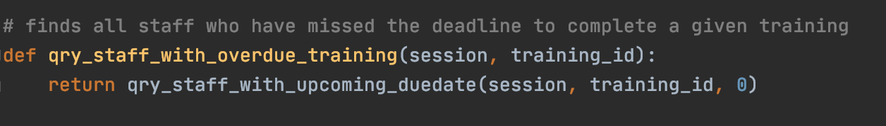Query

Test

This is covered by the test for the qry_staff_with_upcoming_duedate function

Finally, I need to run the unit test file to make sure that all of my queries have passed their tests.

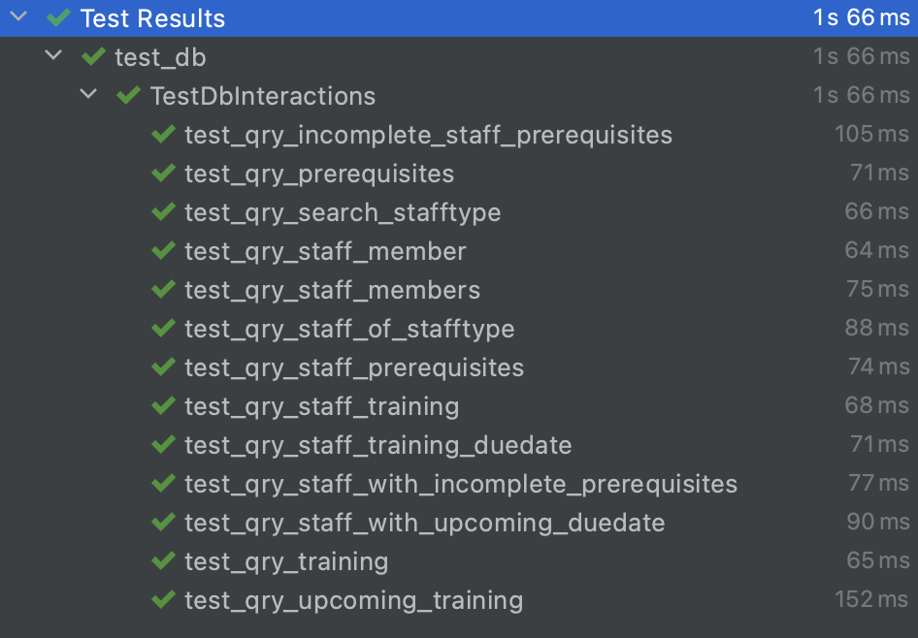

And thankfully they did.

## Update on Testing Checklist

Currently, this is how my testing checklist looks:

|  |  |
| --- | --- |
| **Action to test** | **Working?** |
| Buttons on the Home screen take you to the relevant page |  |
| Buttons on the Staff Profiles screen take you to the relevant staff type section, and the Home takes you to the home screen |  |
| Profile (and training) buttons can be scrolled through and pressing one takes you to the correct profile. Directory buttons work |  |
| Create [staff type] button takes you to the relevant staff creation screen |  |
| Profiles only created when inputted data passes validation |  |
| Creating a staff profile (or training) will add all necessary records to the database | ☑ |
| Search Bar works by showing only profiles (or training) with a name similar to the input | ☑ |
| Buttons on a profile page bring you to the correct page for the correct staff member. Directory buttons work |  |
| Information displayed on profile (and training) info pages are correct |  |
| Prerequisites can be marked as done and have the information stored on them | ☑ |
| Training can be added to a staff profile from the profile’s training screen |  |
| Dates can be added for when staff complete a training | ☑ |
| Staff can be added to a training from the training attendees page |  |
| Dates for one or many staff can be added via the training profile |  |
| Contacts can be created | ☑ |
| Contacts can be added to training | ☑ |
| Training can be added to contacts | ☑ |
| Contact creation works and creates correct records in the database | ☑ |
| Upcoming training can have time frame changed | ☑ |
| Query finds all profiles with incomplete prerequisites | ☑ |
| Query finds all incomplete prerequisites given the profile | ☑ |
| Query finds all trainings with staff members who have missed their deadline for it | ☑ |
| Query finds all staff members who have missed the training deadline given the training | ☑ |
| Query finds all trainings with staff members who need to have it done within the time frame selected | ☑ |
| Query finds all the staff members who need to have training redone within the time frame given the training | ☑ |

Now that I have set up and tested both the database and the queries, I now need to create the GUI for my software.

## Stage 5 & 6 - GUI Development & Testing

First, I created a ‘GUI’ file. For the GUI, I will be using Tkinter.

Initially, I had intended to have one class for my entire GUI (which would inherit the inbuilt tk.Tk root), using methods to represent each of my screens. After attempting some screens in this way, I soon realised that this would be a much more difficult and ineffective system than it could be.

After doing some research around the most effective ways to switch between screens in Tkinter, I decided that I would create my own root class, with a separate class for each screen which would inherit my root and communicate with it to change screens and the inputs for each screen.

### Root and Menu

In my root, I declare a variety of attributes, including scroll values for different screens so that I can scroll through profiles and several lists so that I can add to them when there are multiple things I need to add for my queries. For example, I have lists for my trainings so that multiple staff can be selected to add a date of completion to a training.

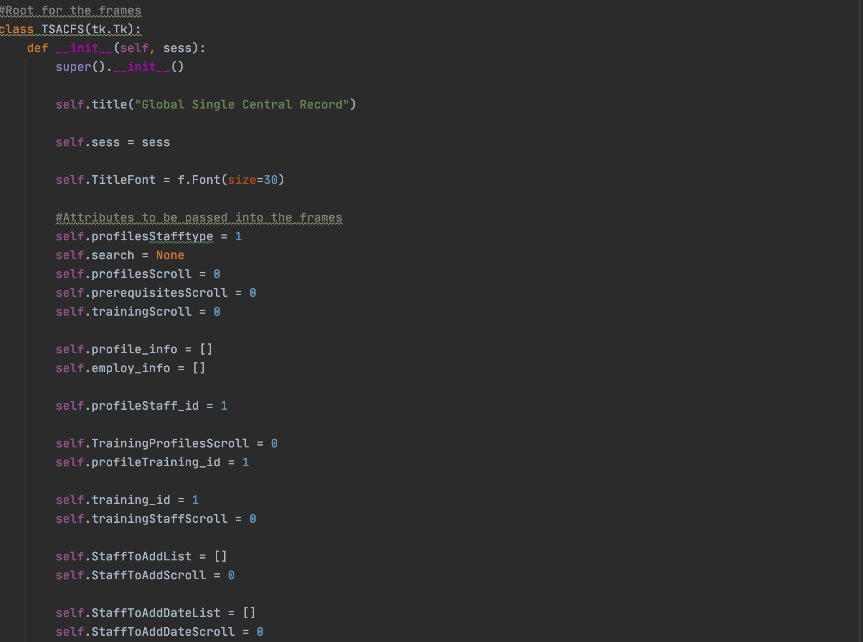Below is a screenshot of my root class along with some of the aforementioned attributes.

Next, I created a class for each of my screens which inherit from the root along with all of the parameters that are needed for the screen. I then gave each of these a create_widgets method. An example of this, the ‘MenuScreen’, can be seen below.

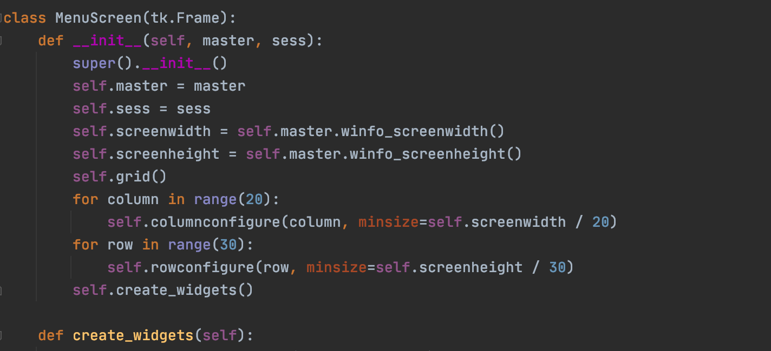

I then create a frames dictionary in my root so that my root could establish and reference all the screens.

(In the TSACFS root class)

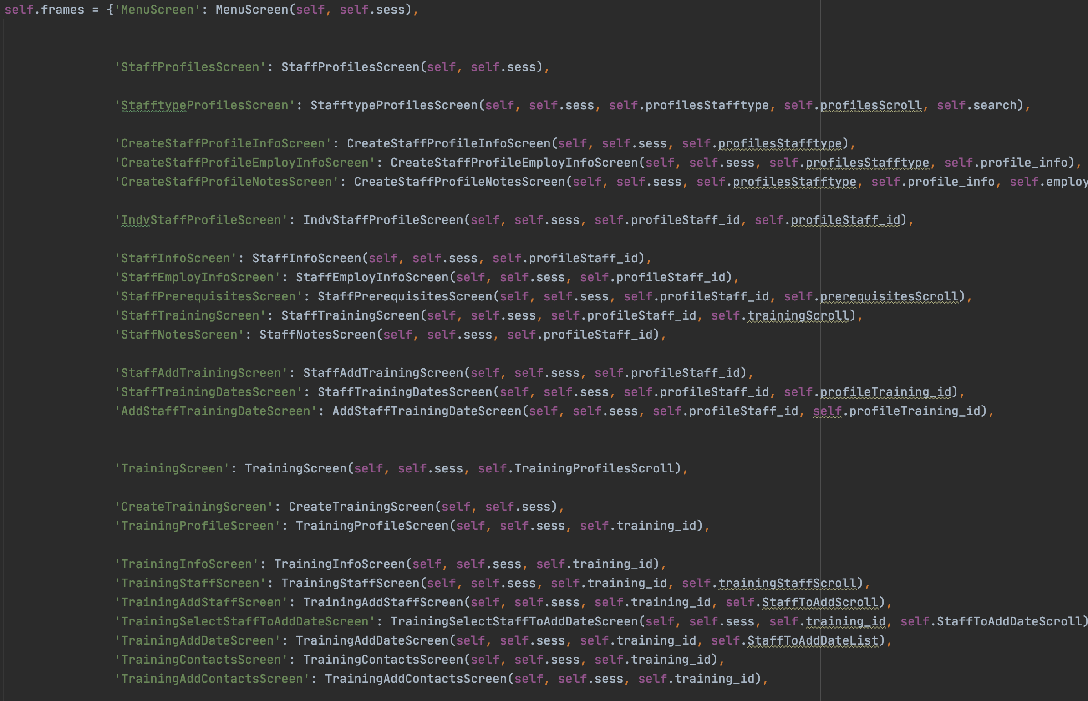

In my root, I then created loads of methods to set/reset my attributes, and to reload/reset (reinitialise) all of my frames/ screens. Some of these can be seen below.

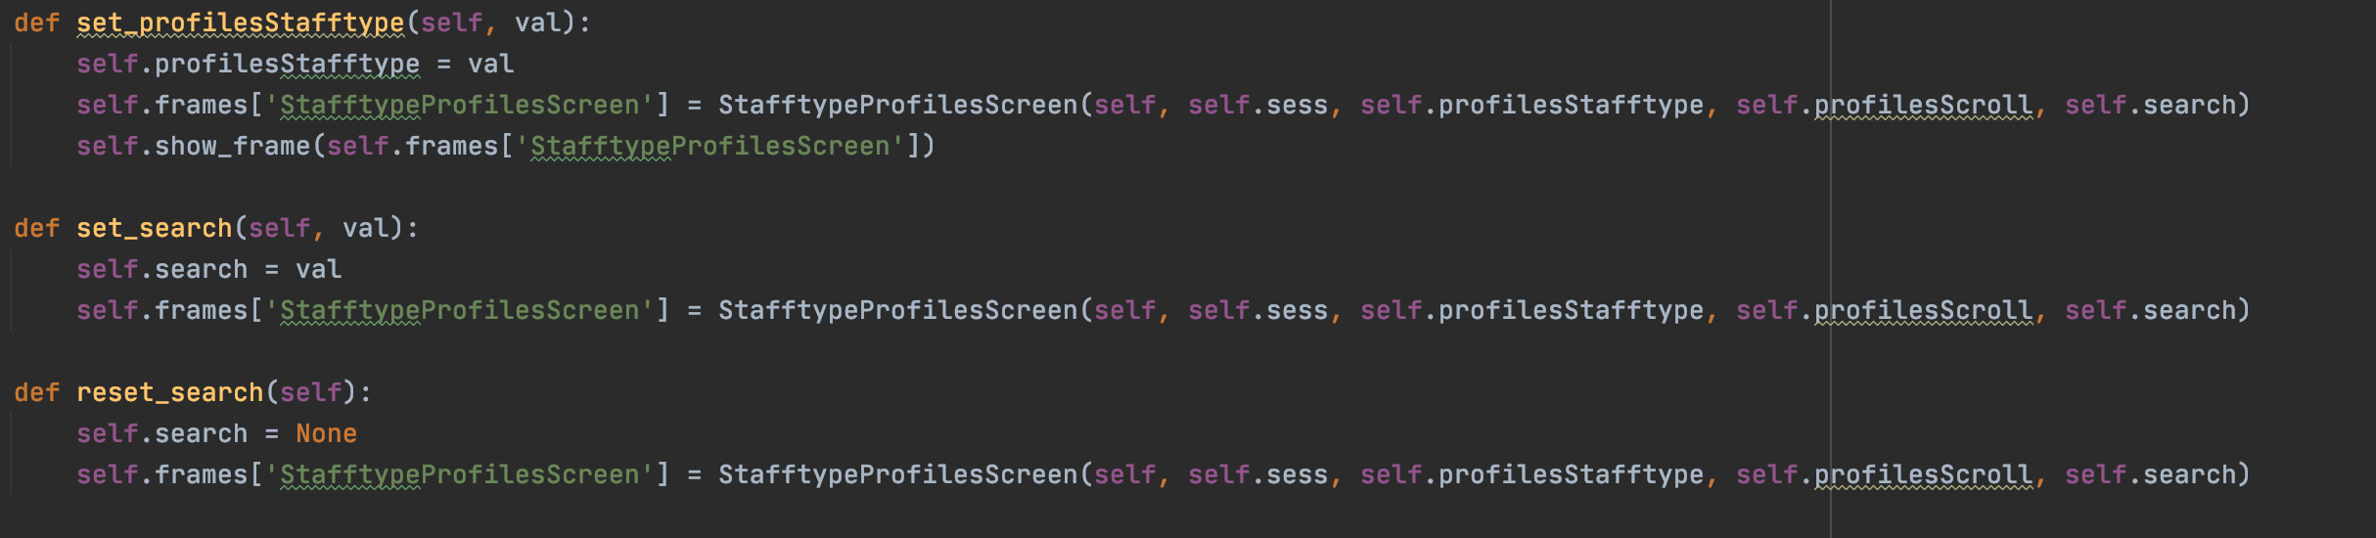

Next, I created a show_frame and a forget_frames method in the root so that I can change between the screens.

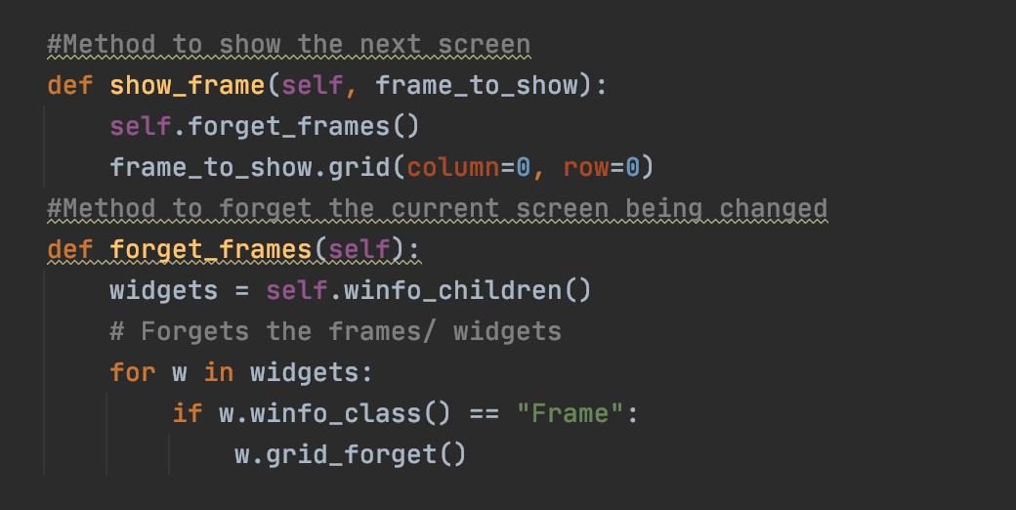

Next, it was time to code all the widgets that would be gridded onto each of the screens.

First was the Menu screen which would first appear every time my code ran. The code for this can be seen here.

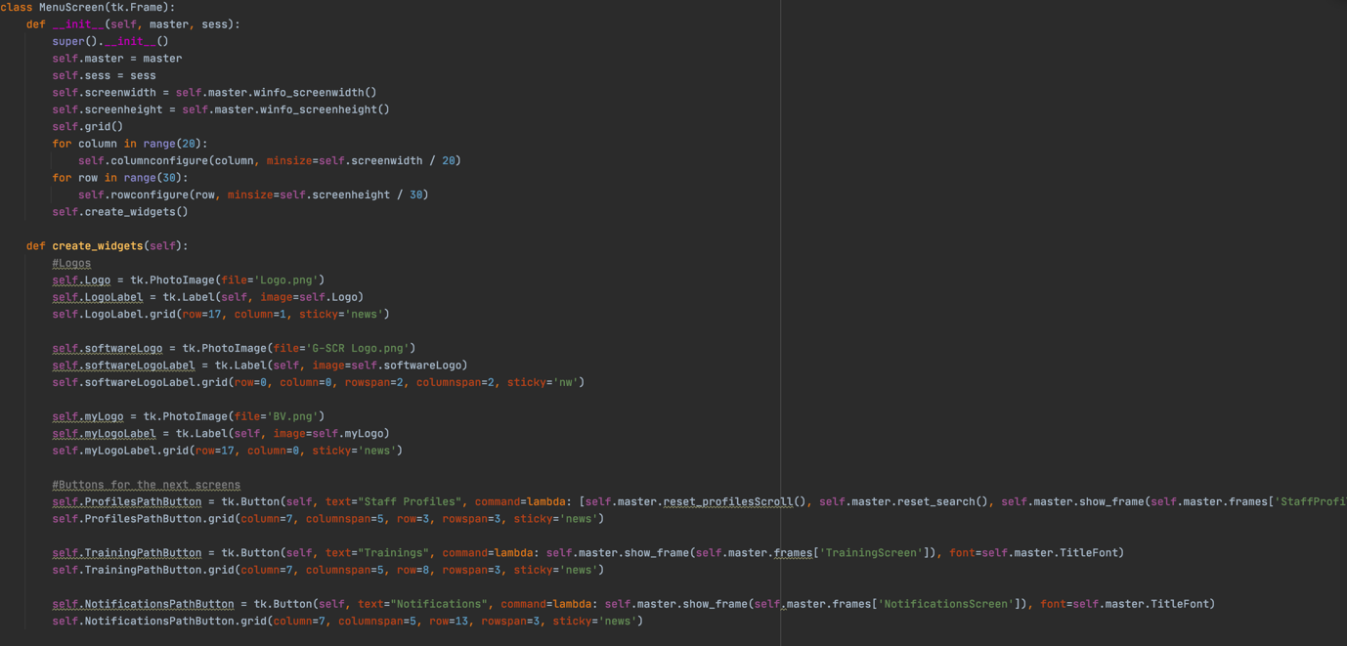

And this is how that looks.

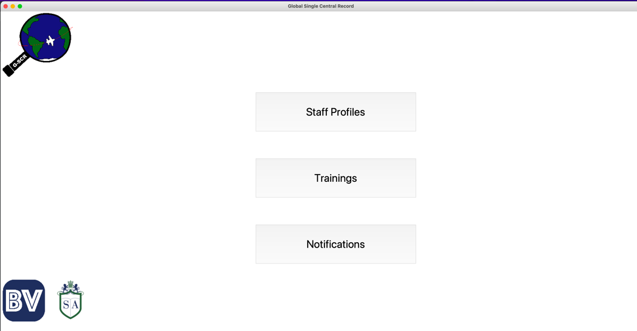

### Staff Profiles Section

Next was the StaffProfilesScreen, where the user will select which type of staff they want to see the profiles for.

The code and result can be seen below. 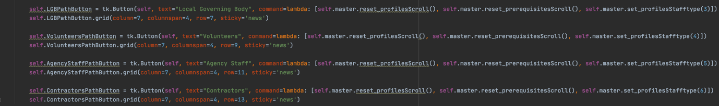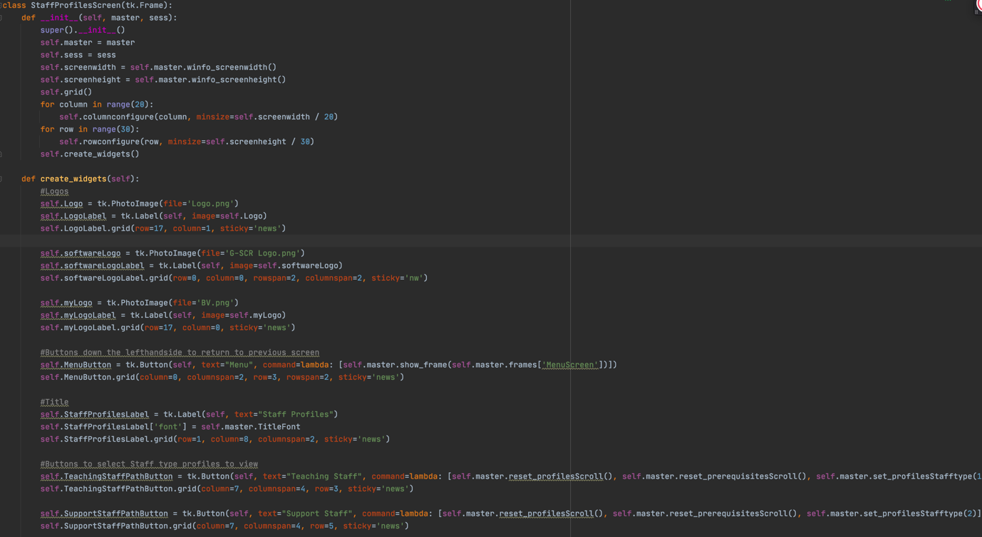

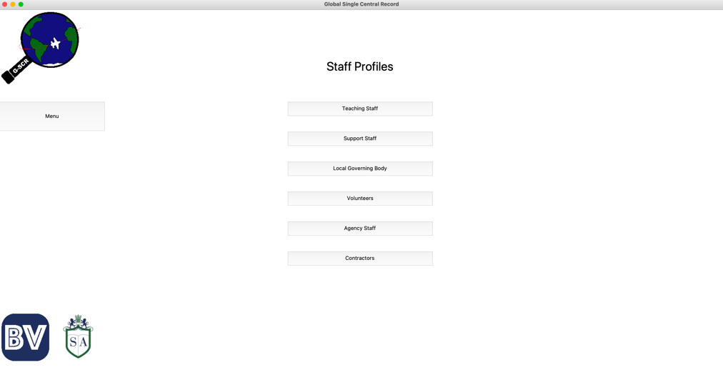

Next was the code to display all of the Staff with the selected staff type, I also added a Search Bar for the user’s convenience.

All of the staff types use the same code and so I will only show the result for the Teachers (given that they all work the same way)

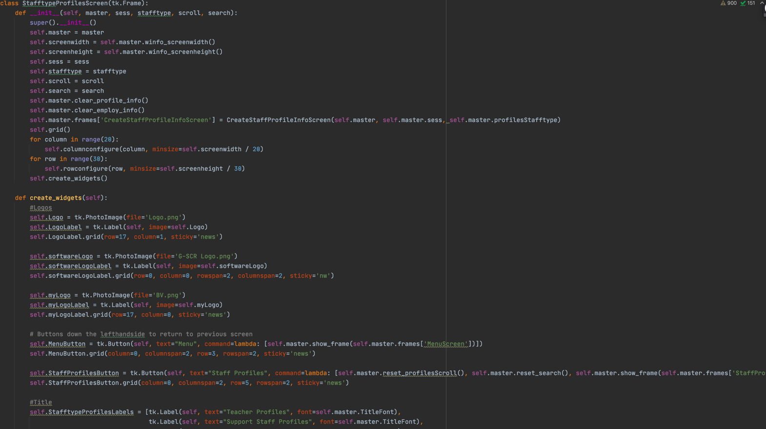

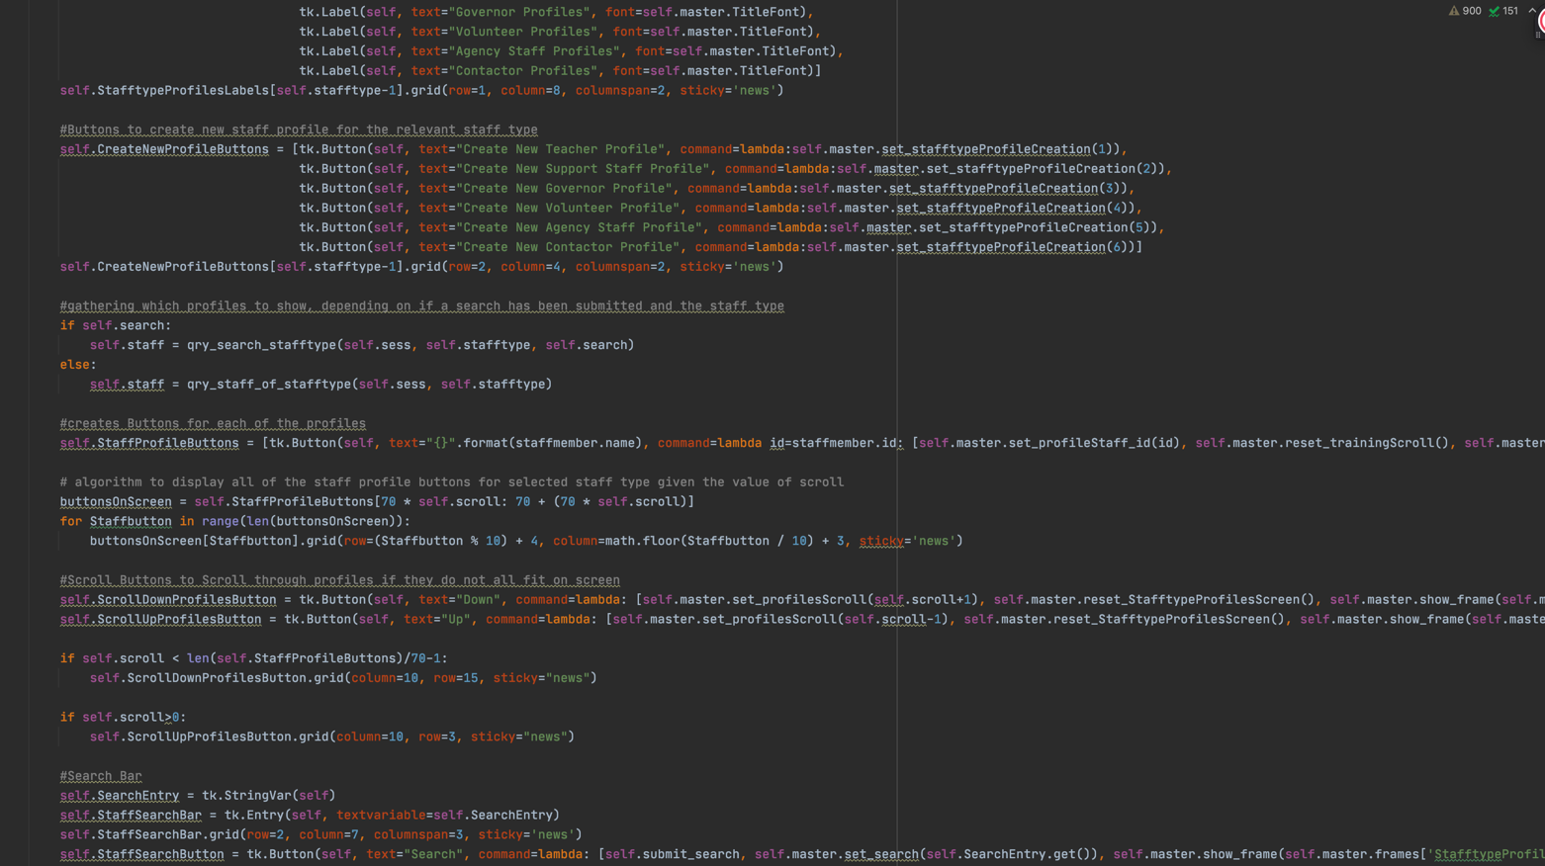

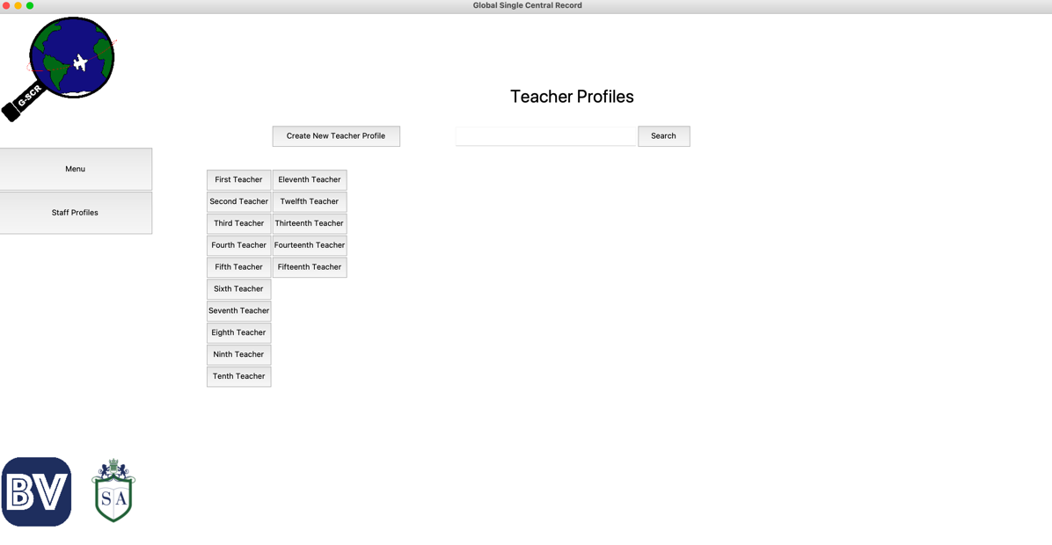

For the sake of clarity, I have added 15 instances of each staff type.

To demonstrate that the search bar works, I will search for ‘f’ and show the result below.

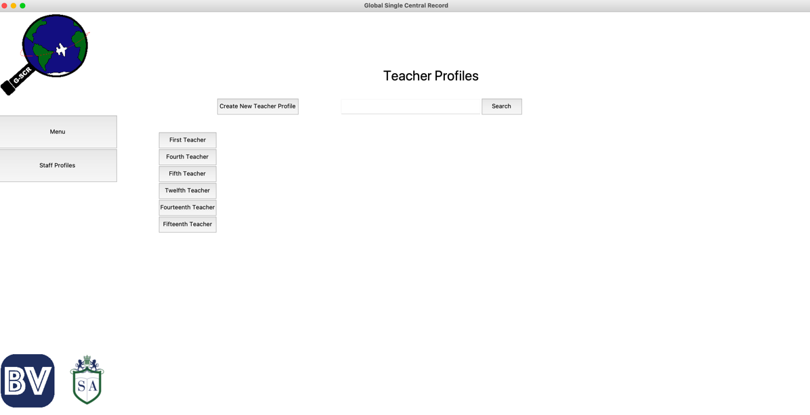

Next, I needed a way to create staff members from within the interface. As this is multiple Screens, I will show the code first, followed by a demonstration of me creating a teacher.

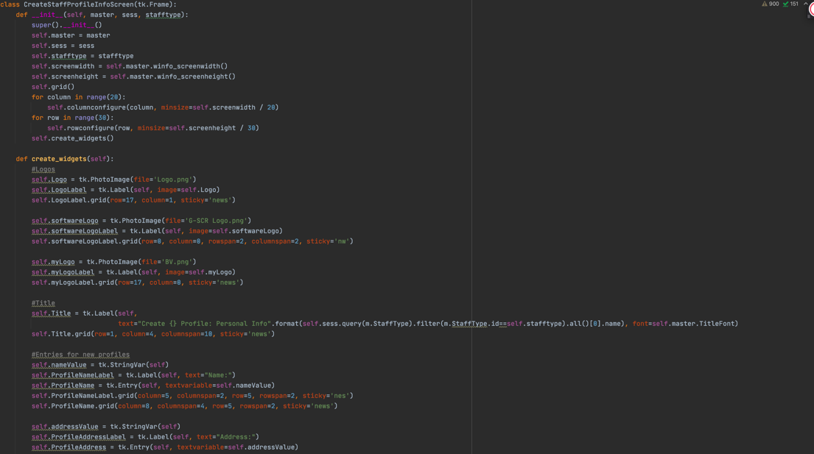

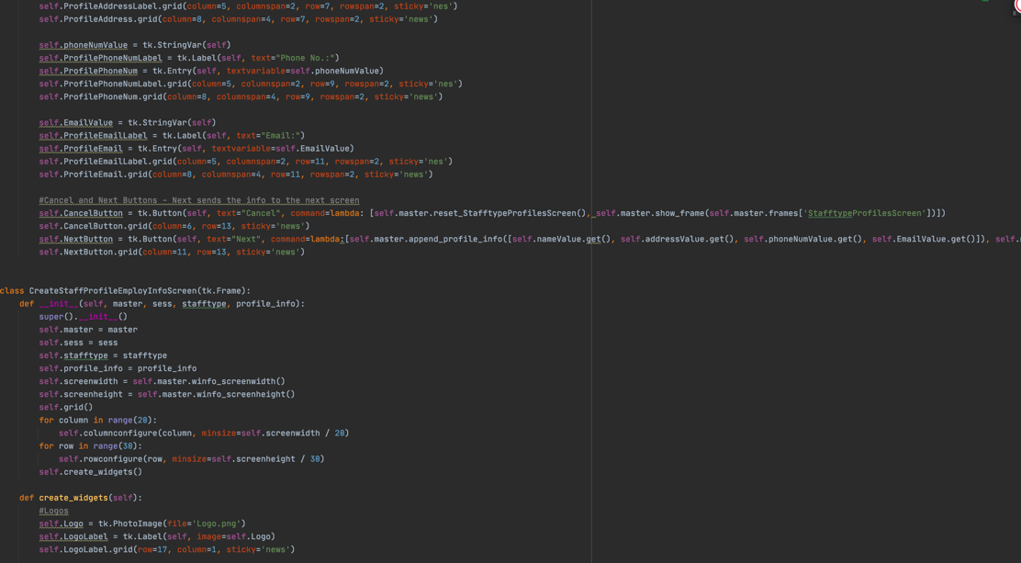

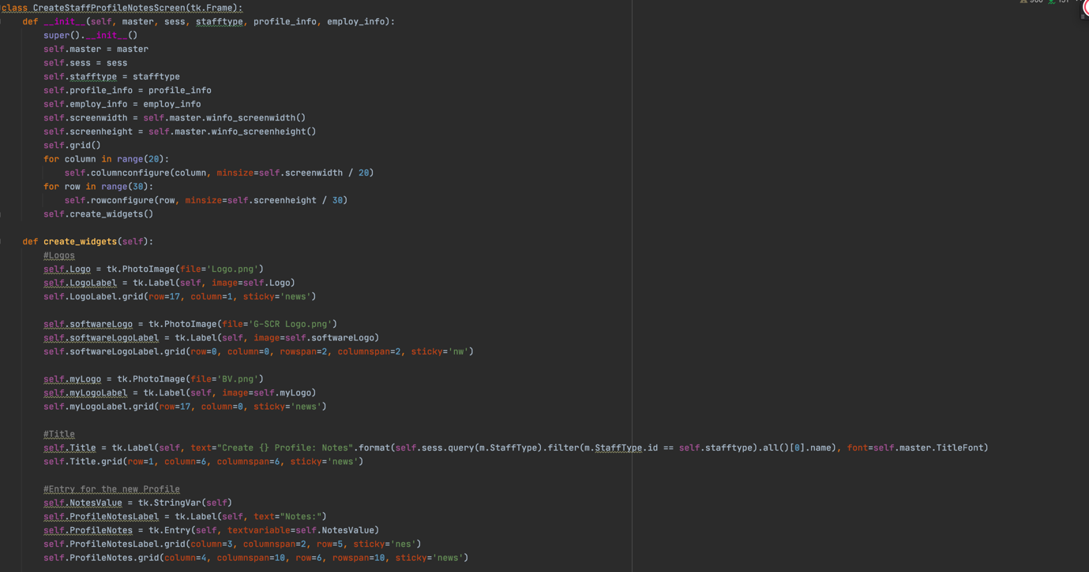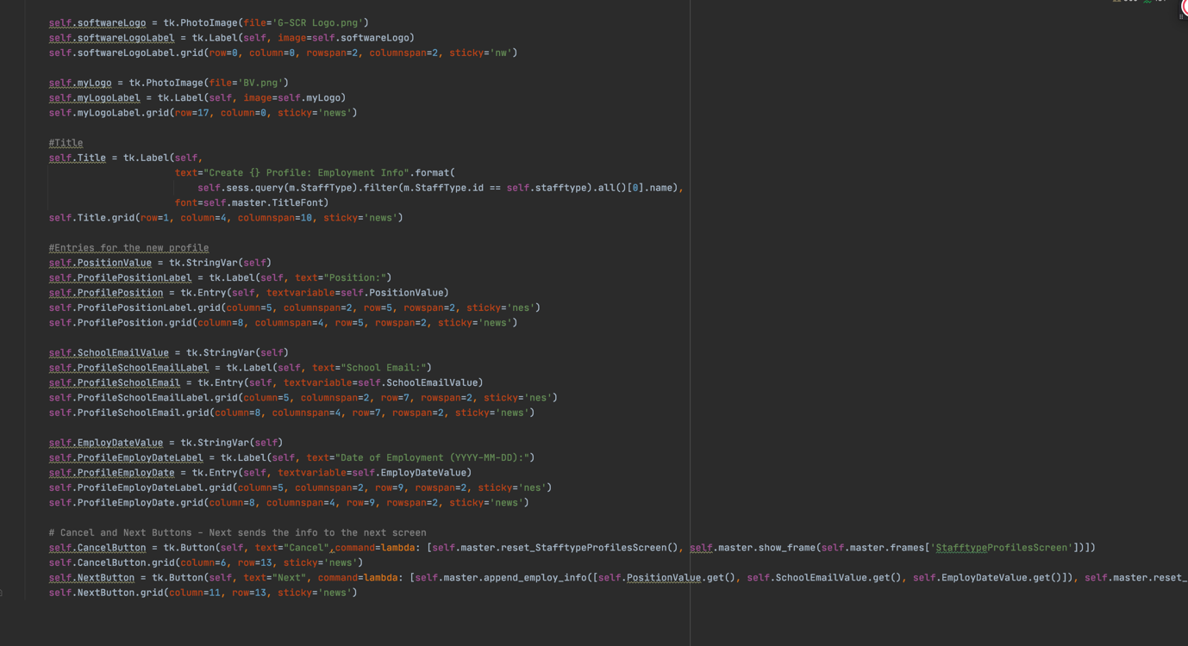

And now to show the creation of a Teacher Profile:

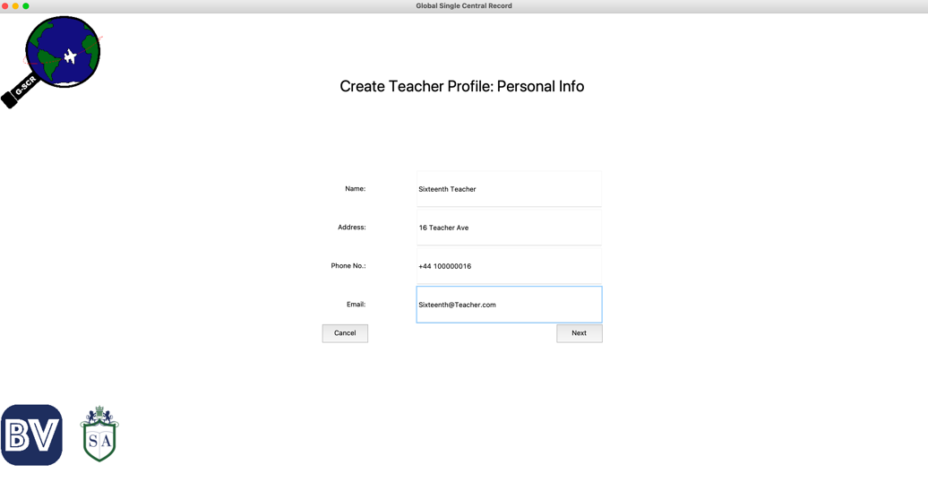

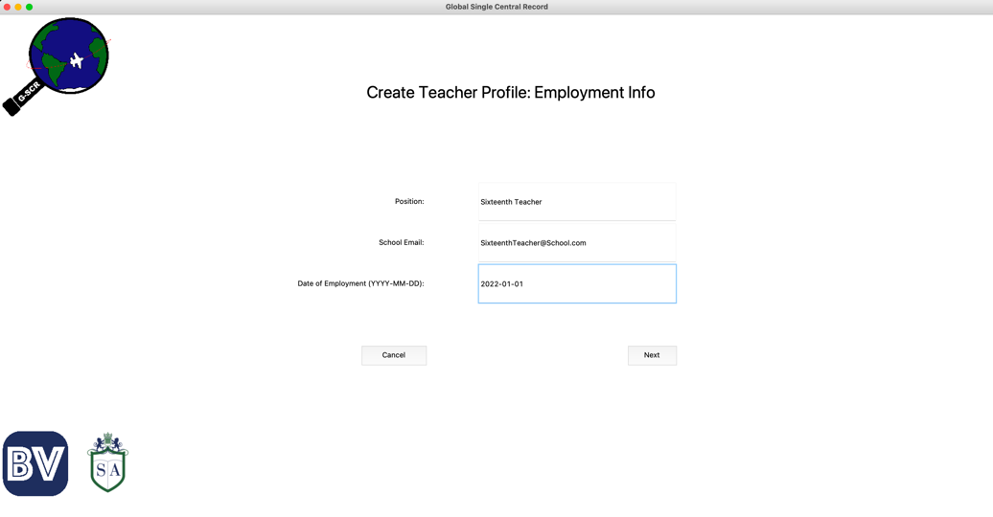

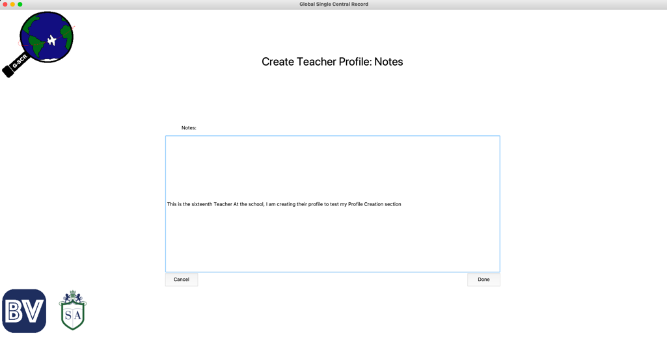

Now, when we click the “Done” Button, we should be taken back to the teacher profiles, and we should be able to see out new teacher.

However, clicking the done button seemed to have no effect. When I looked back at the command line in an attempt to see why this was occurring, I was met with this error message:

It was at this point that I realised that I was trying to pass the date as a string, not a date. To rectify this, I used the strptime method of the datetime module to convert the date of employment entry into a Python date object.



After doing this, I attempted to create the profile again with the same information and it worked, taking me to this screen after clicking the done button.

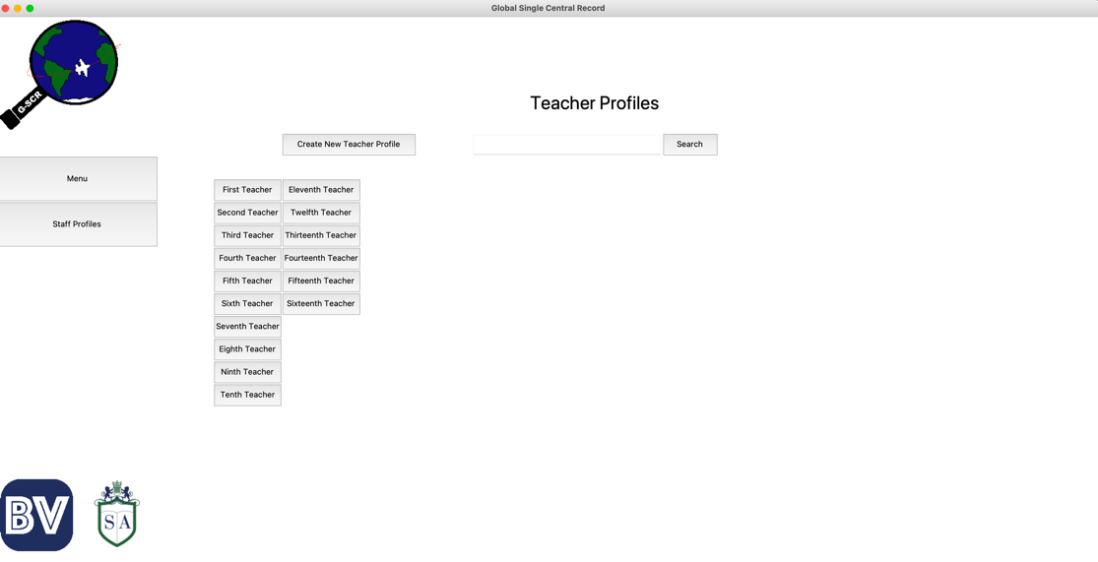

And we see our new “Sixteenth Teacher” profile there.

To me, I know that this now works but to prove that the record was actually added to the staff table in the database, I will show the new row below: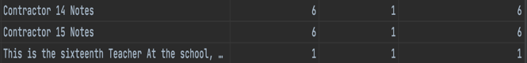

At this point, I realised that I also wanted the relevant prerequisites to be automatically added to the staff profile, which is why I added some code to my create_staff function in my queries file. This new function can be seen below.

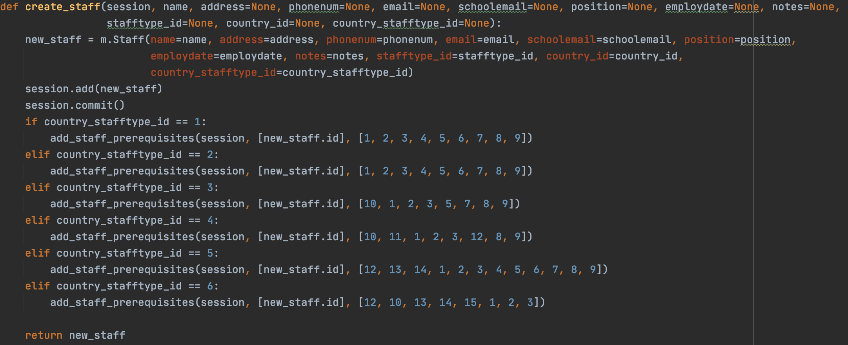

I then deleted the Sixteenth teacher record just created and did the same thing again to test this new addition to the create_staff function.

I know that the new profile has an id of 91 so I will check the staff_prerequisites table to see if the new records have been created for staff_id of 91.

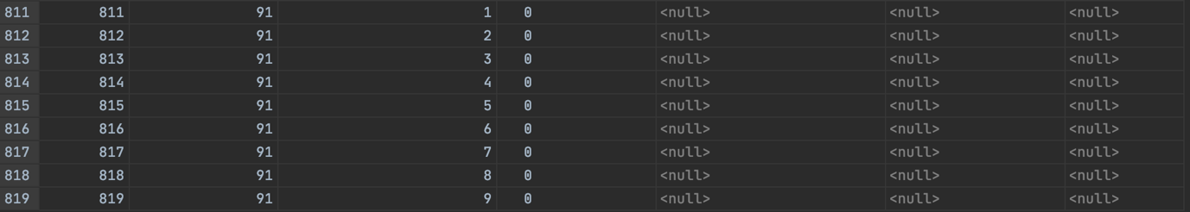

And here I can see that they were all successfully added and are yet to be completed (given the 0s in the 4th column)

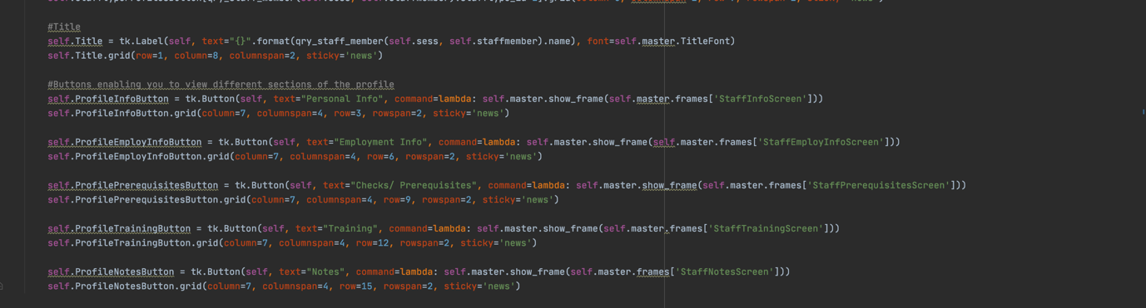Next, I must create the page to view individual staff profiles. The code for this screen can be seen below:

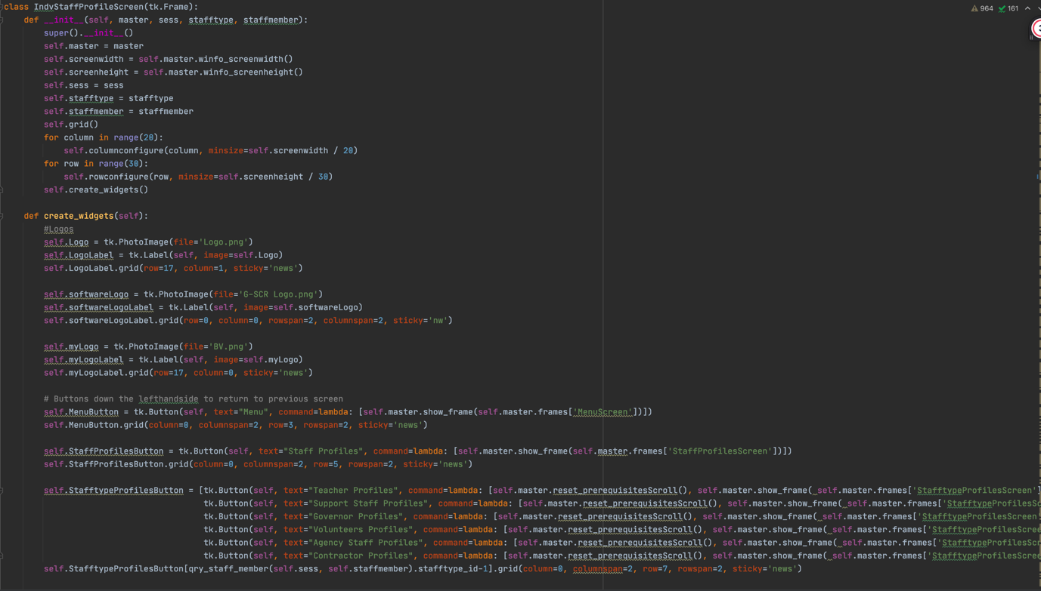Unfortunately, attempting to run the code led to this error:

As a result, I had to update the code with this line:



After trying again, I was met with another error message:

And here is the code that rectified this:

From my testing of the queries, I should have realised that the initial code was going to create an error. I was treating the output from the query as a list, when in fact it was a list of lists, meaning I simply had to add ‘[0]’ to the space before ‘.stafftype_id’ and ‘.name’.

With this, I no longer receive any errors and below I will show an example of the screen here below. I’ll show this screen for Sixteenth Teacher created previously so that we can compare the information with what was inputted while creating the Profile.

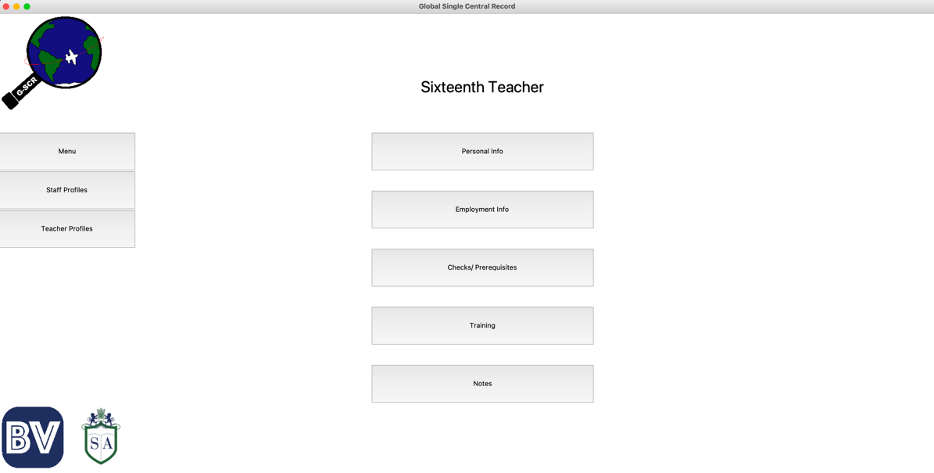

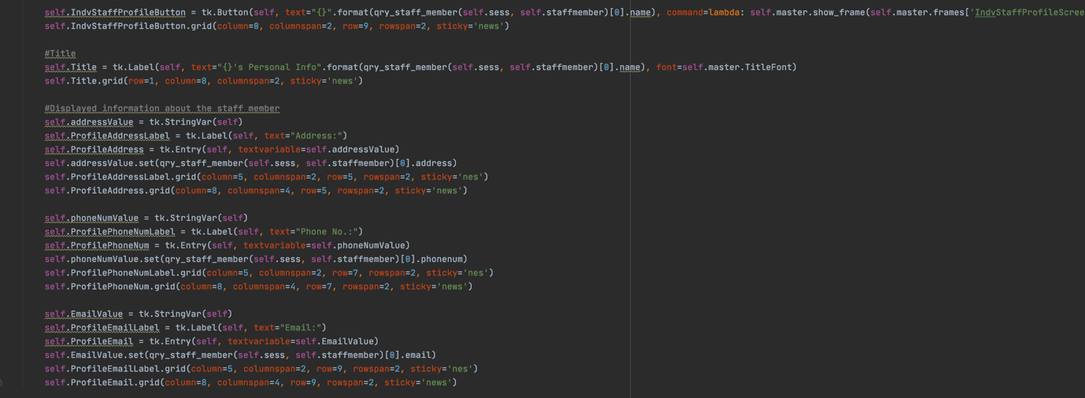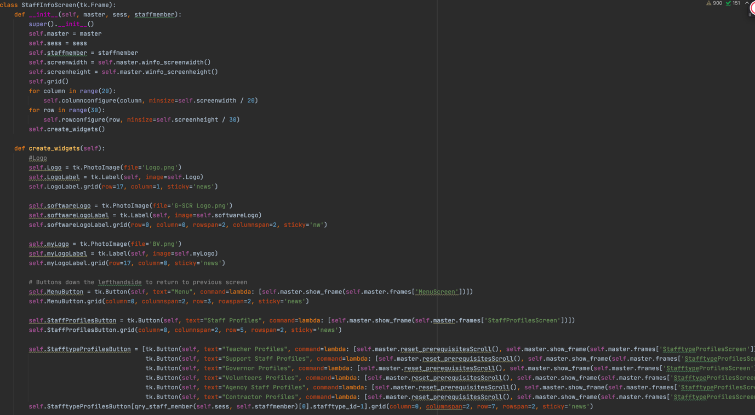Now I need to code the widgets to display the relevant information for each of the sections. First, I will create the Personal Info Section. This is the code for this.

And here is the Personal Info Screen for Sixteenth Teacher, which we can see contains the correct Information.

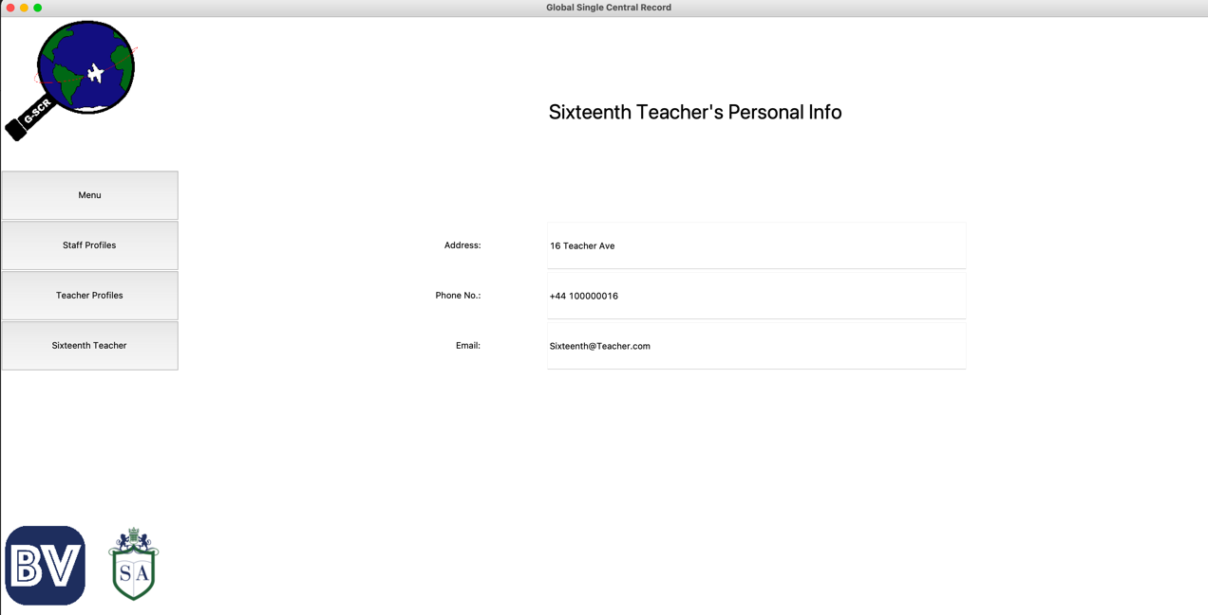

Next, I will create the Employment Info Screen, again checking it for Sixteenth Teacher so we can compare. Here is the code and result, which we see is correct.

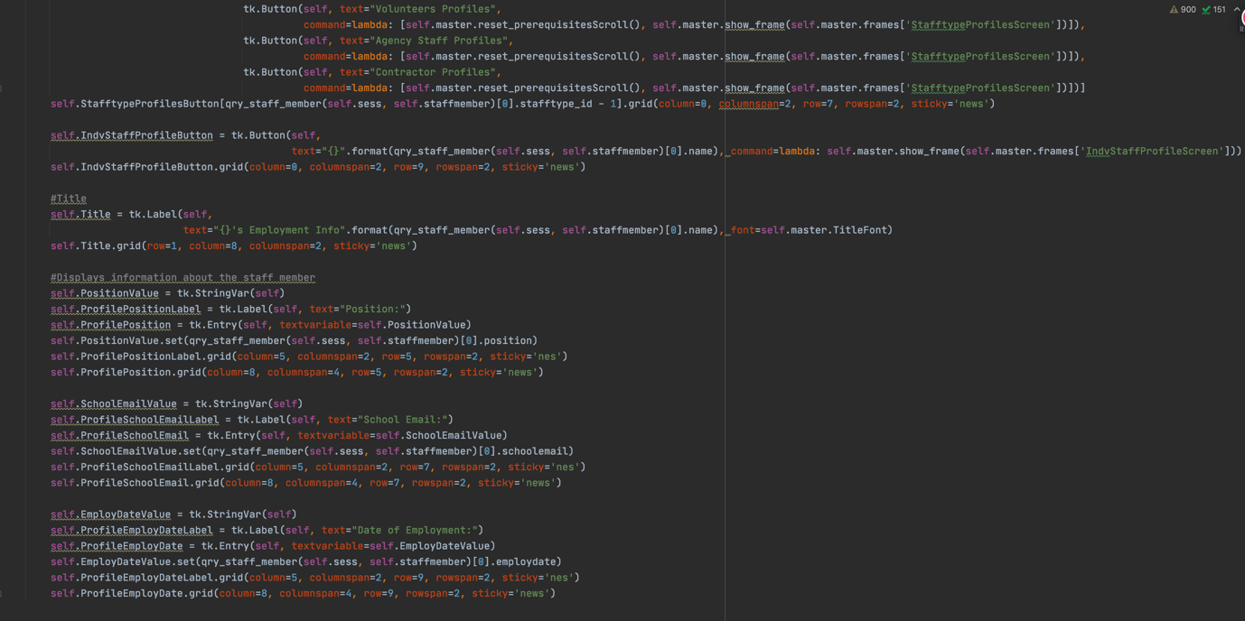

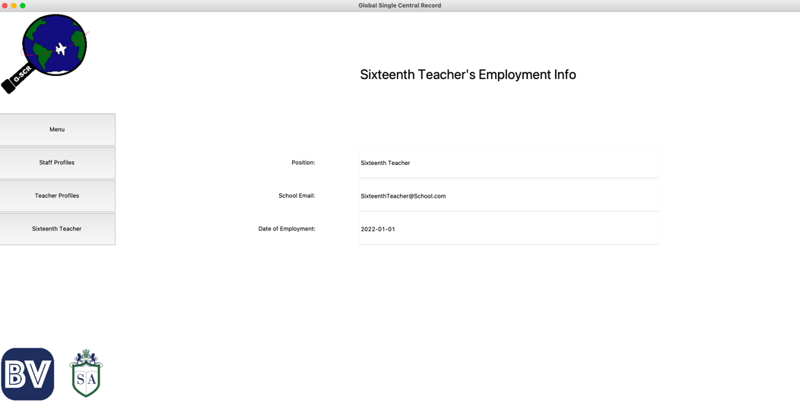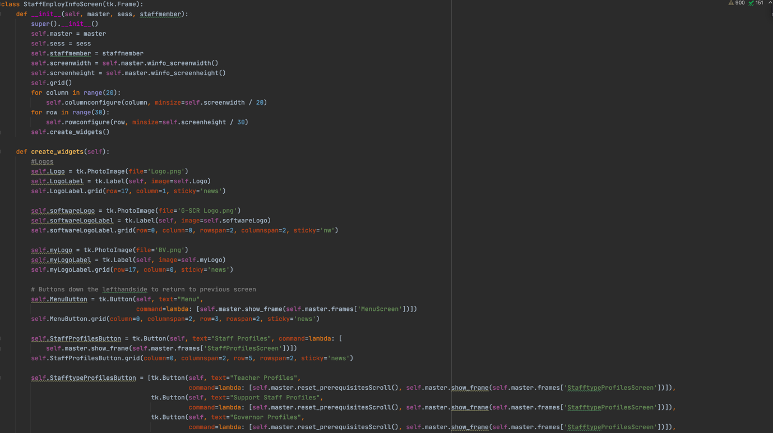

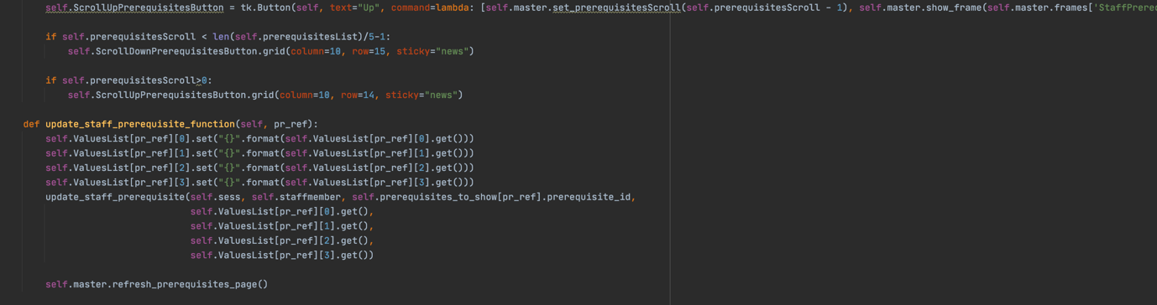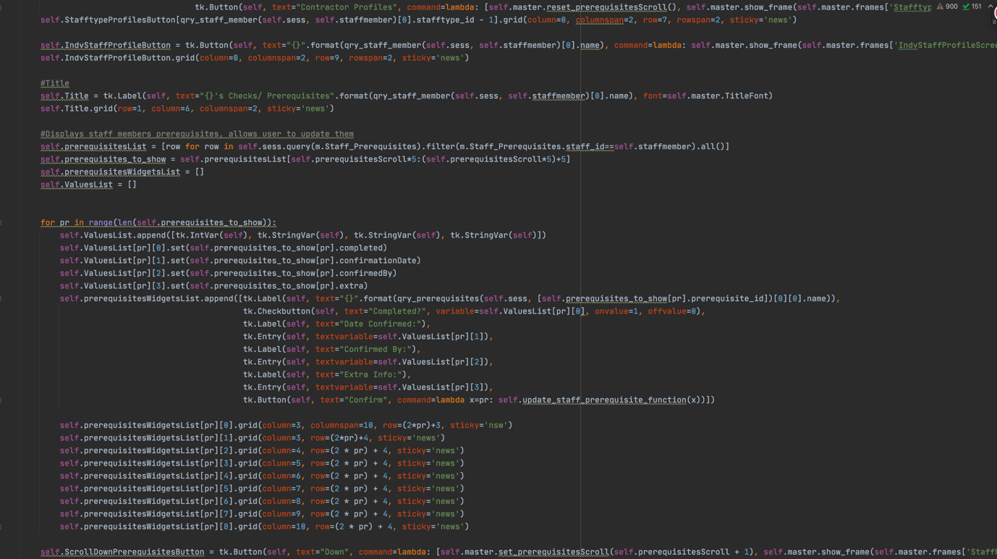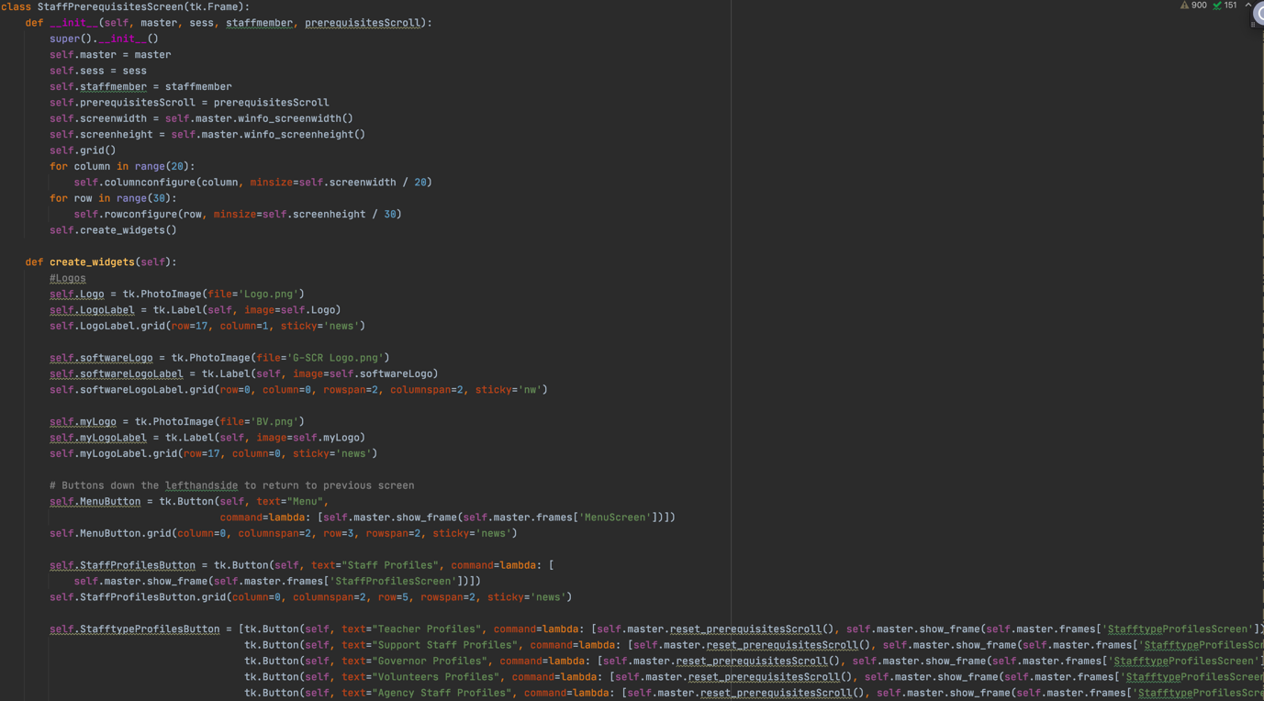Now I will make the Screen to display and update the staff members prerequisites. Here is the code and result.

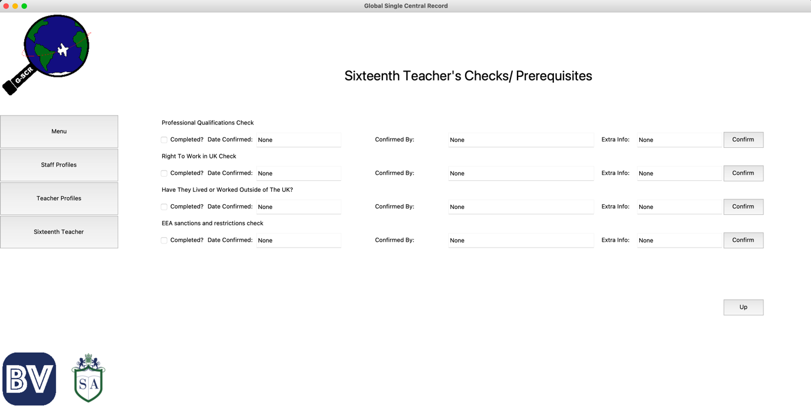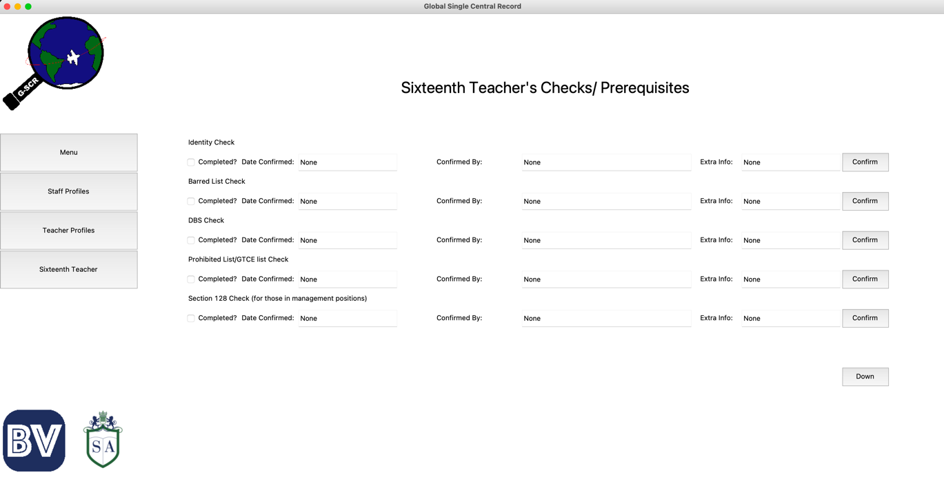There are a few different features of this screen to check. First is the ability to scroll through to the next lot of prerequisites. This next screen can be seen below.

Additionally, we can also update the information. For example, we can mark a prerequisite as completed and fill out some of the information. Clicking confirm will update this in the database. This can be seen below

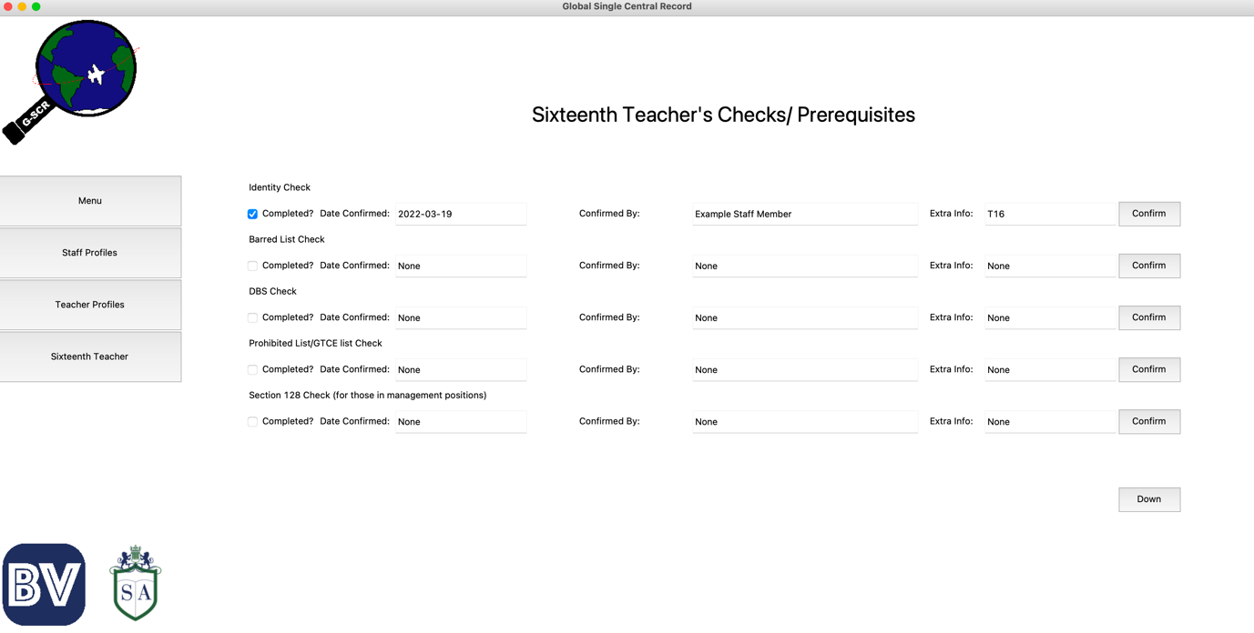

To make sure that this has been added to the database, I will check the relevant row in the staff_prerequisites table.

And here we see that it has been successfully updated and committed.

With that screen completed, I will move on to the Training section for the Staff Profile. As there are multiple screens for this, I will show all of the code for this section, followed by a demonstration of the screens. This code can be seen here

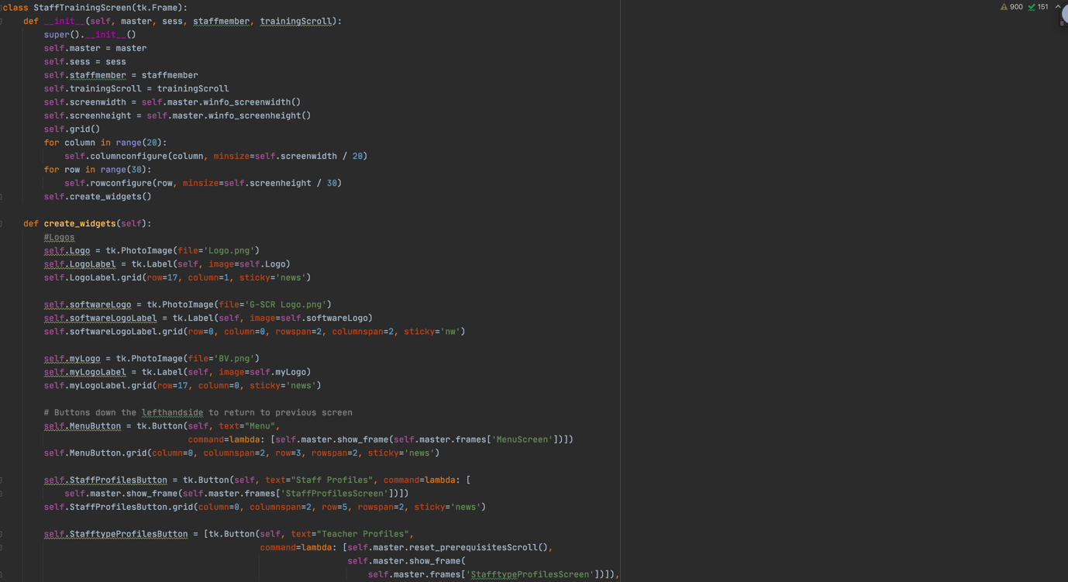

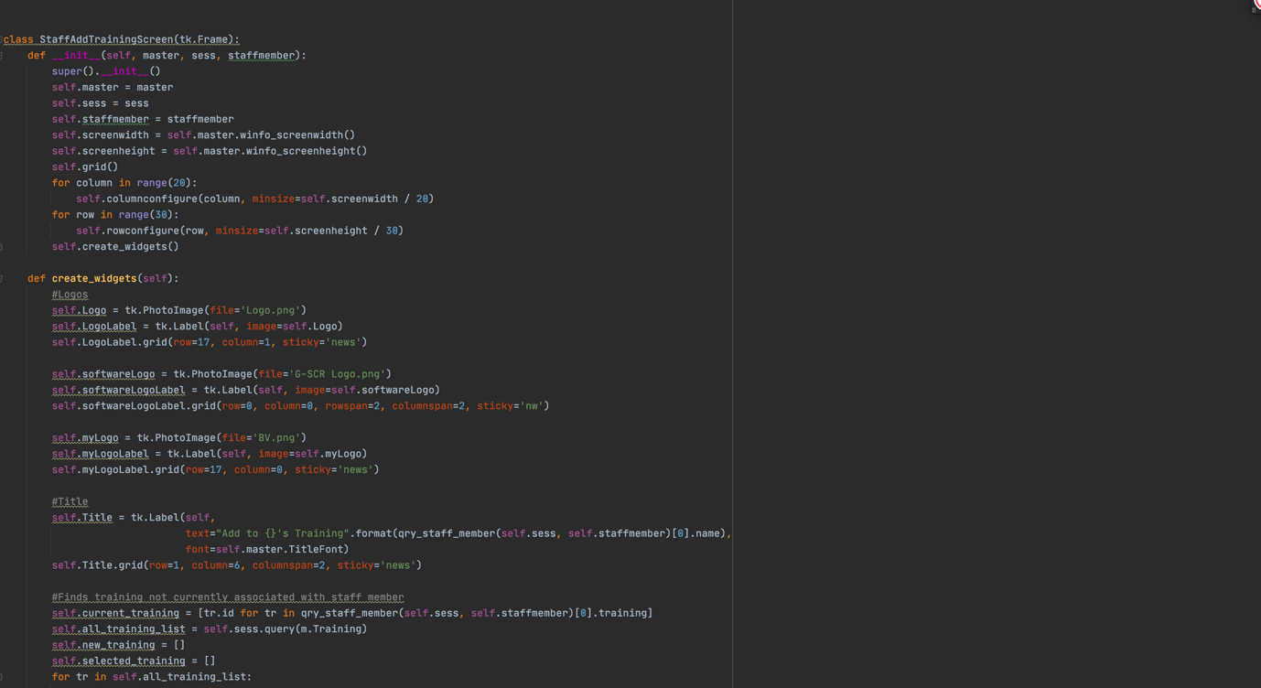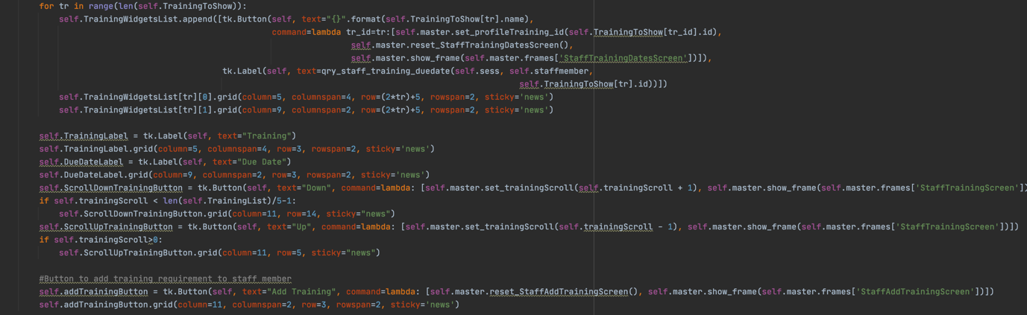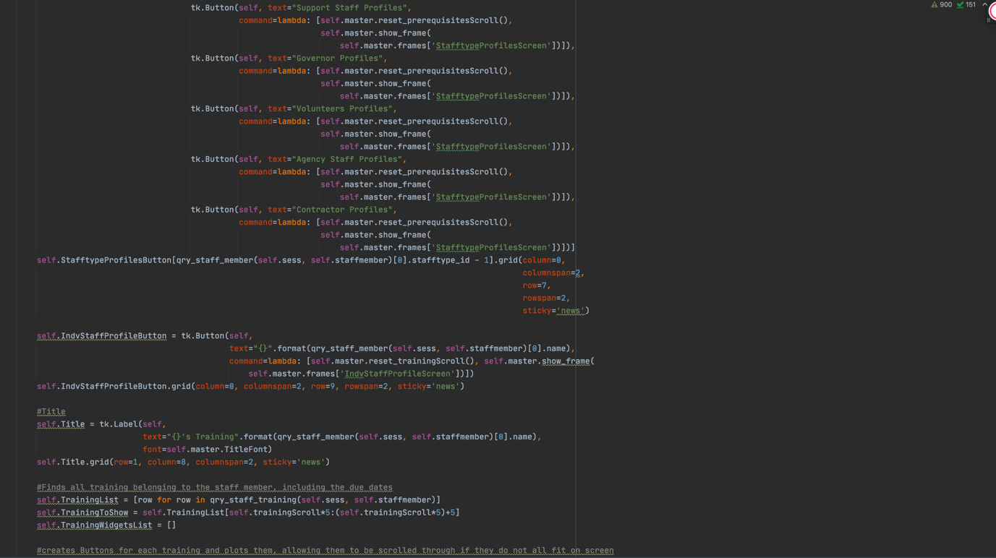

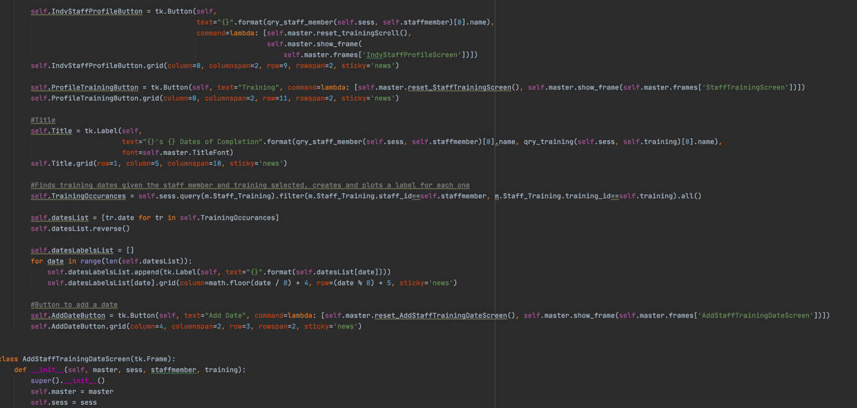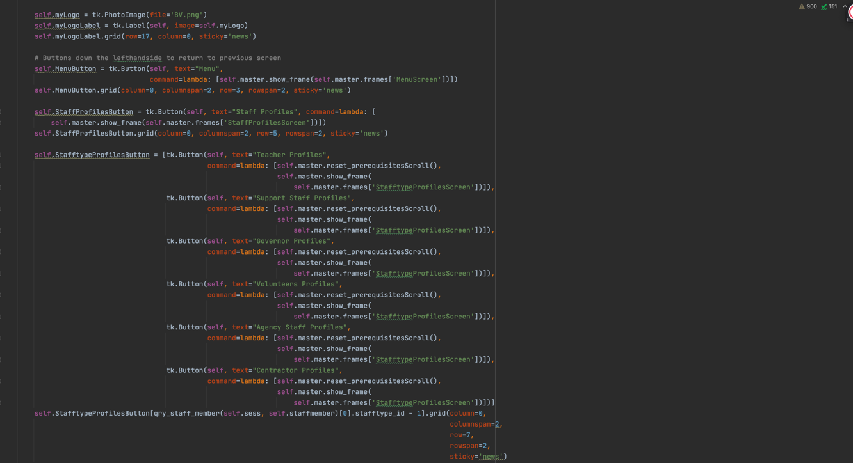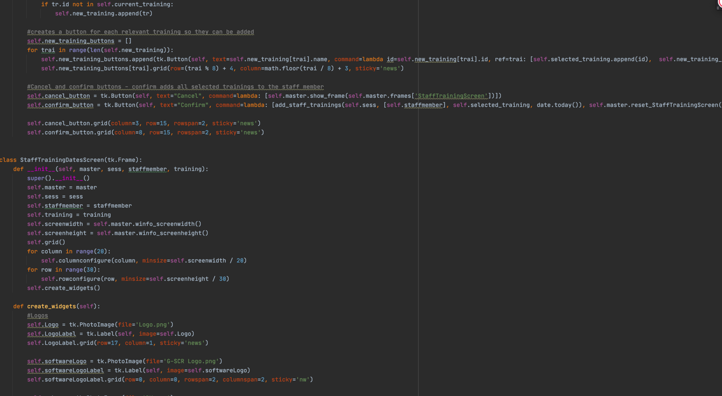

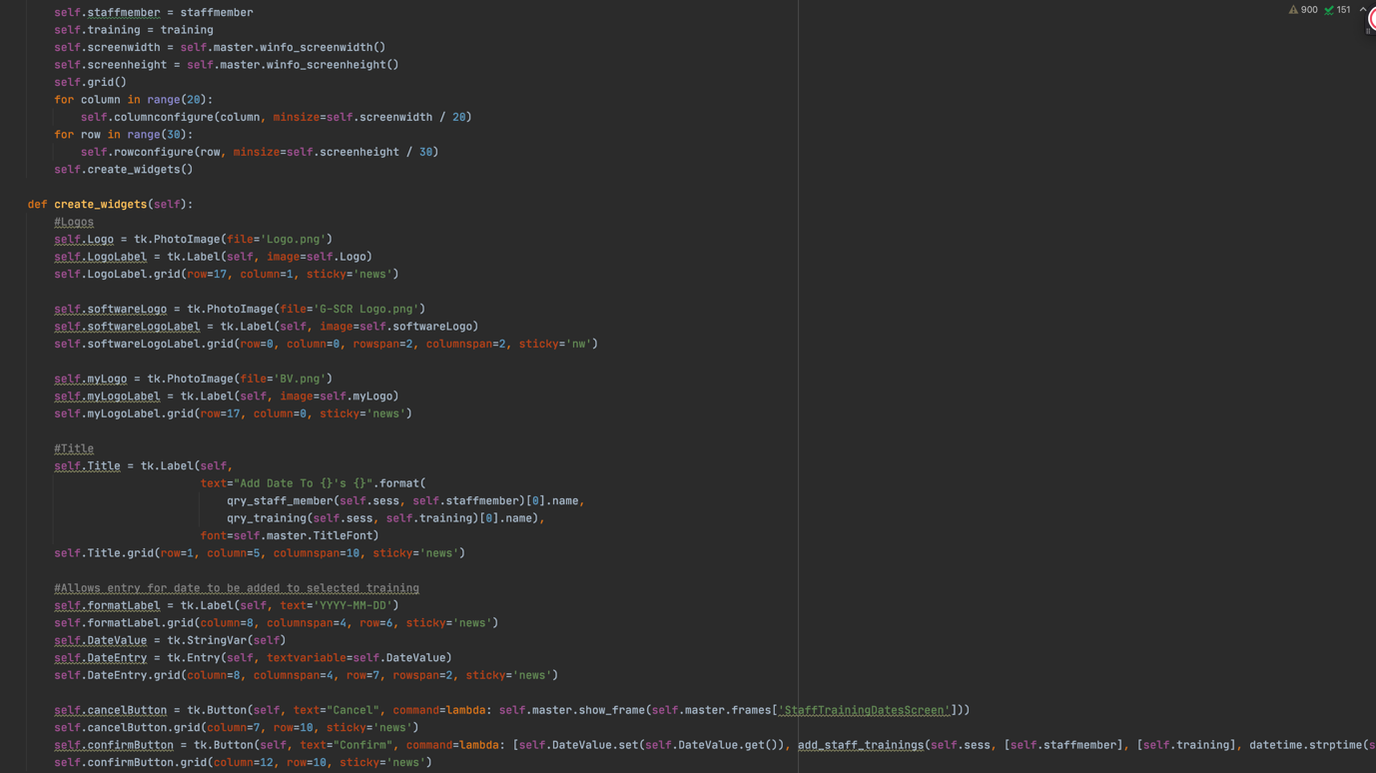

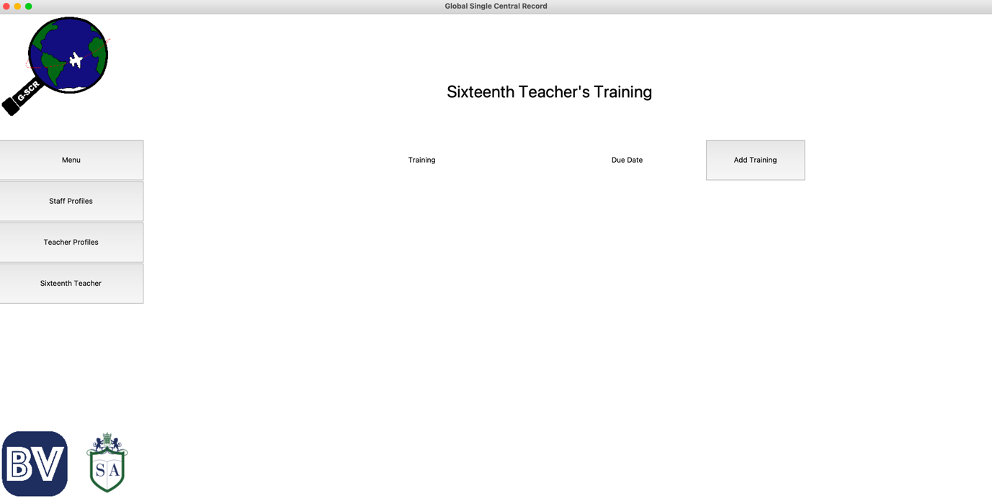This is how the section looks for our teacher.

Of course, It is currently blank as we have not yet added any training to our teacher. We do this by pressing the Add Training button, which takes us to the next screen.

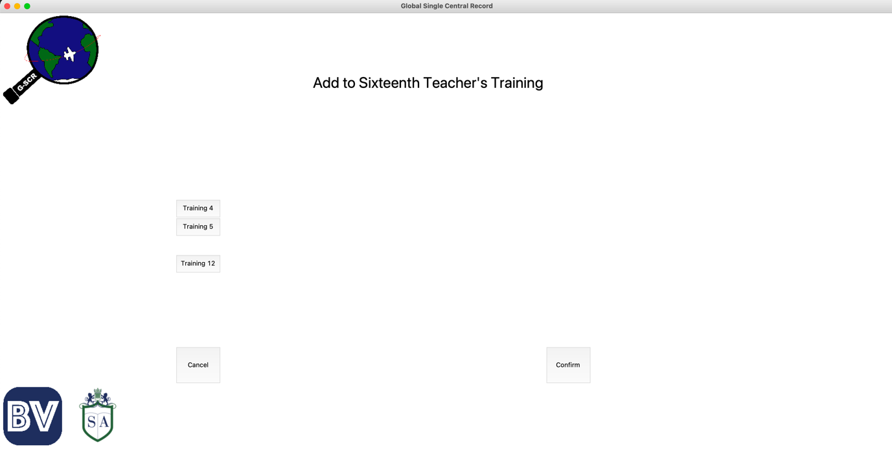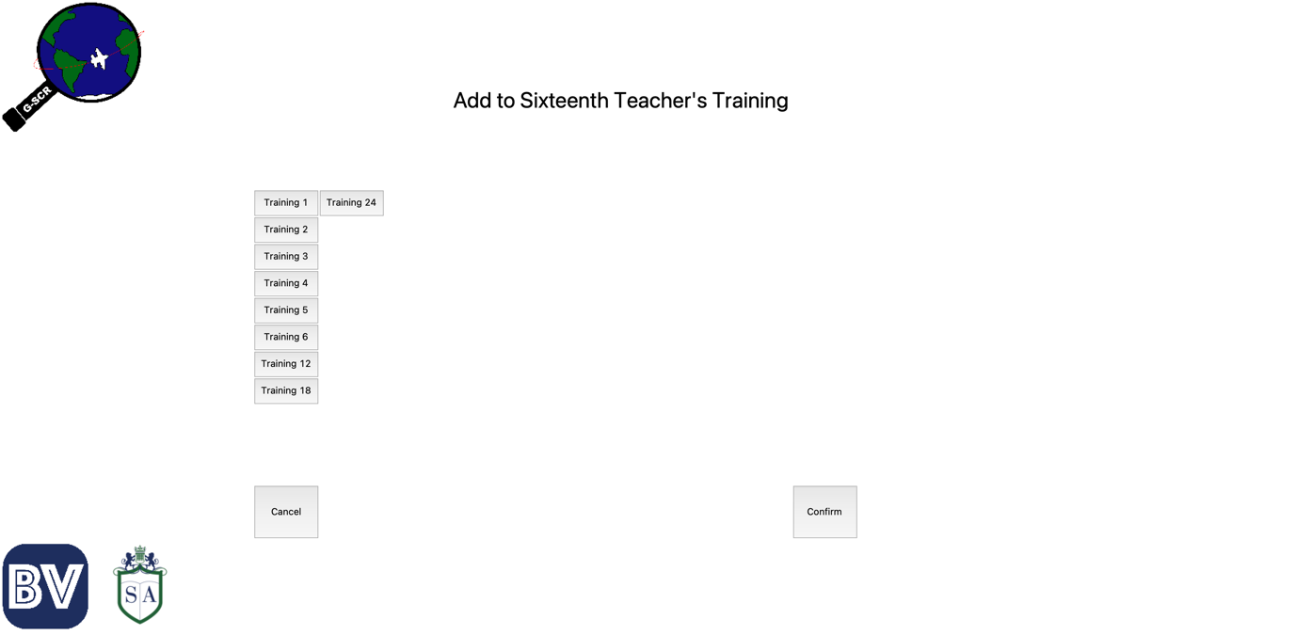From here, we select all the trainings we would like to add. I created some filler ones so that we can test this. The time between requiring completion equals the number next to training. For example, Training 5 must be completed every 5 months. Once we select a training, it is added to a list and disappears from the screen so it is not accidentally selected multiple times. To demonstrate this, I will select Training 1, 2, 3, 6, 18, and 24. This is how the screen now looks.

Once we Confirm this with the button, we are taken back to the Training section of the profile where we can now see that the trainings have been added.

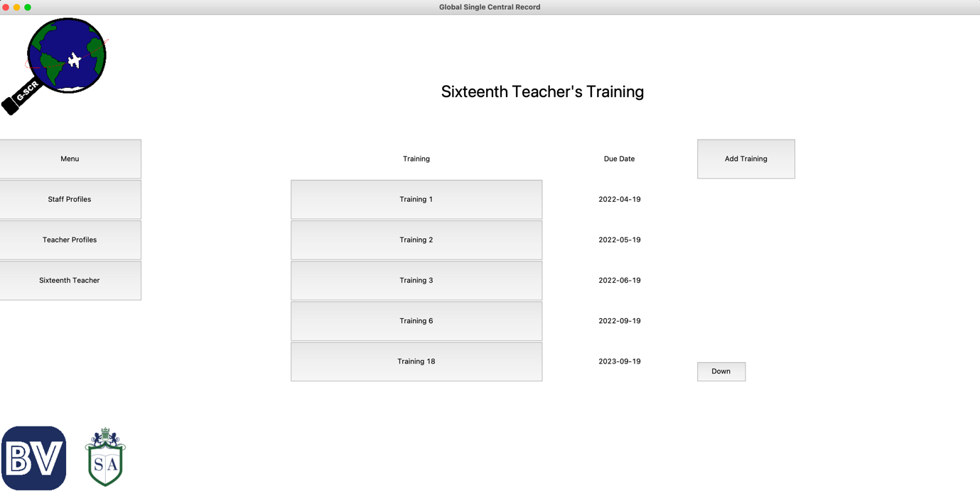

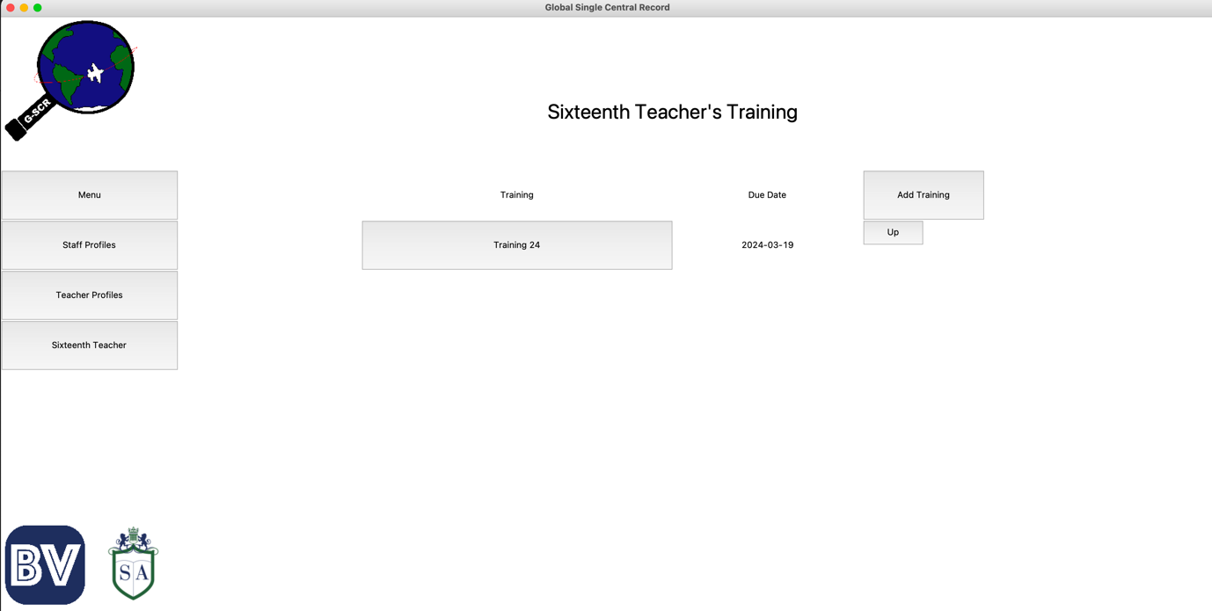Since these do not all fit on one page, we can scroll through to another page.

From these screens, we can also see that the Due Date functionality works. For example, Training 24 is exactly two months from today, when I added the training to the staff member. We know that these Trainings have successfully updated in the database by checking the Staff_training table records.

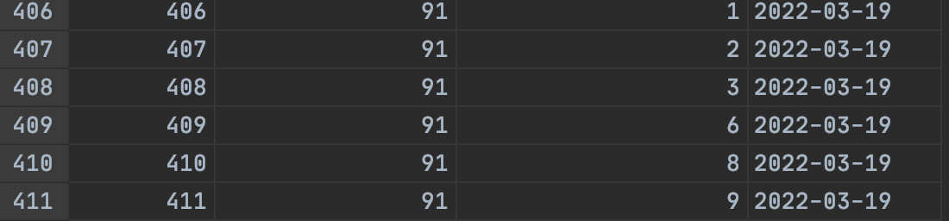

From this screen, we can also click on the button for a training to view the dates it has been taken. For example, this is the page for Training 1.

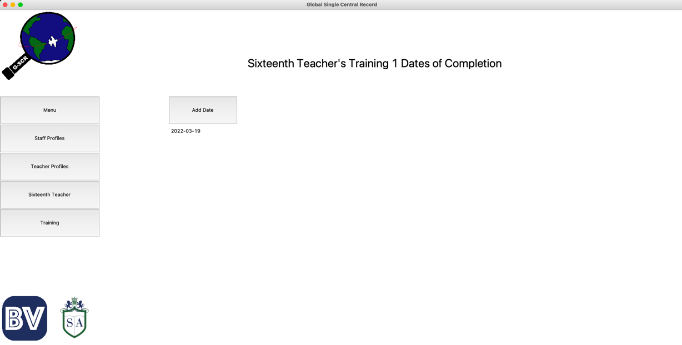

To Add a date, we simply click the Add Date button and enter the date of completion.

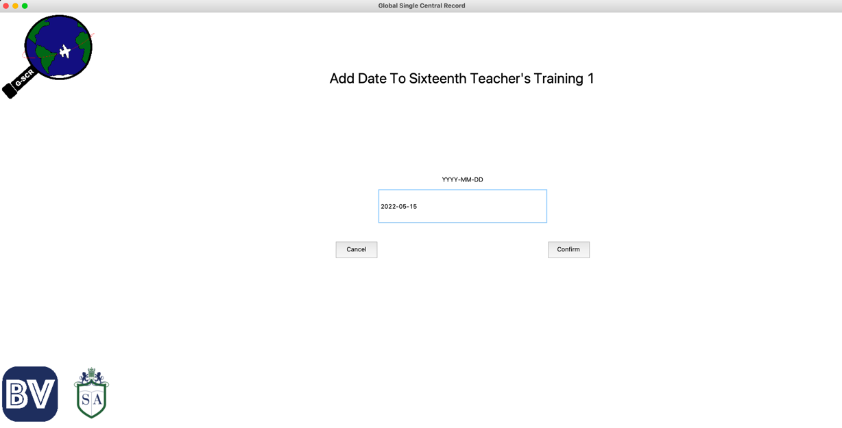

When we confirm this, we are taken back to the Screen with the dates of completion with the new date.

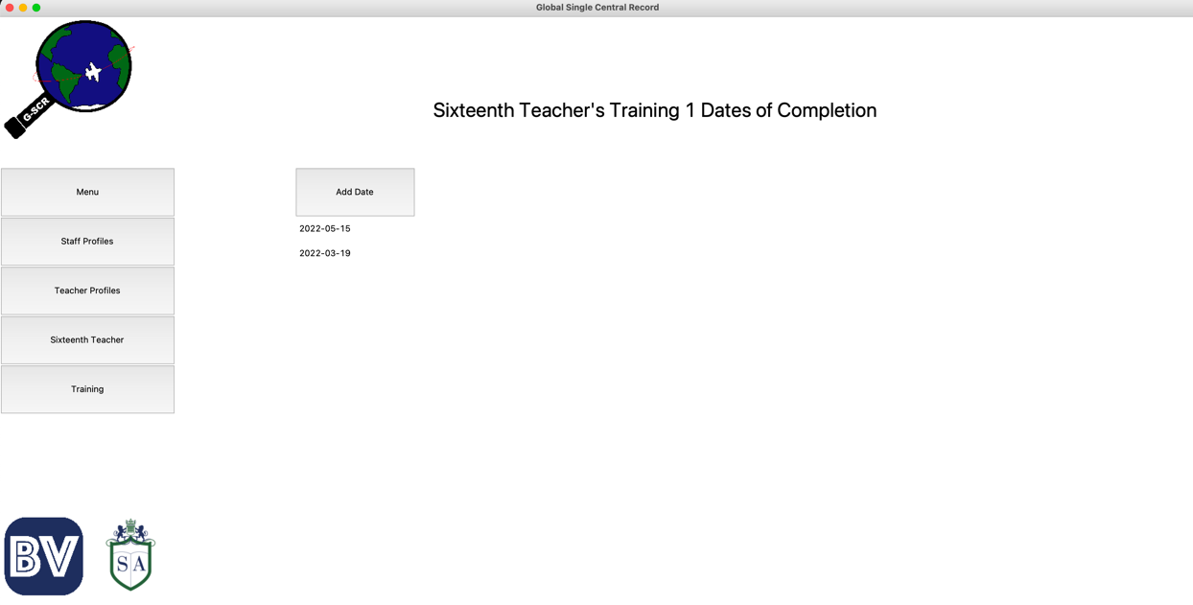

We can check that this update has been committed by checking the staff_training table again. Here, we can see that the record has been created with this new date.

When we go back to the main screen of the training section, we should also be able to see that the due date for this training should have updated.

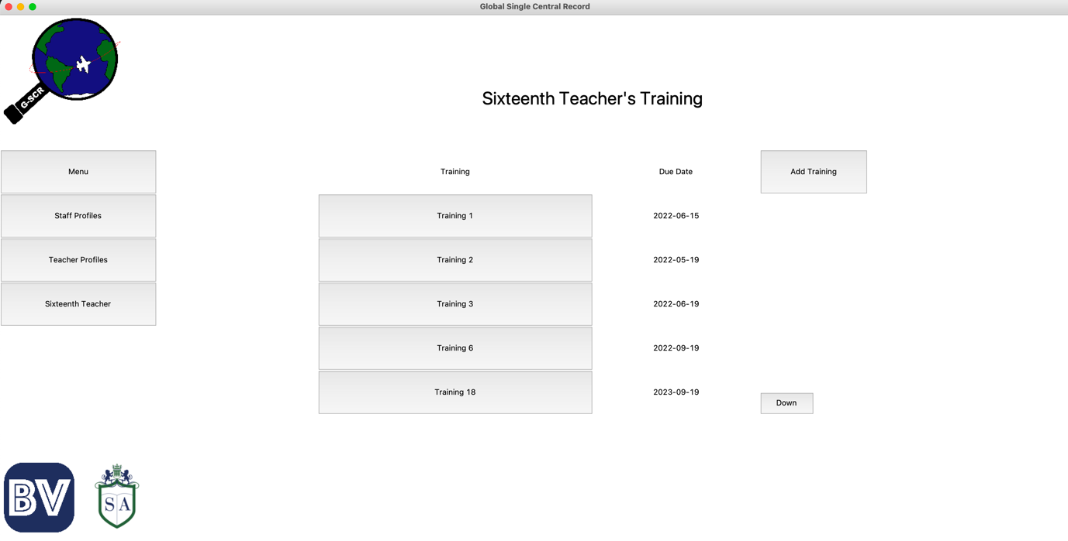And we can see that it has.

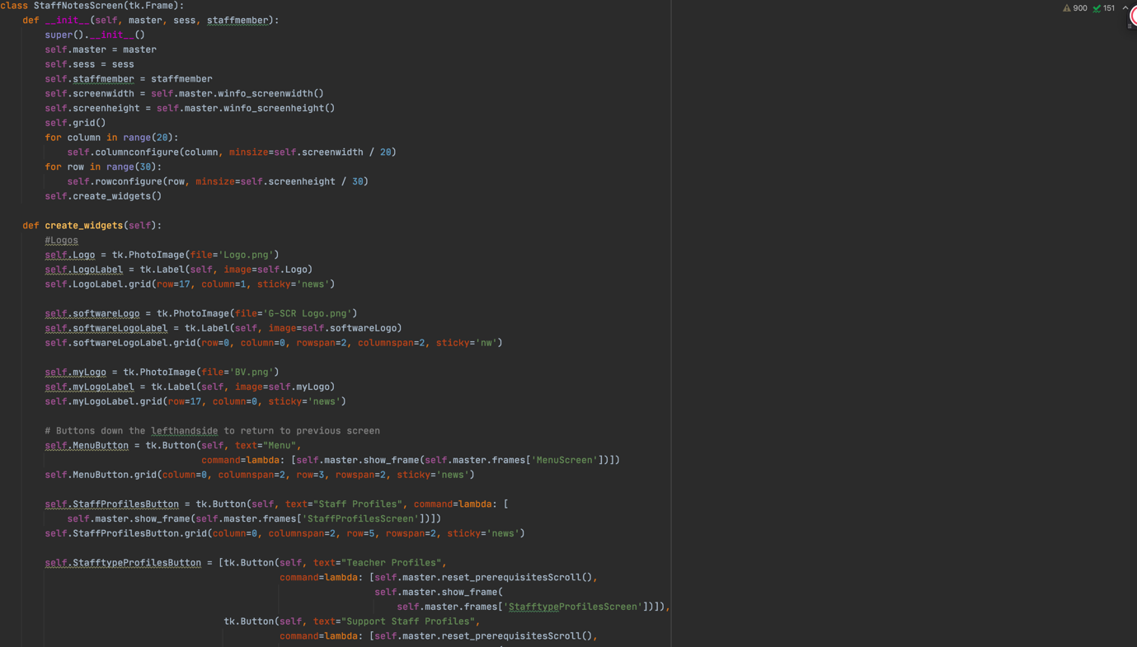The last screen of the Staff Profiles section we need to create is the Notes for the staff member. The code for this can be seen below.

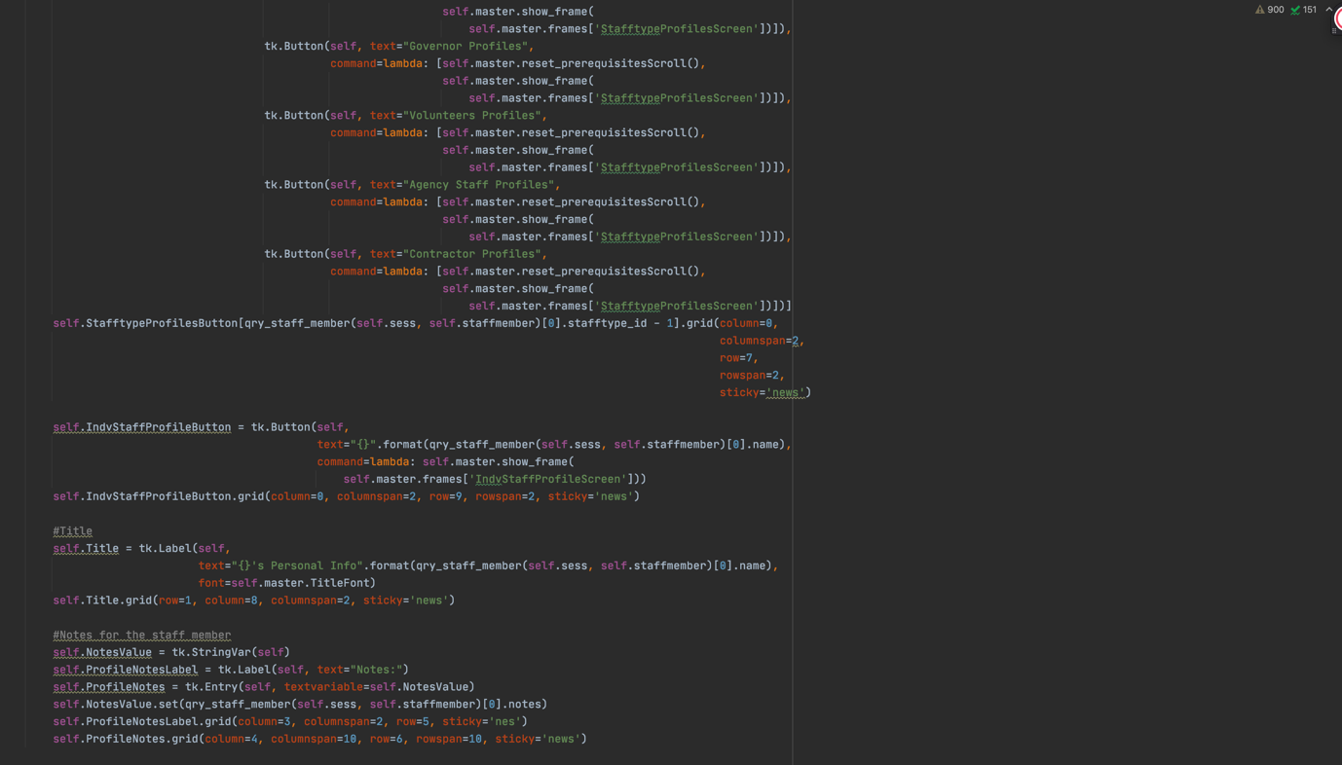

And this is how the screen looks.

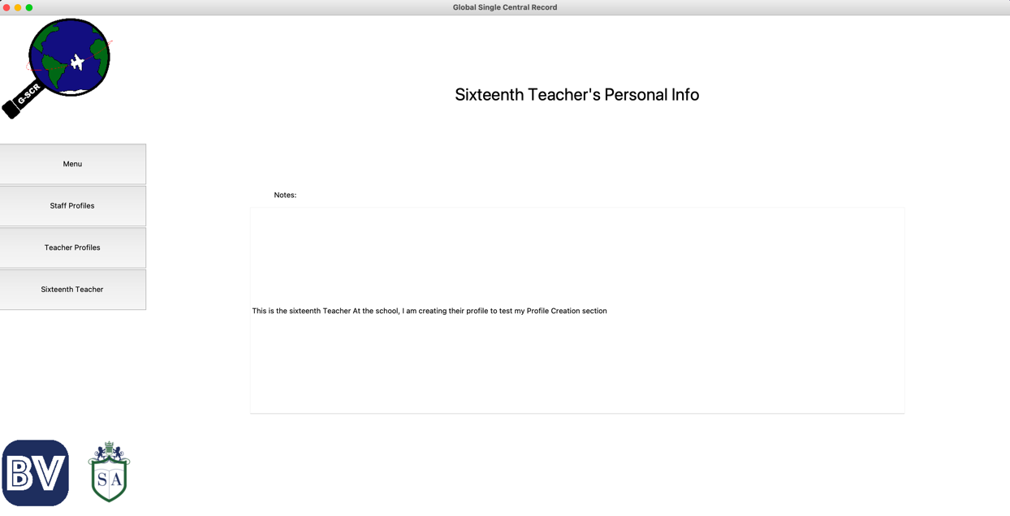

Which we can see has the note I wrote when creating this Teacher earlier.

With this section now completed, I will be moving on to the Training Section.

### Trainings Section

I was planning to do the all the Contact screens, but I decided against it for the time being so that I can focus on the core parts of the program. Once I have finished with this and ensured it is as robust as possible, I will add the contacts screens in the future. This is why I am also not removing the contacts stuff from elsewhere in my other files so that when it comes time to create the screens, I will have everything ready.

First, I will make the TrainingsScreen where all trainings will be displayed as buttons. Here, training can also be created.

The code for this can be seen below.

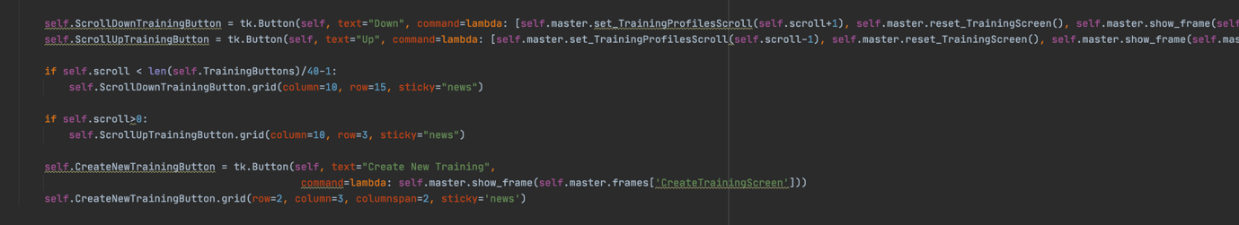

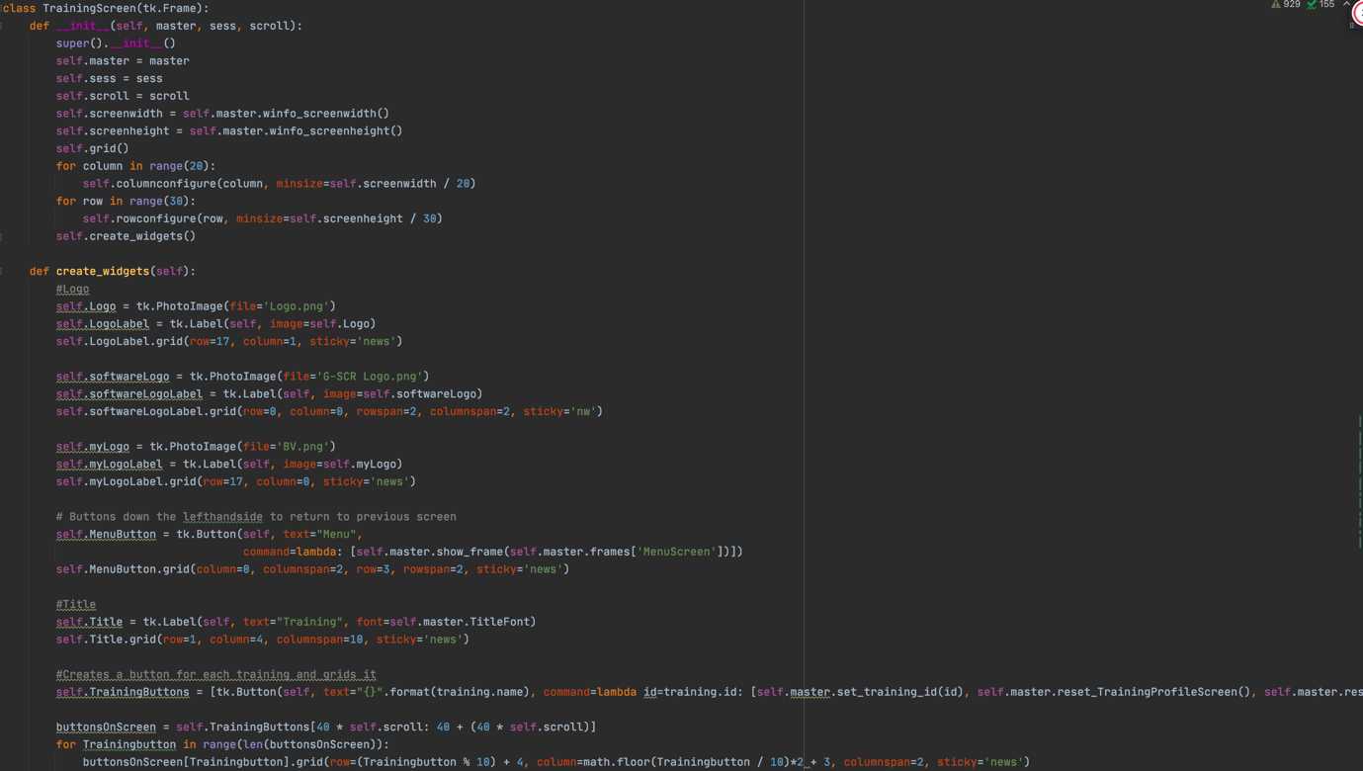

This is how the screen looks, I added some training already for clarity.

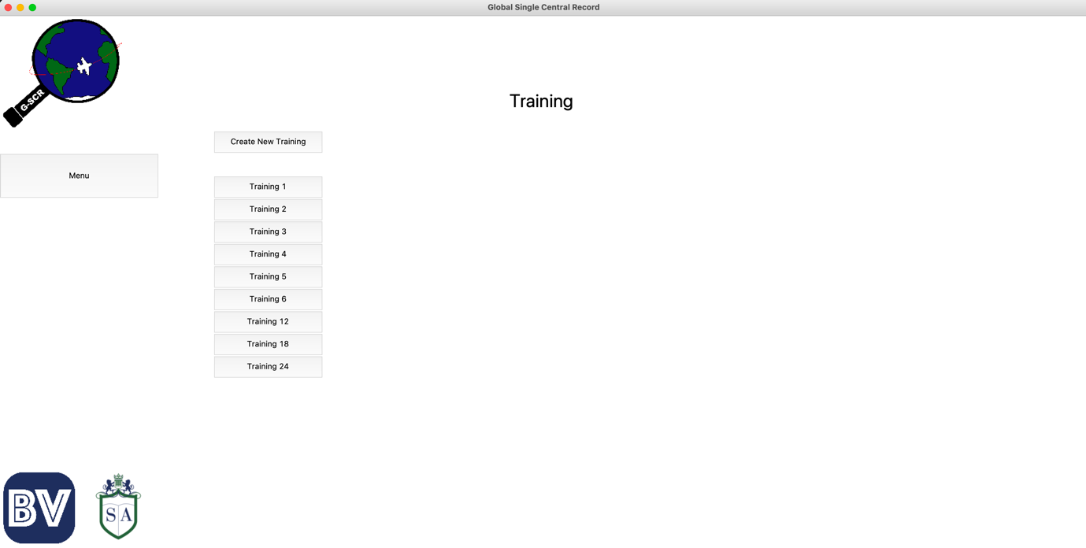

Now, I need a way of creating trainings from the interface. The code for this screen, accessed by pressing the ‘create new training’ button on the training screen, can be seen below.

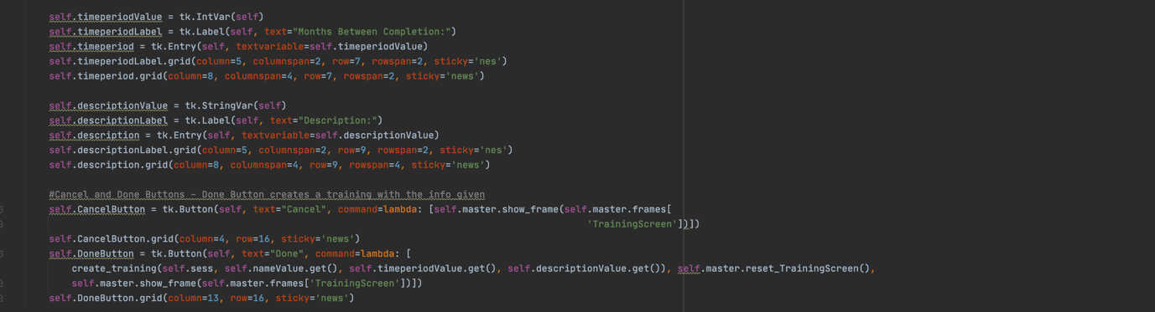

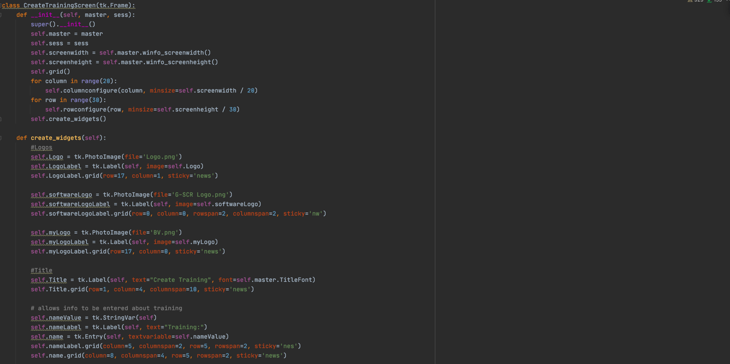

This is how the screen looks. I will demonstrate how a training is created.

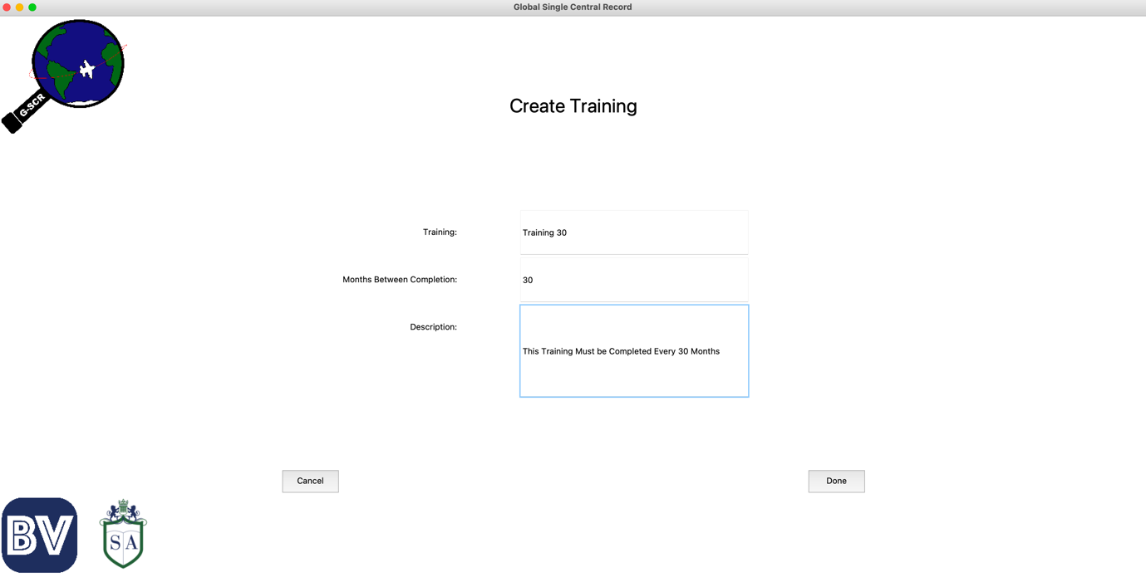

Hitting the Done Button creates the training, which then appears on the training screen.

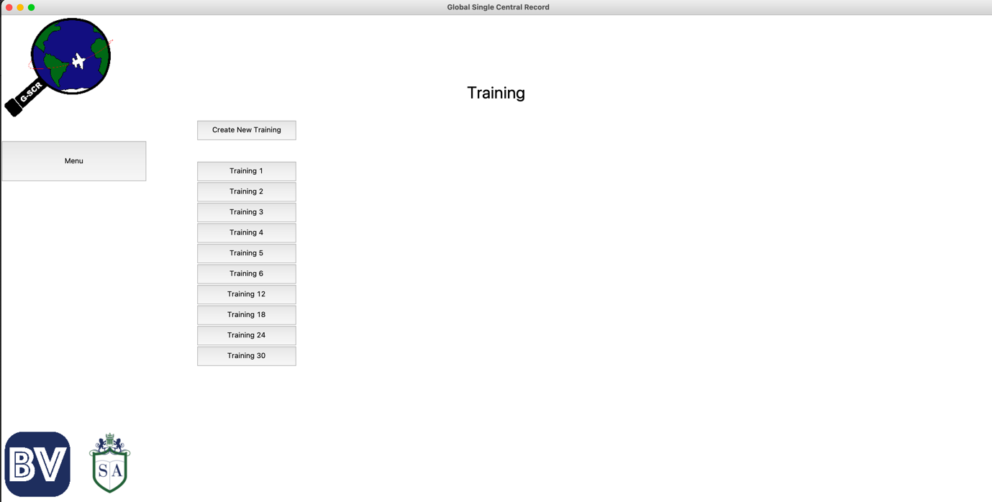

Aside from this, I can know if this has worked by checking if it has made a new record in the Training table in the database. This new record can be seen below.



Next, I need to make the screen that will allow me to view the different pieces of information about the training. The code for this can be seen below.

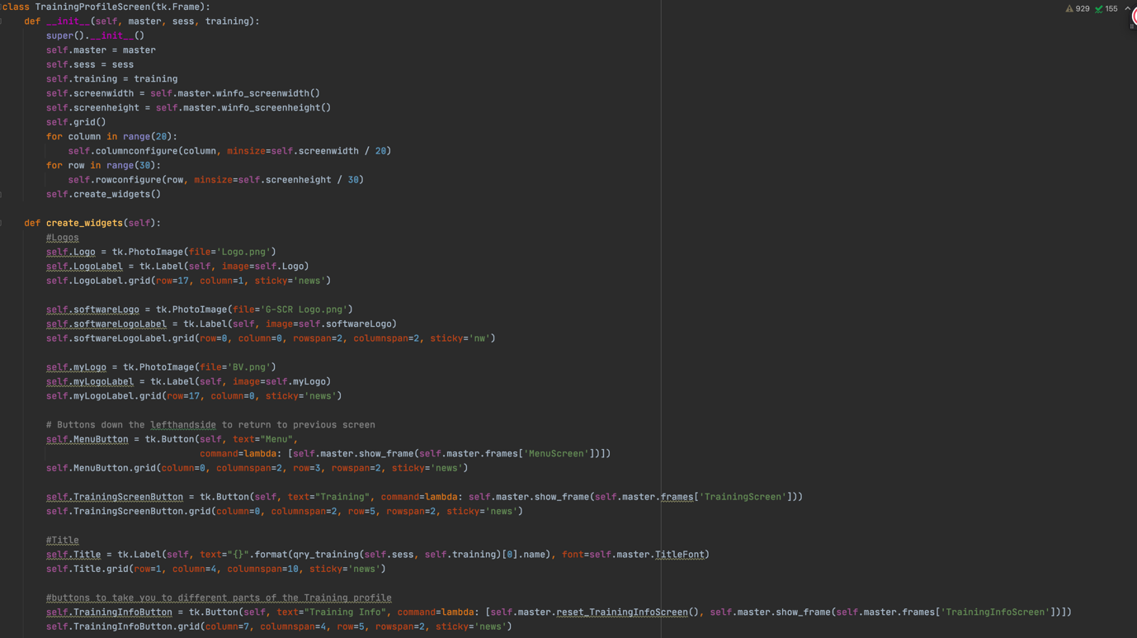

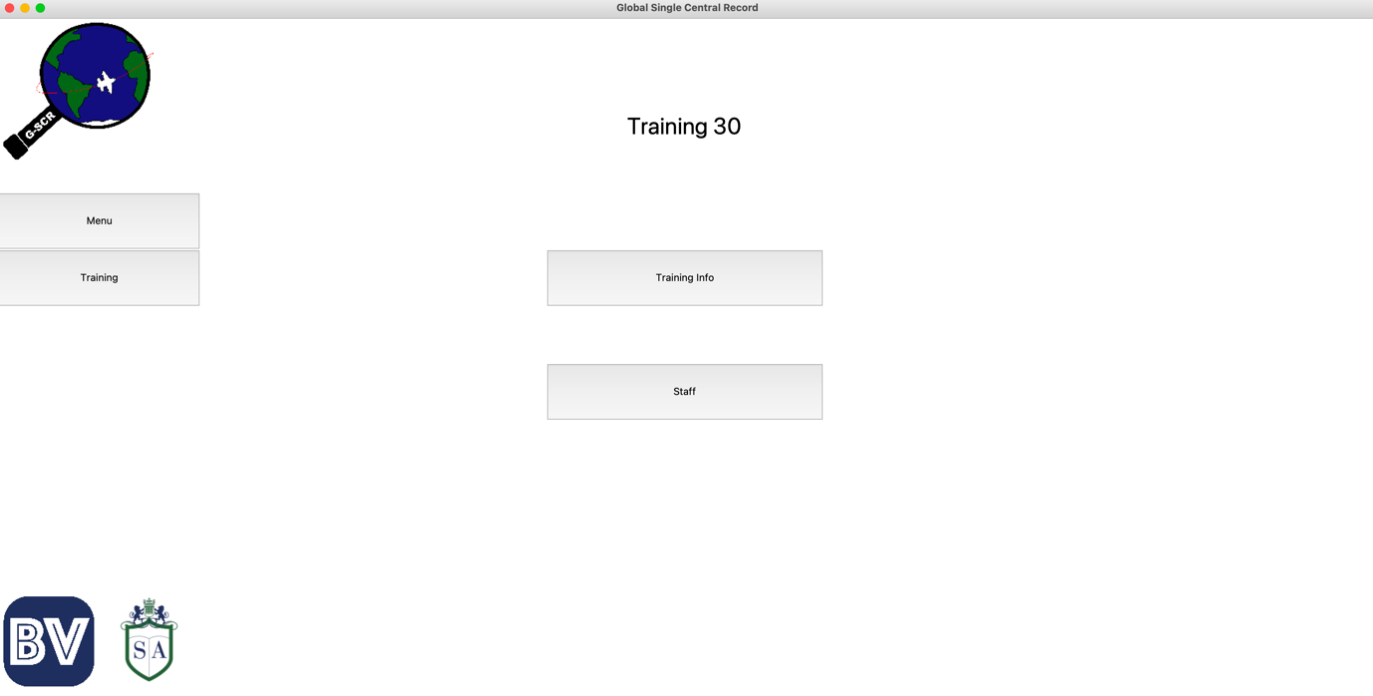This is the result of that code.

Next I need to make the Training Info Screen. This is the code for it below.

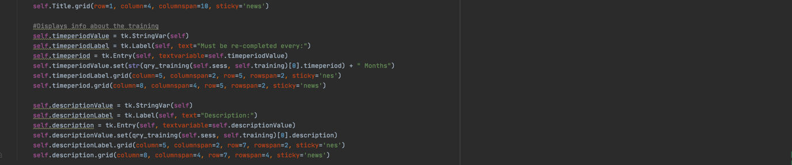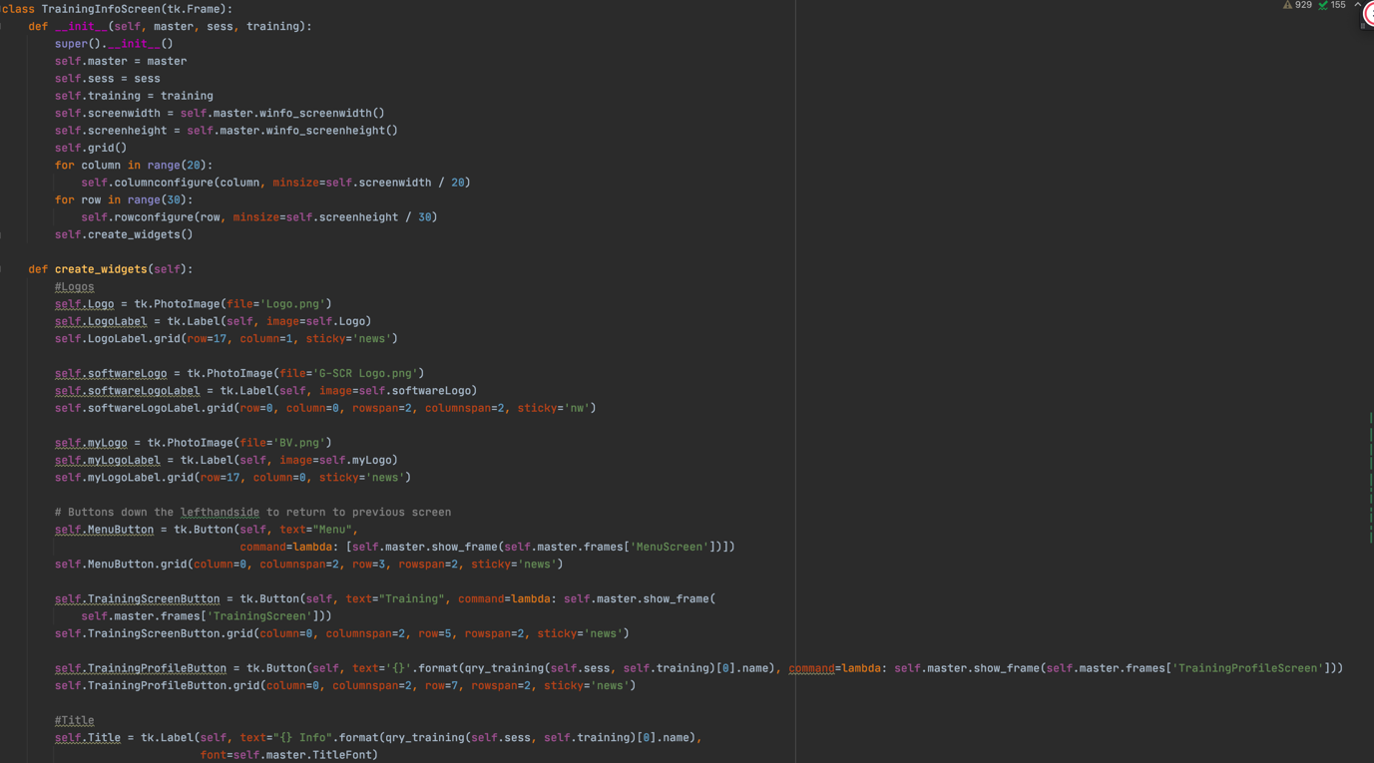

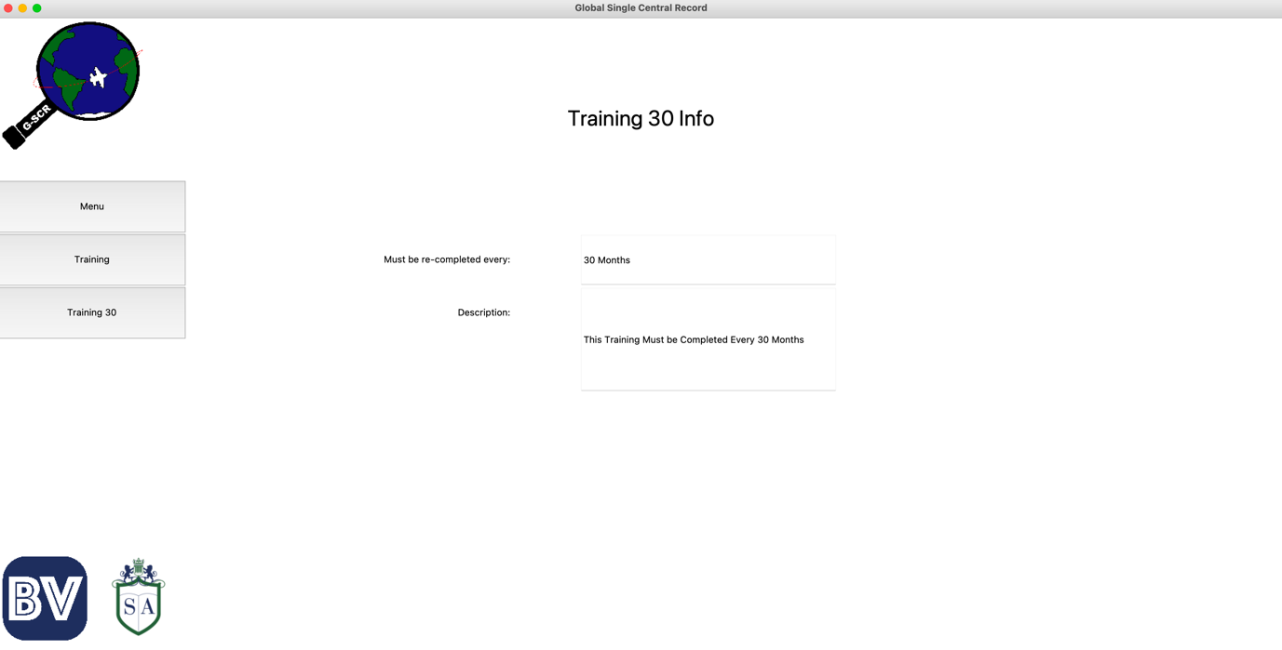This is the result of that code.

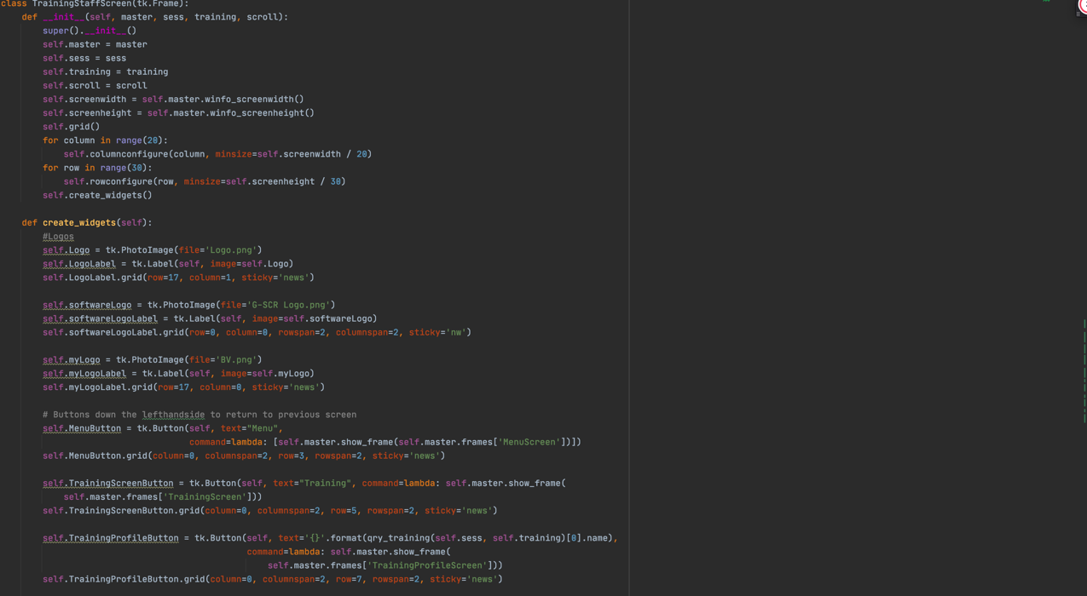Next, I need to code the Staff section for the Training Profile, which can be seen below.

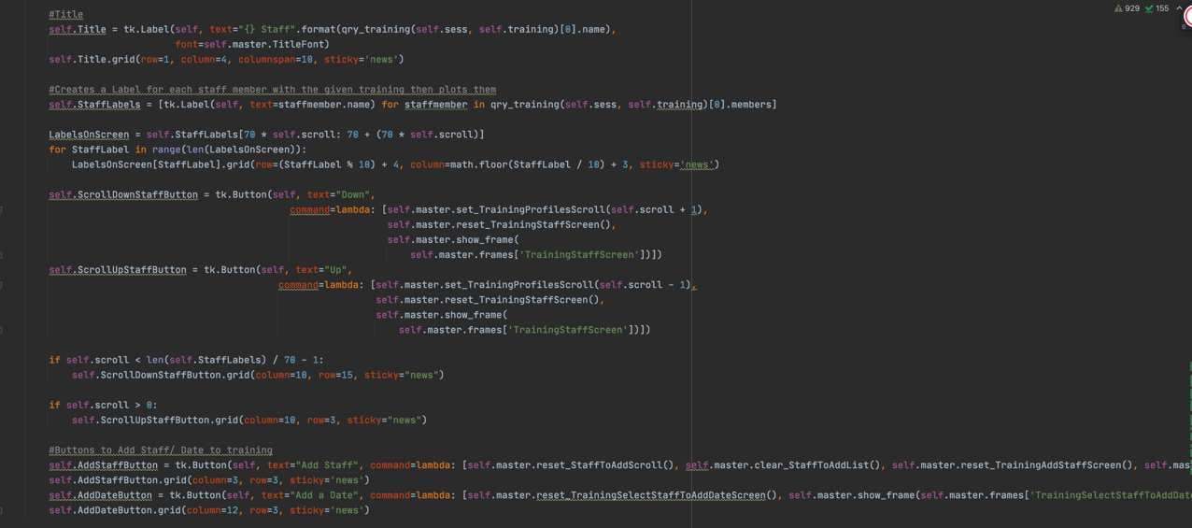

Here is the result. Because I have not yet added any participants to Training 30, I will show this screen for a different training.

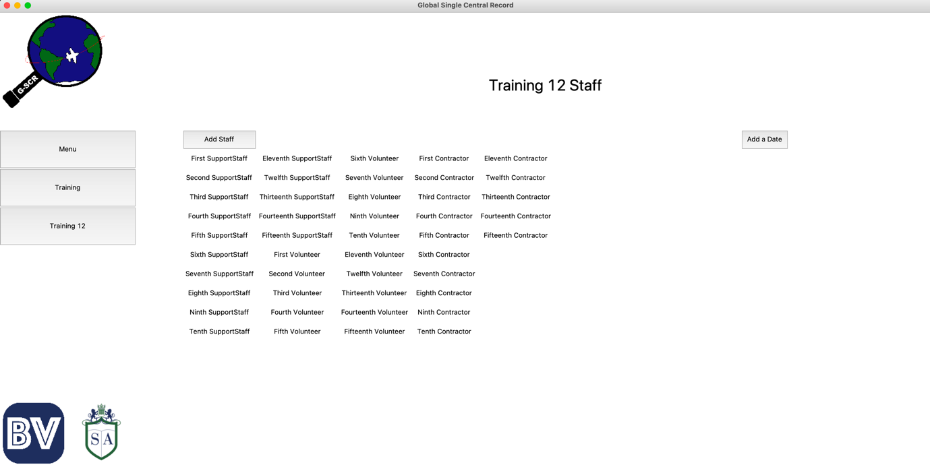

Now I need to be able to add Staff members to training from this screen. The code for this new screen can be seen below.

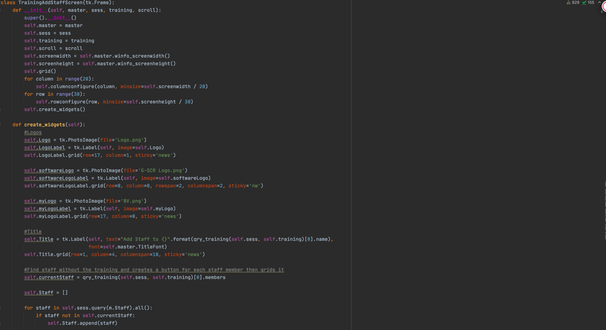

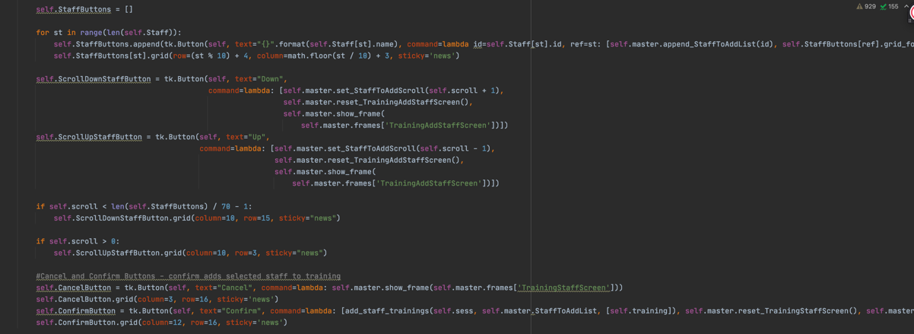

Below I will show how this will allow me to add staff to Training 30.

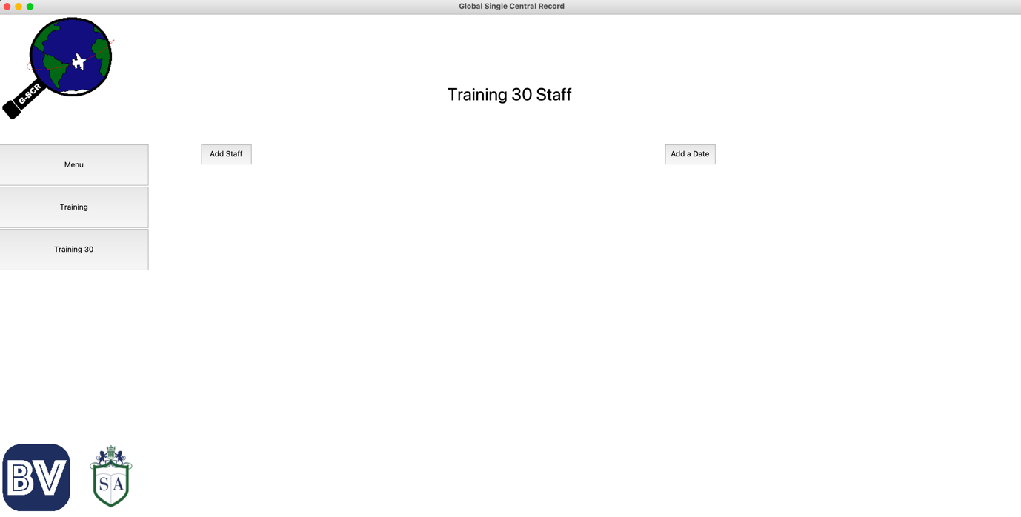Training 30 starts out with no staff. Add staff button pressed.

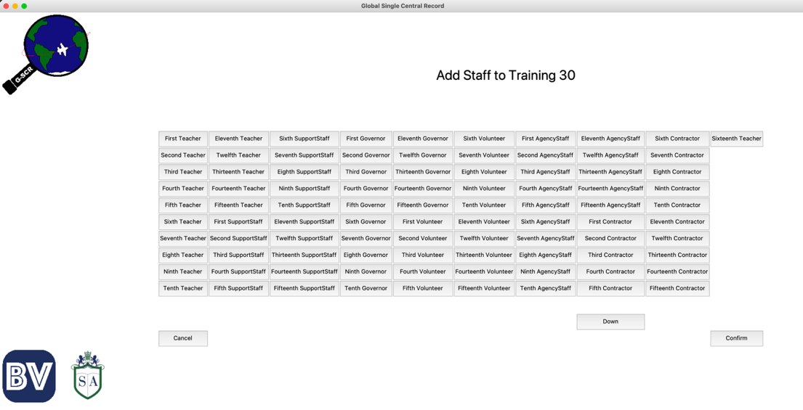

Here, I noticed that all of the staff members were being added to the page at the same time. I only wanted 70 to be added so I had to go back and fix the code.

I had to add a line to cut the list of staff members so that the screen grided maximum 70 at a time. Here is the new code.

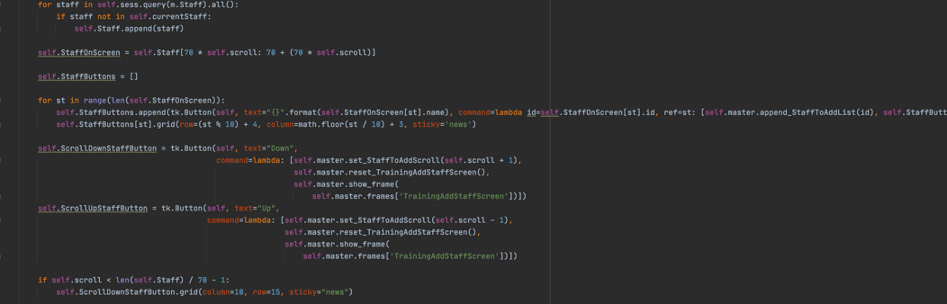

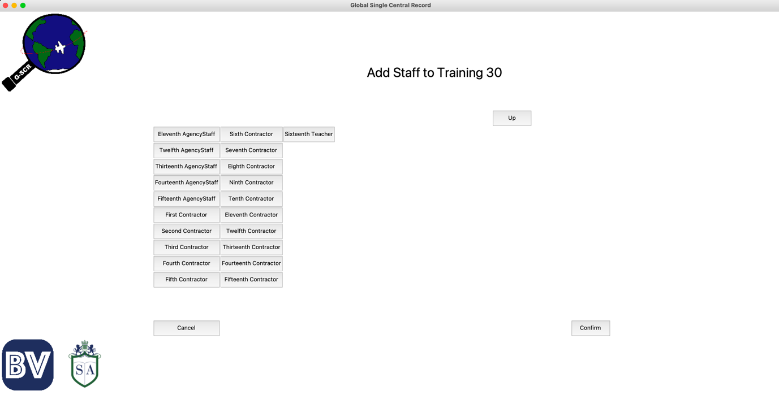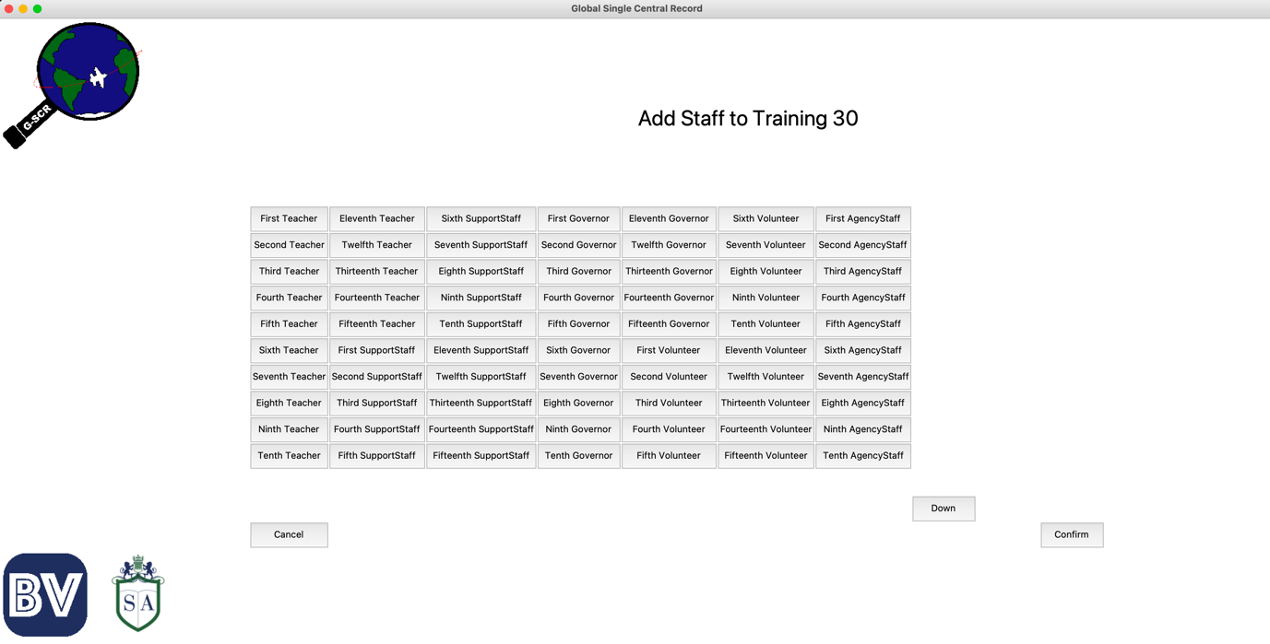Back to testing the ability to add staff. Here is what now happens when add staff is pressed.

Now I will select all Teachers, including Sixteenth Teacher I created earlier. This is what those screens now look like.

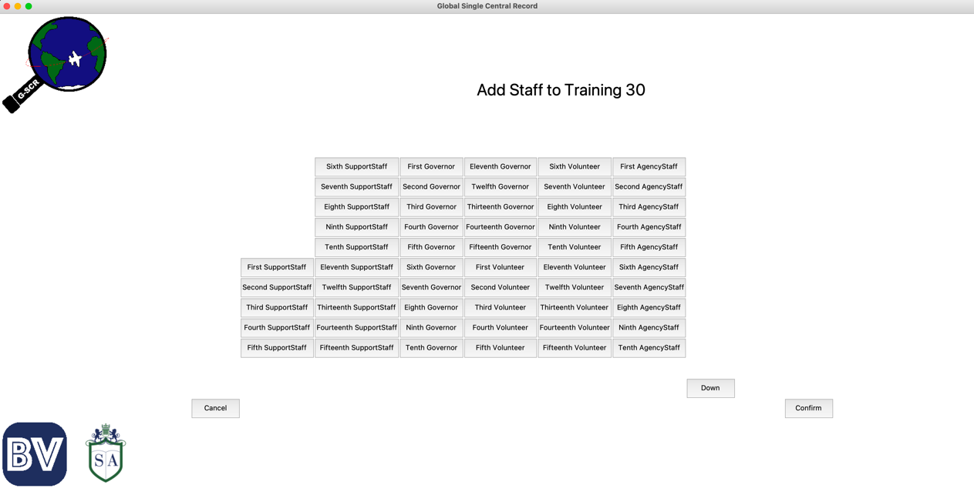

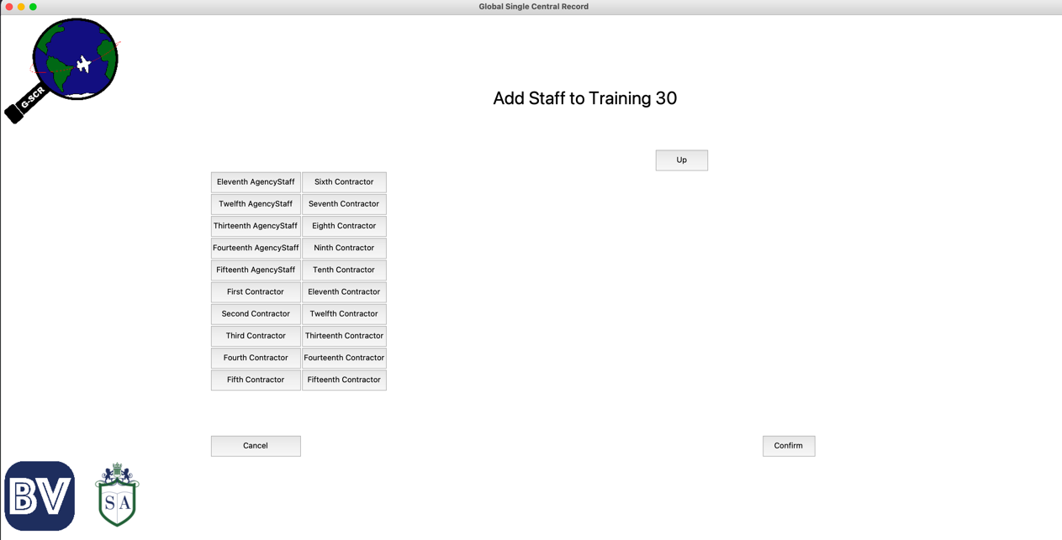

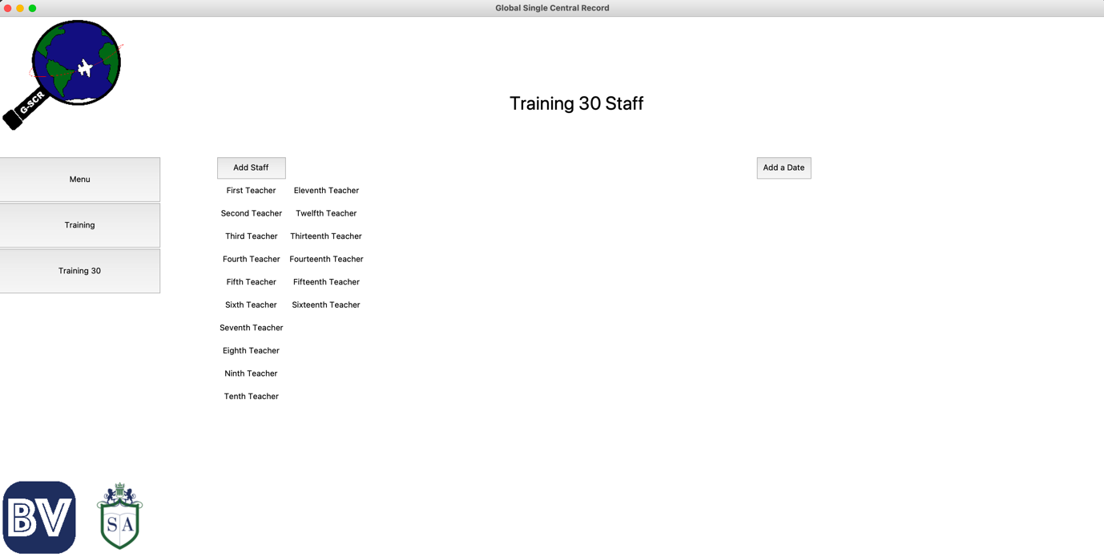After clicking the Confirm button, I should now be able to see all these staff members listed.

Which I can.

If this worked, I should also be able to see this as new records in my staff_training table of the database.

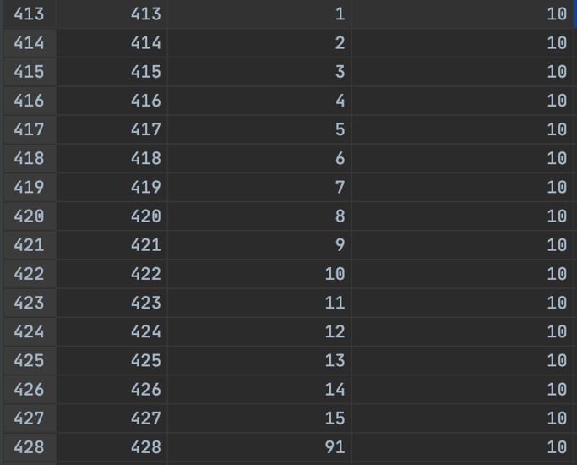

Which can be seen above.

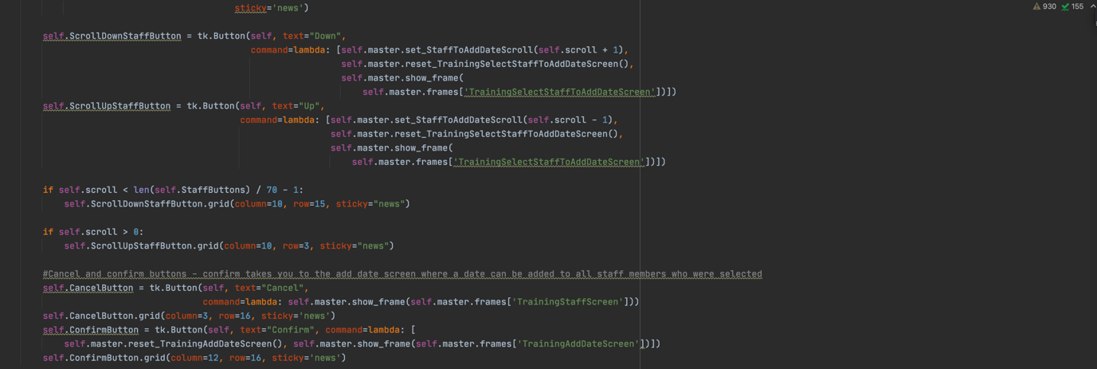Now I need to be able to add a date for whichever staff members I select after clicking the Add date button. The code for selecting staff members for this can be seen below.

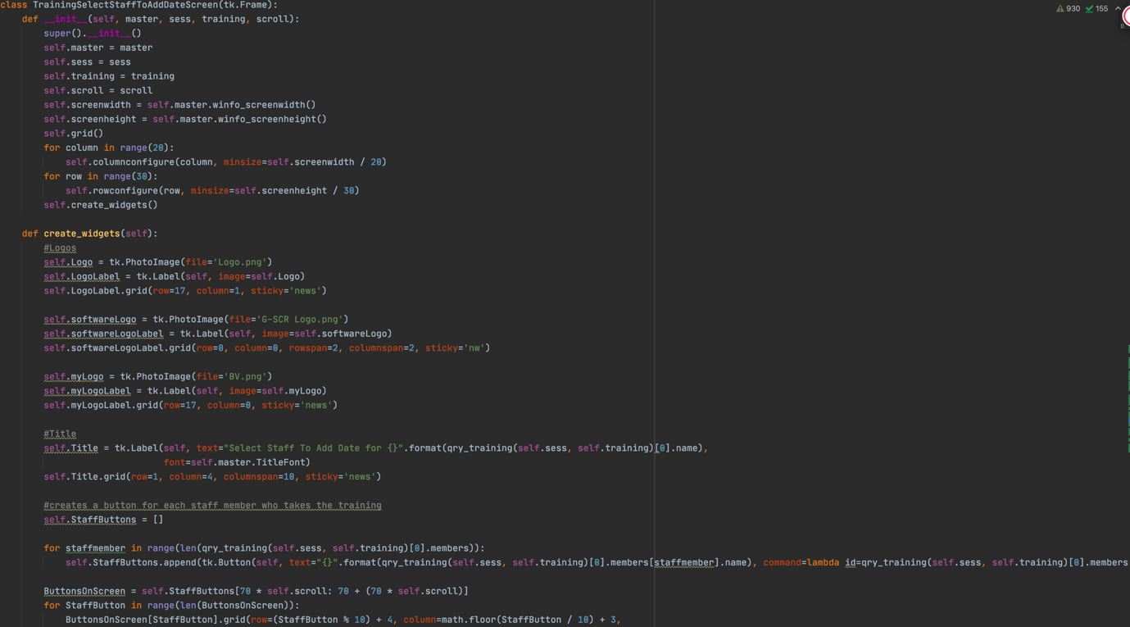Before I test this, I will show the code that will allow a date to be added so that I can test all of this together. The code for this is below.

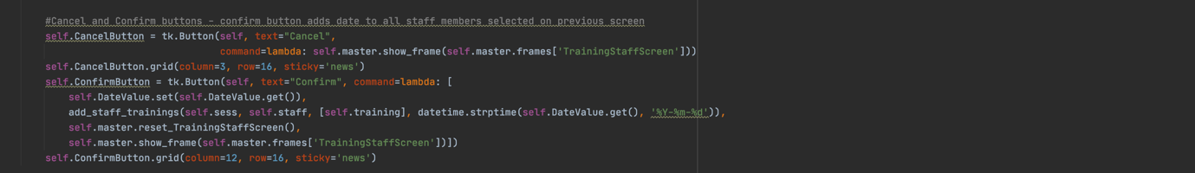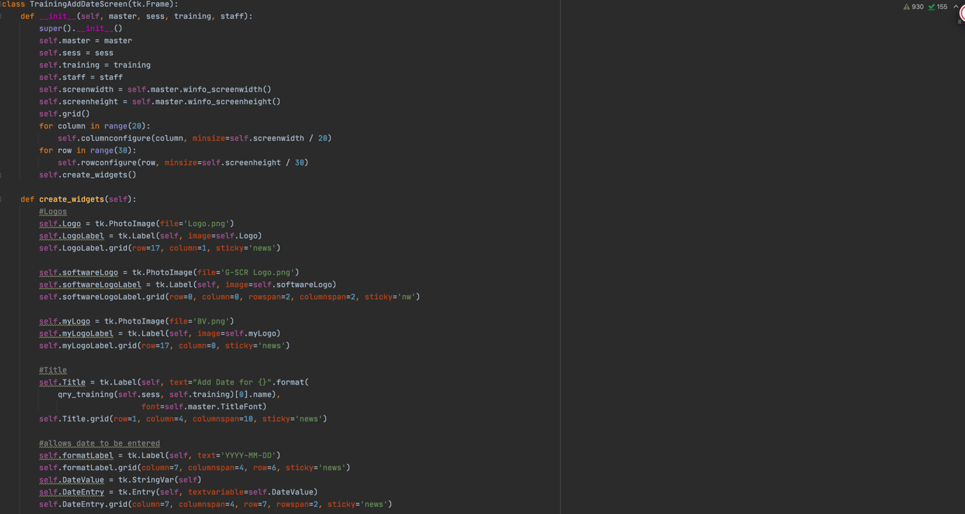

Now I will test both screens by adding the first five teachers, as well as teacher 16.

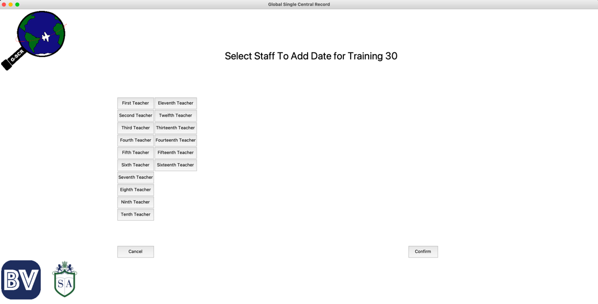

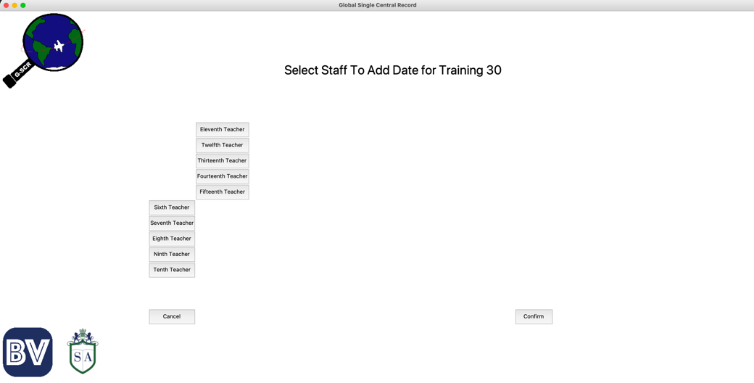

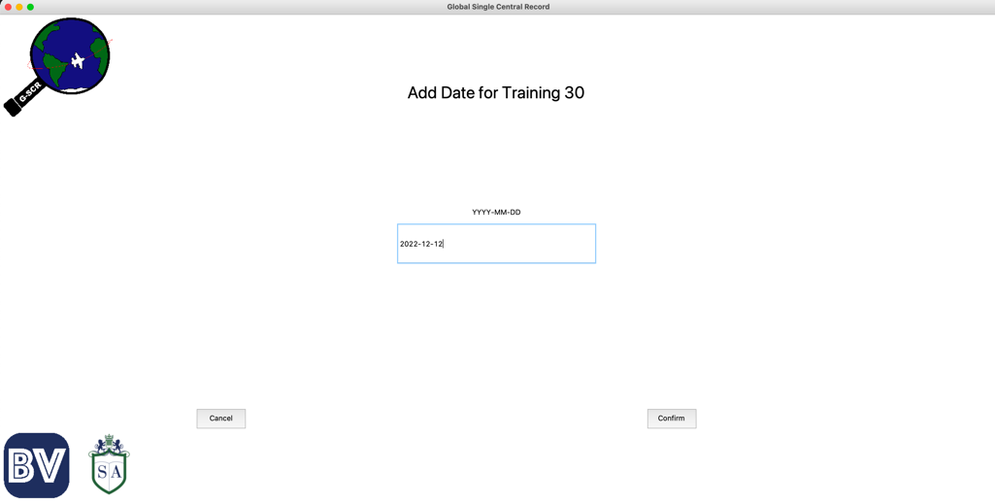

Again, I can see if this worked successfully by checking if it made new records in the database.

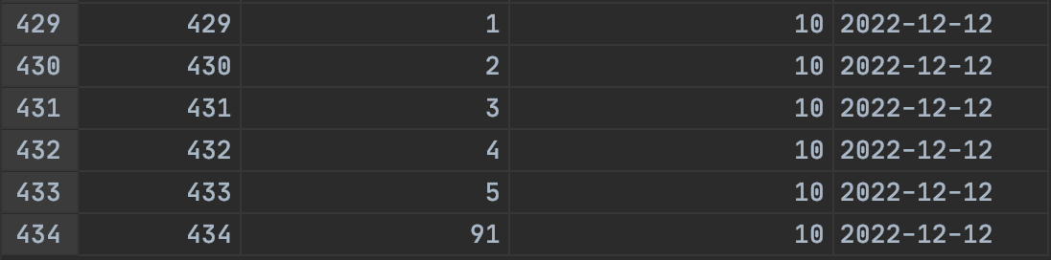

Which it did.

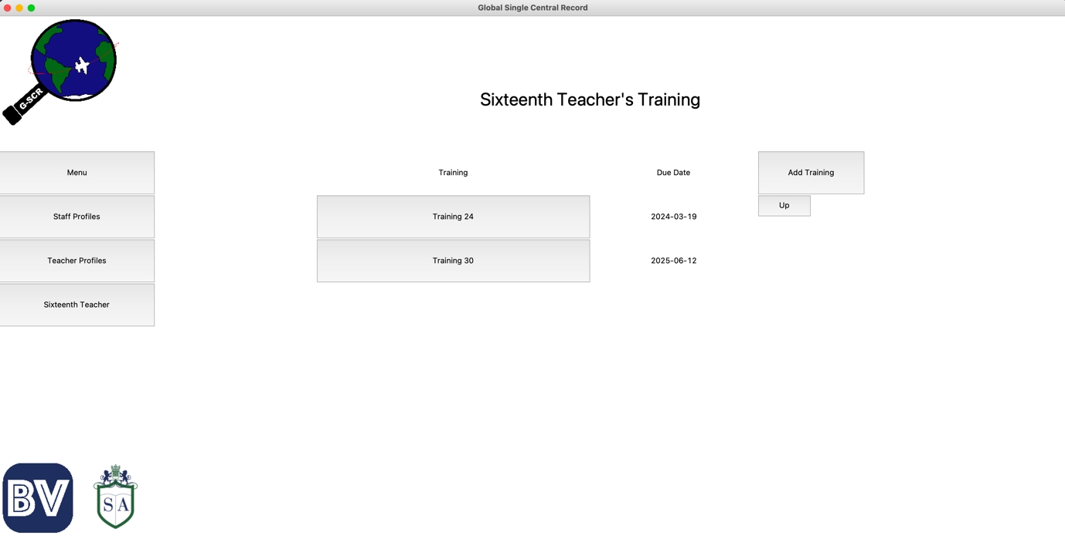I can also check the profile of one of the staff members to see if this worked. I will check Sixteenth Teachers to see if the training is there with the correct due date.

Which it is.

Now that I have finished the training section, I can now start on my last section. The notifications section.

### Notifications Section

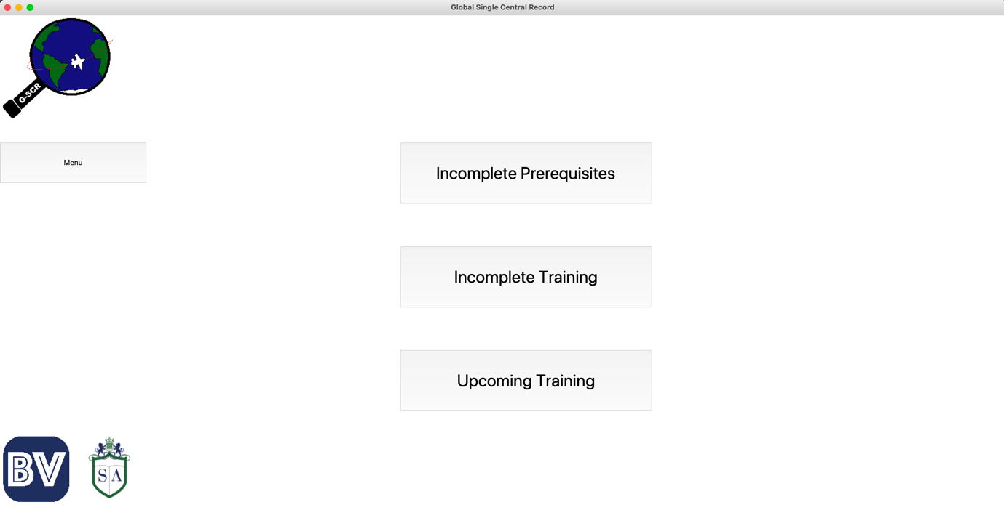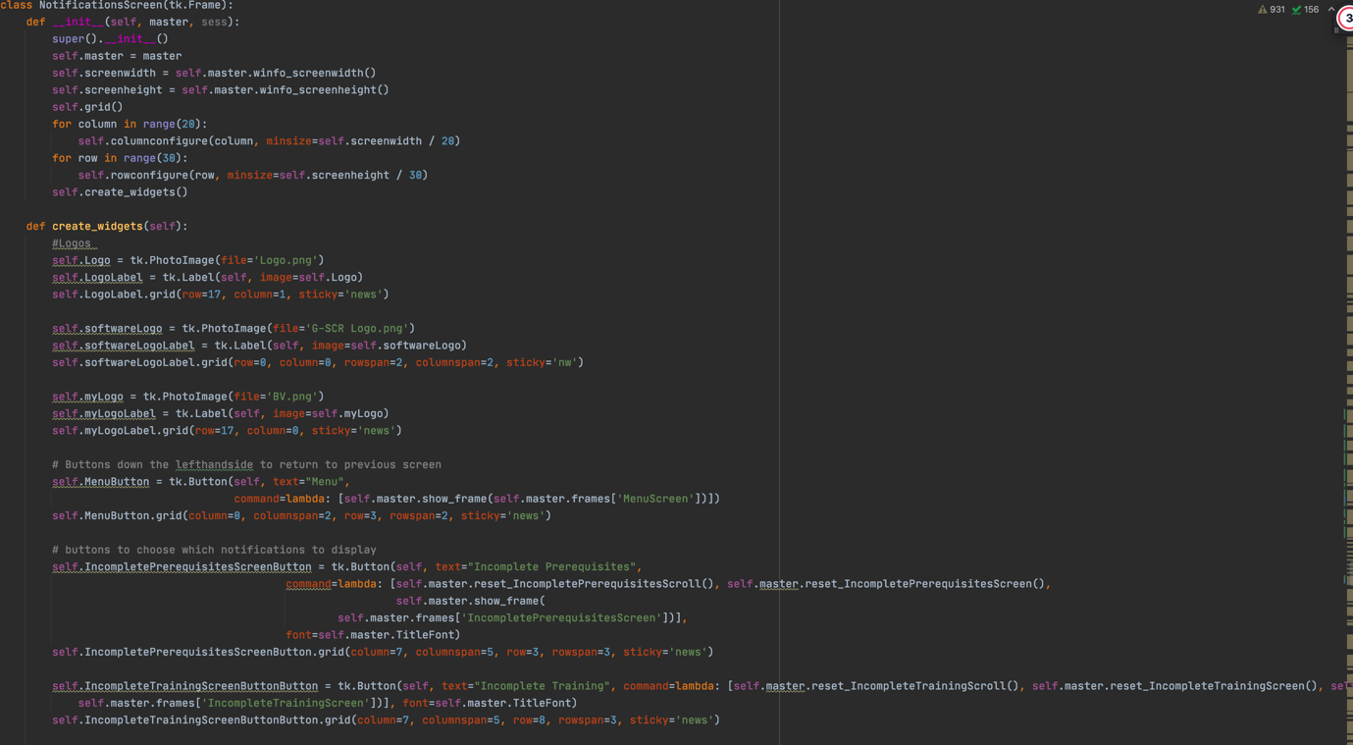The first screen for this is the one with the different options for the type of notifications. The code and resultant screen can be seen below.

Next I will create the Incomplete Prerequisites Section. As this is a series of screens, I will show all of the code for this section followed by the different screens.

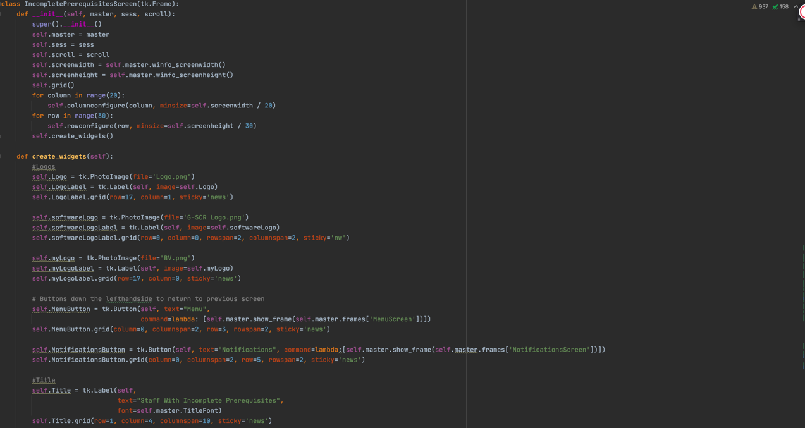

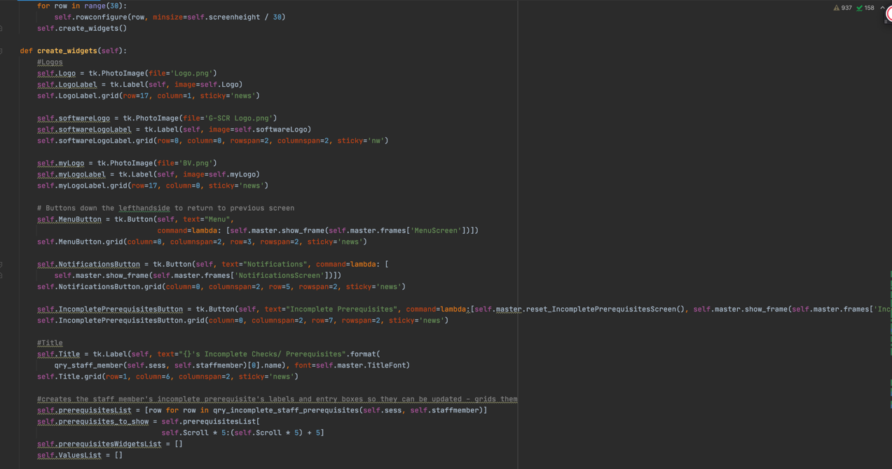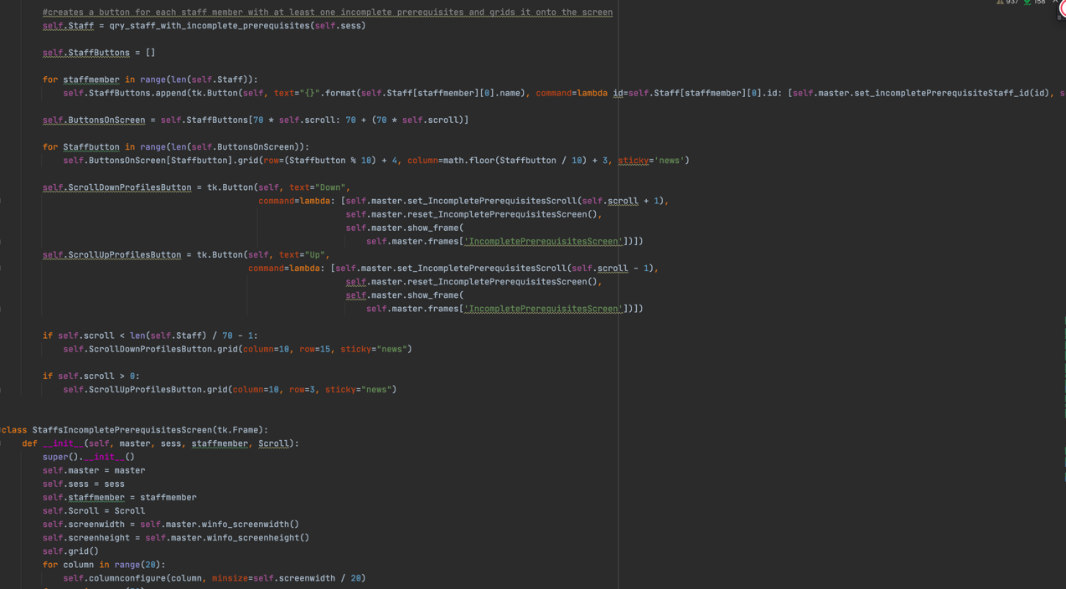

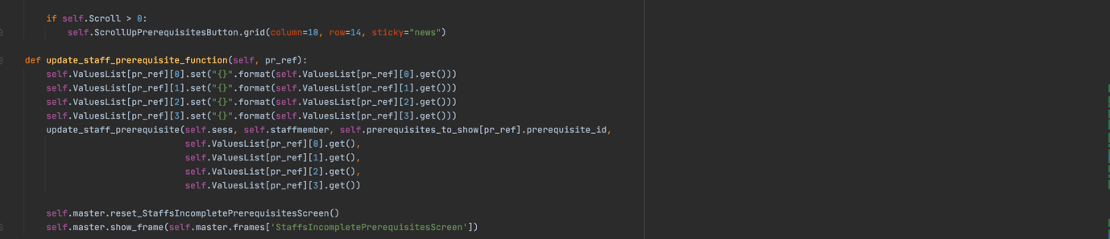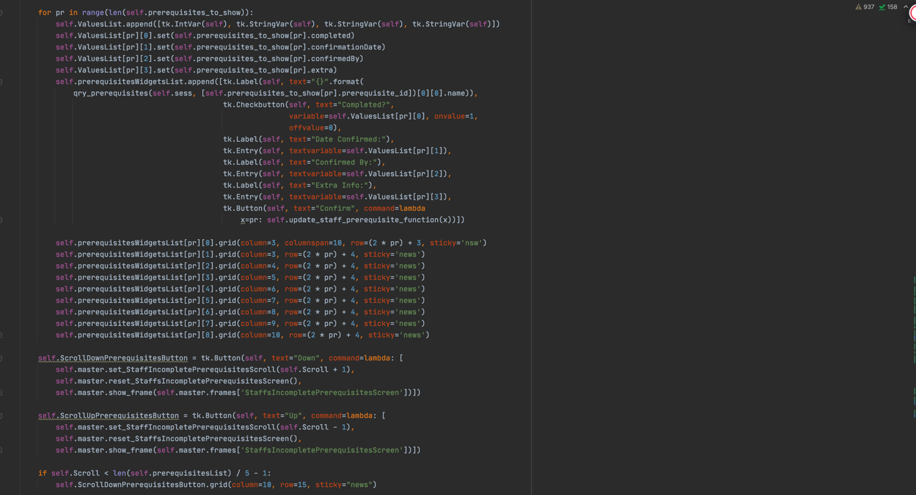

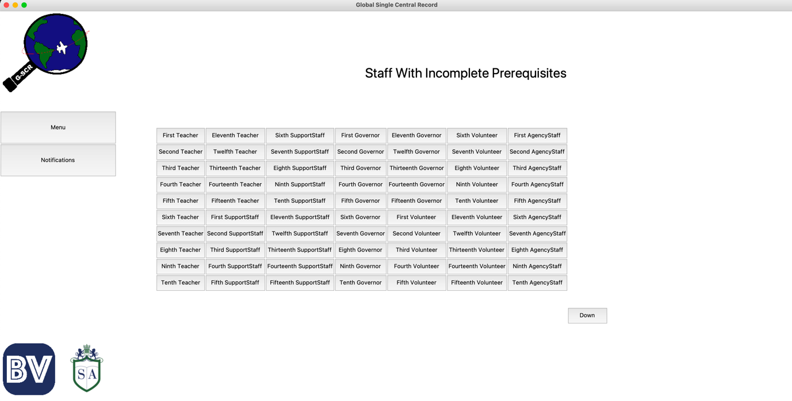Here are the Screens for all staff members with incomplete prerequisites.

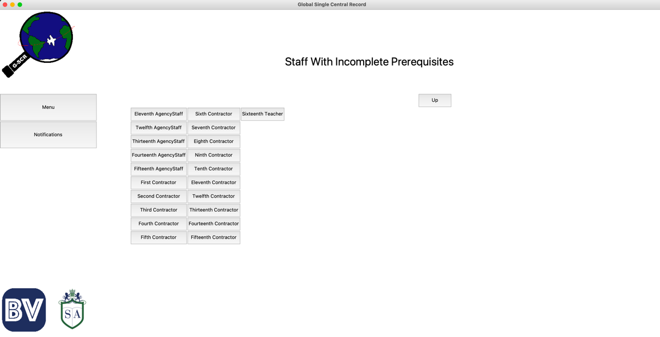

Checking Sixteenth Teachers Incomplete Prerequisites, we should see them all except identity check, since we marked that as completed earlier.

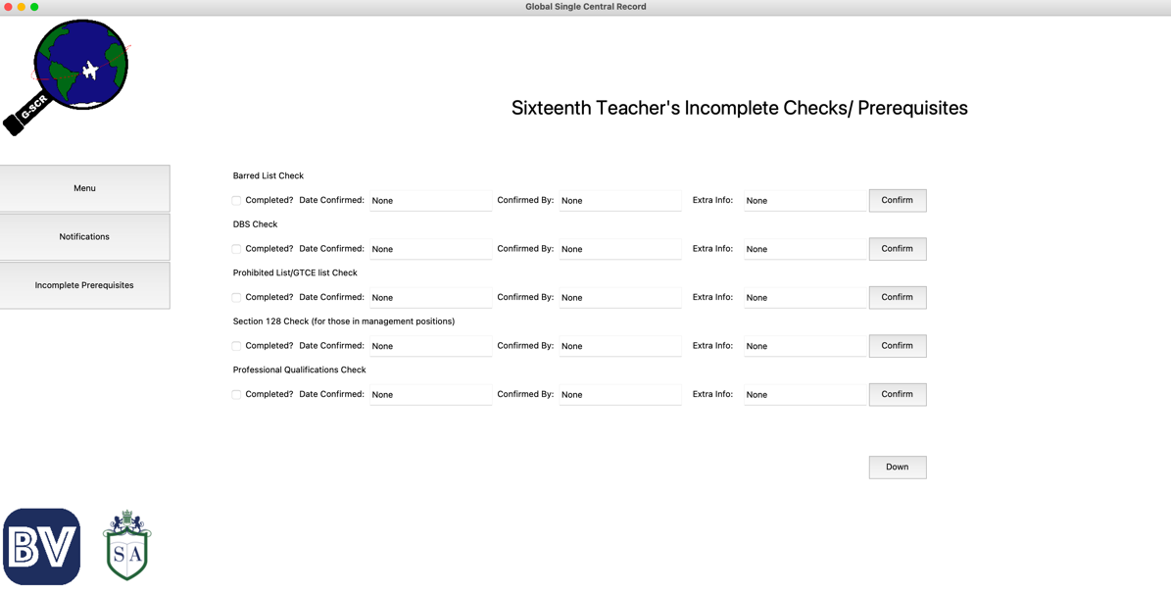

It seems to have worked, but to make sure that this is not just a bug, I will mark some more prerequisites as completed to see if they also disappear.

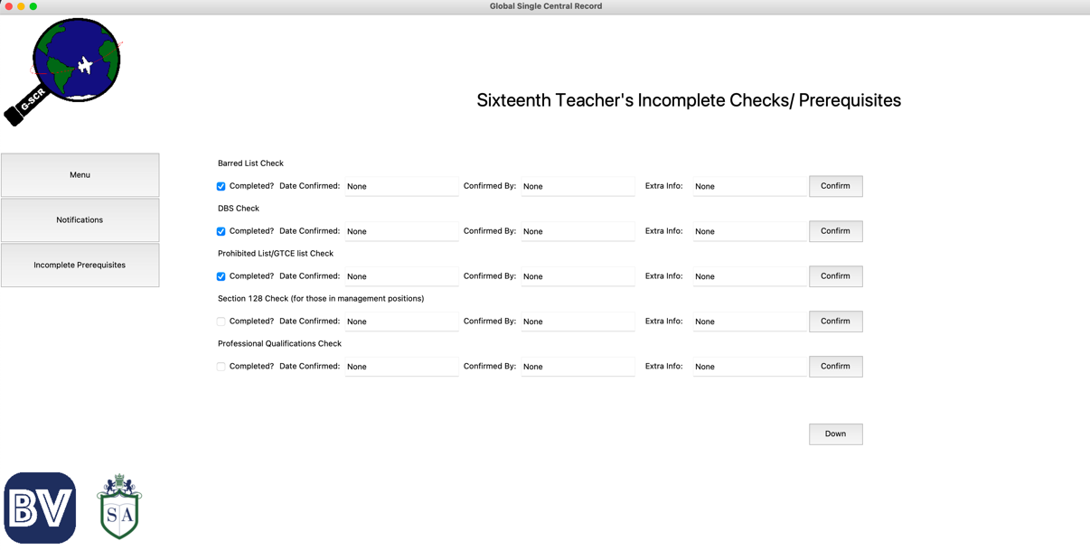

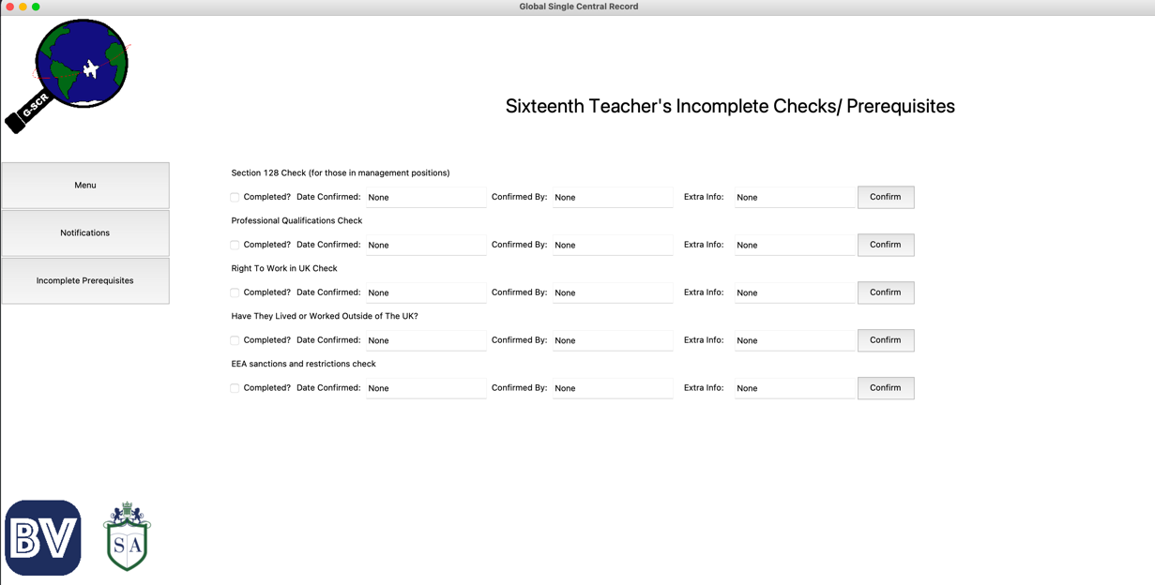

Which they did.

Now, I will mark all prerequisites as completed in the hope that Sixteenth Teacher no longer appears in the incomplete prerequisites section.

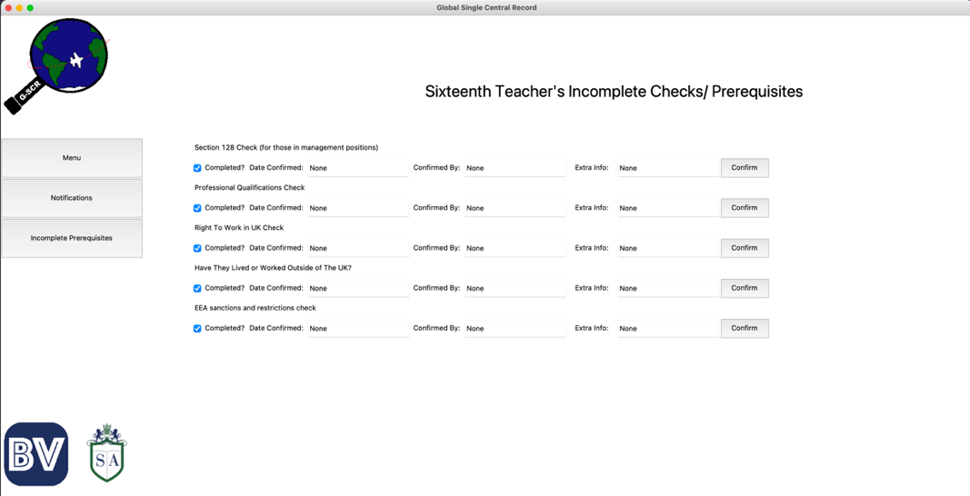

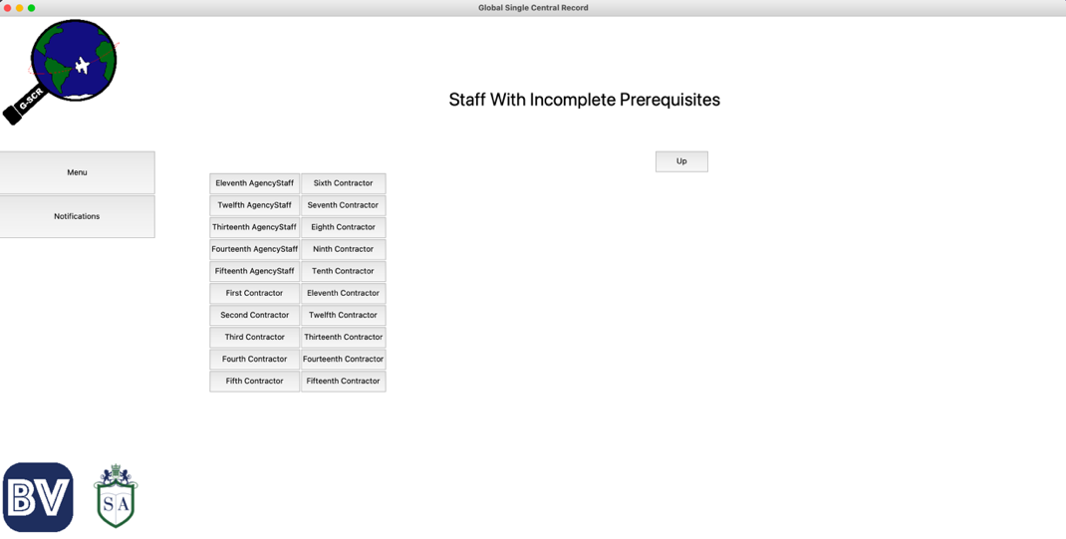

Which it doesn't. To make sure that these updates were actually made to the database, I will check the staff_prerequisites table.

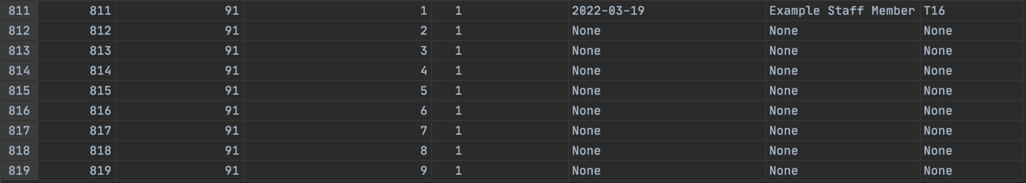We can see here that this was successfully committed.

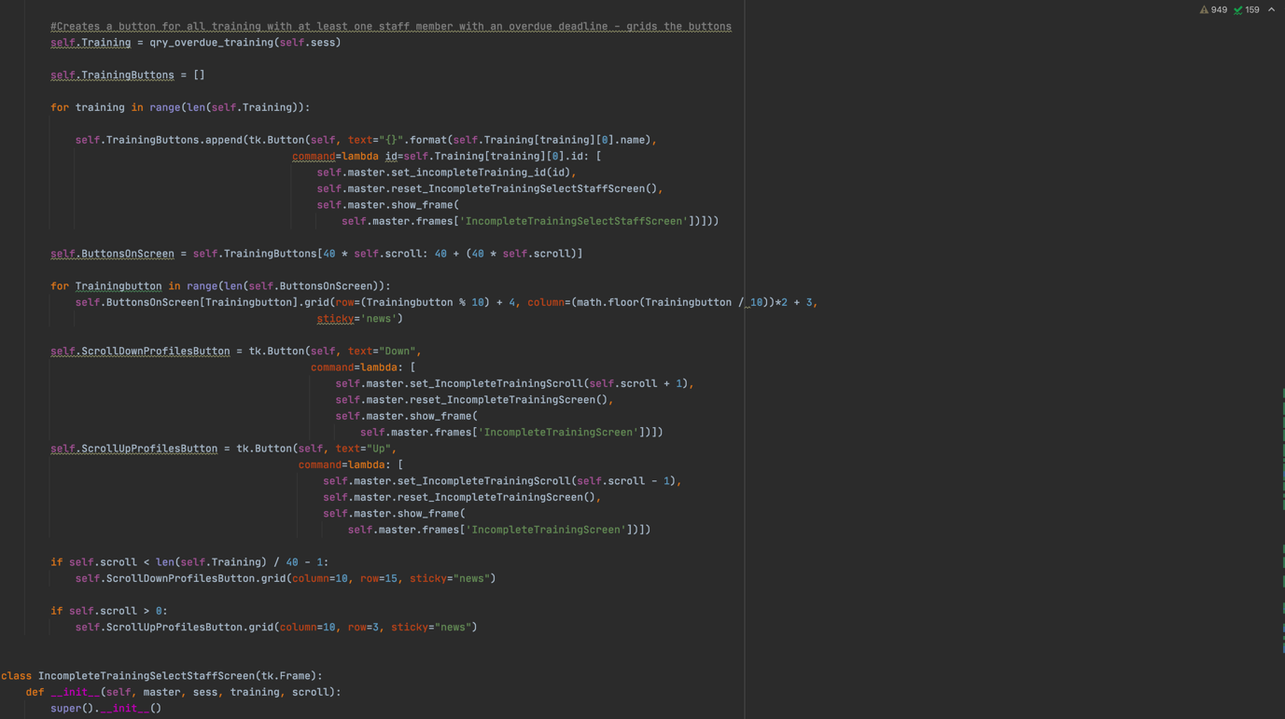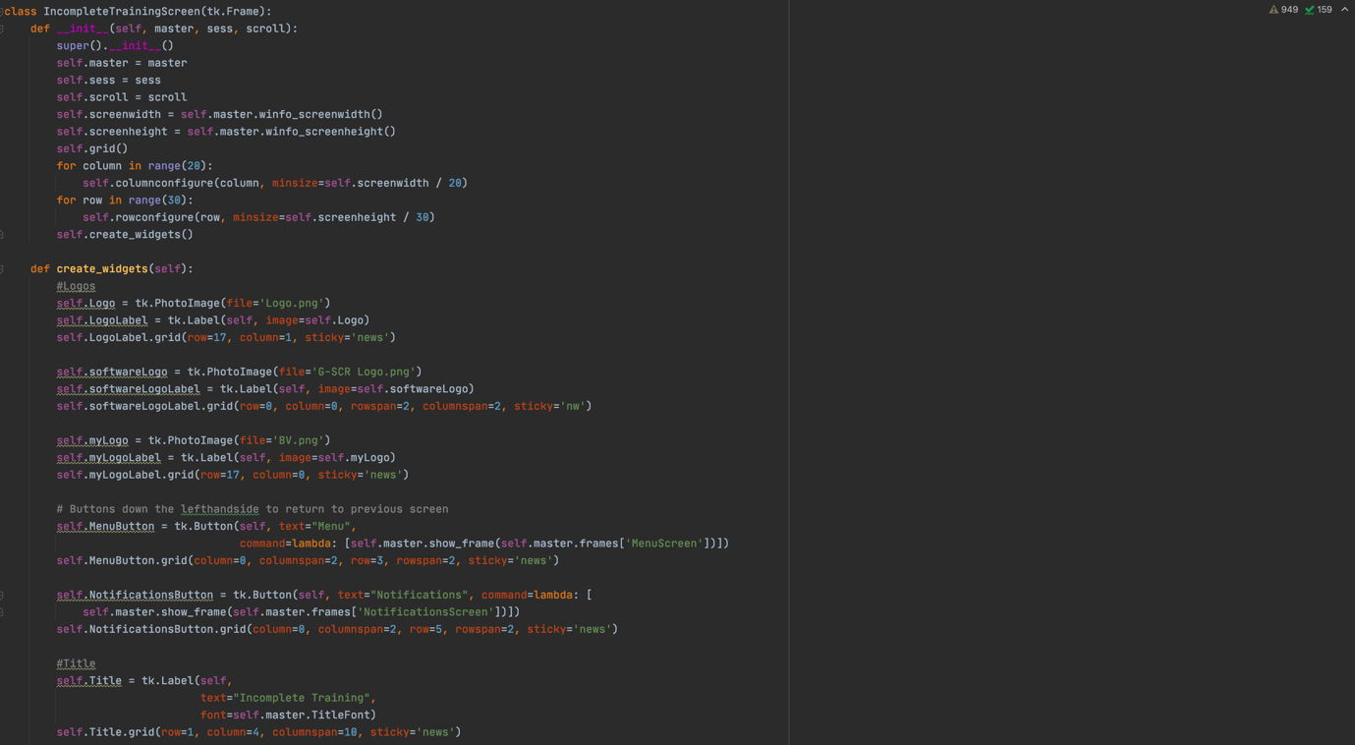Next is this Incomplete Training Section. Again, this is composed of multiple screens and so I will show all of the code first, followed by the testing of the screens.

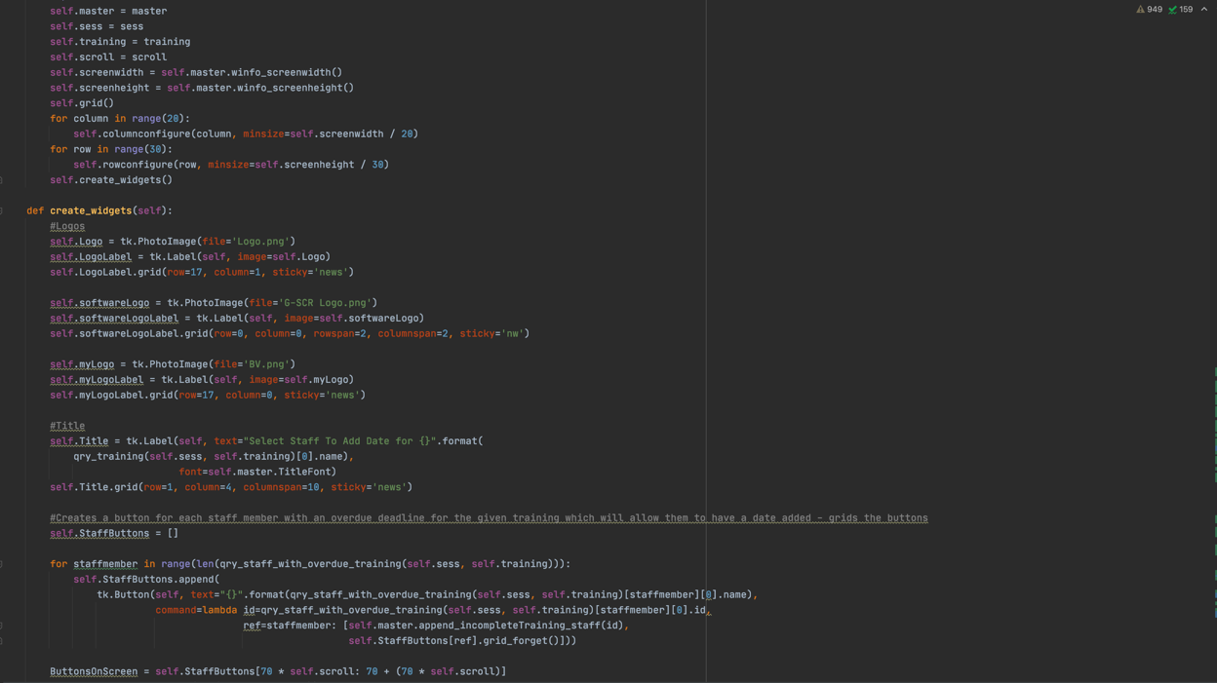

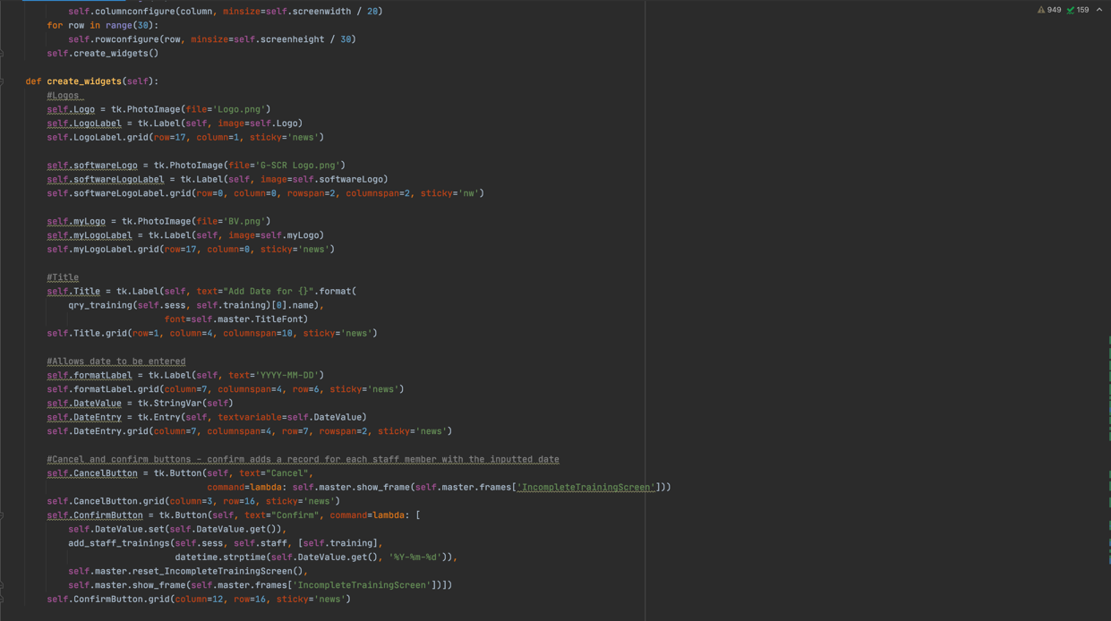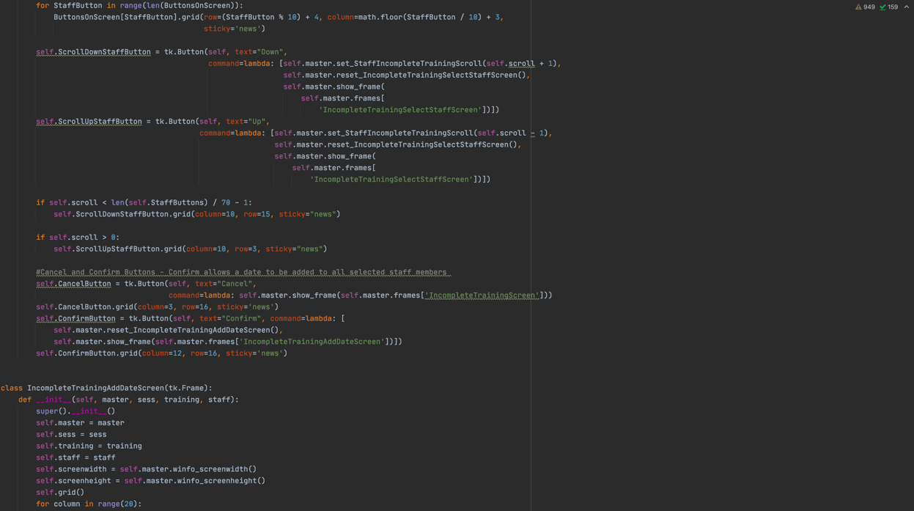

Since no staff currently have overdue training and I do not intend on waiting months for this to occur, I will add some trainings to all the teachers so that the due date for the next completion has already passed

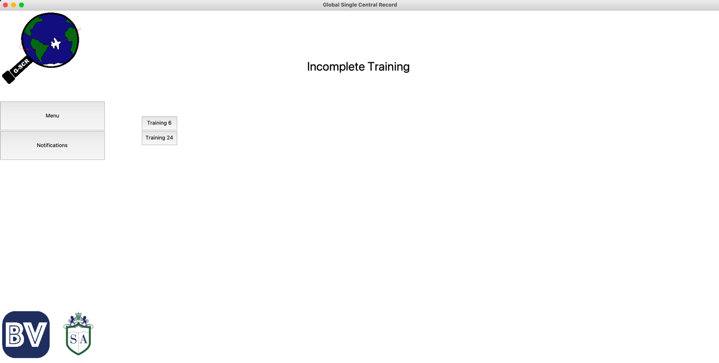Adding All Teachers to Training 6 and 24 with an expired due date. This is how the Incomplete Training Screen now looks.

And This is how it looks when the Training 6 Buttons is pressed.

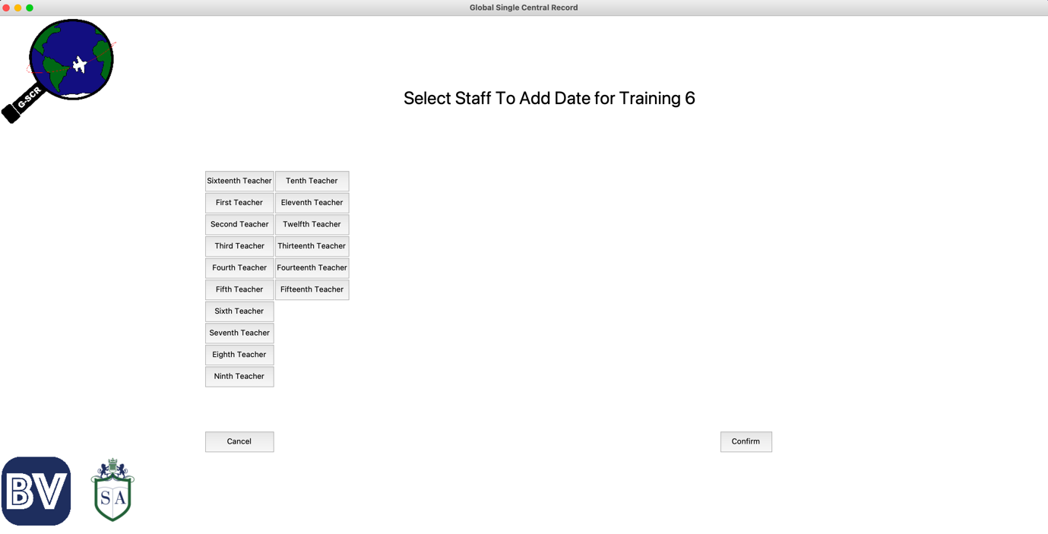If I select Teachers 1-5, This is how the screen looks

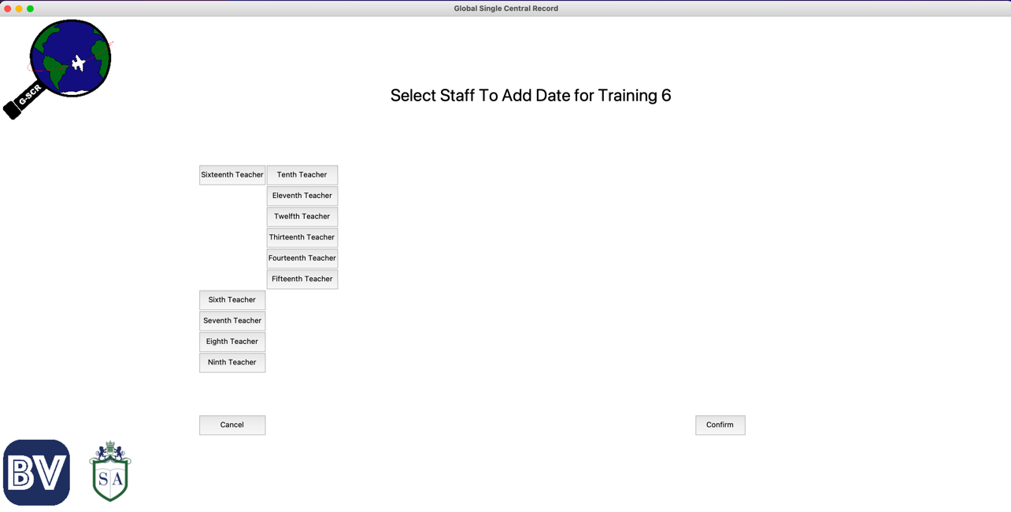

And here, I add a date to these chosen teachers which makes their training not incomplete.

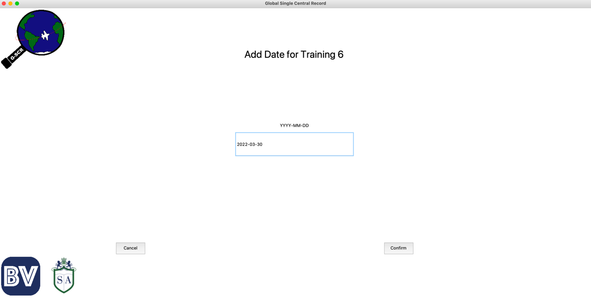

If we check back on the previous screen, these teachers should no longer be there.

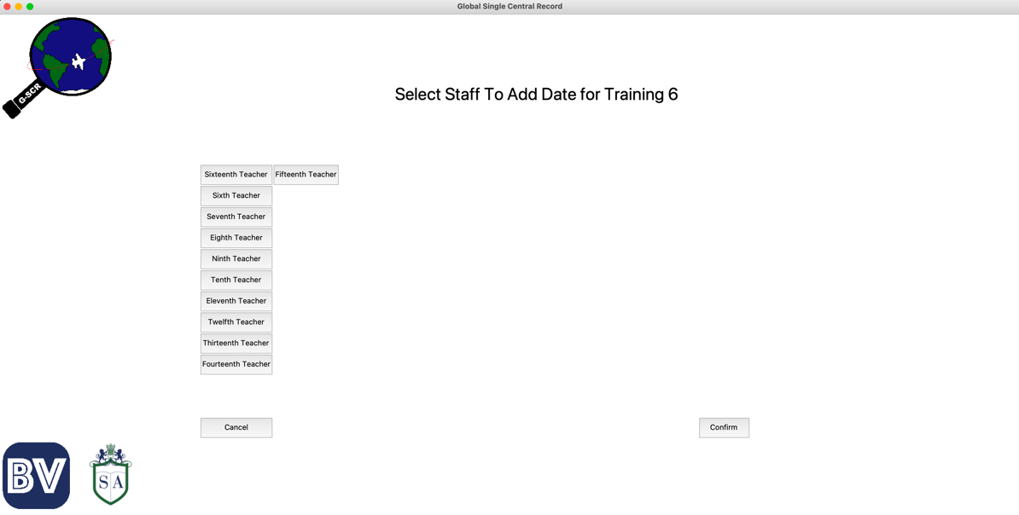

And here we can see they are gone.

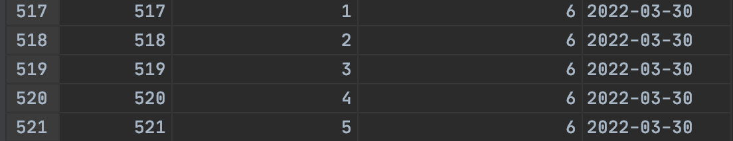We can tell if this actually worked by checking if new records were added to the staff_training Table of the database.

And here they are.

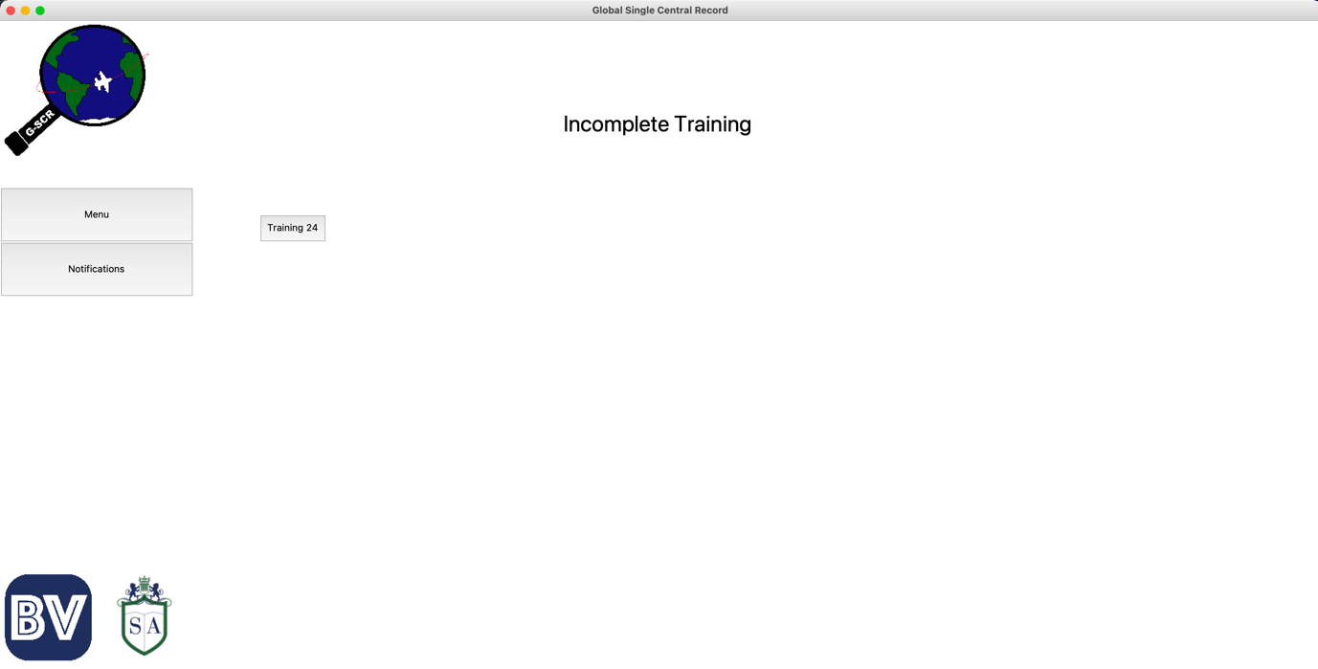Now, I will add a new date to all the other teachers in the hope that Training 6 no longer appears on the Incomplete Training screen.

And we can see that this has worked.

We can also see these new records in the staff_training table.

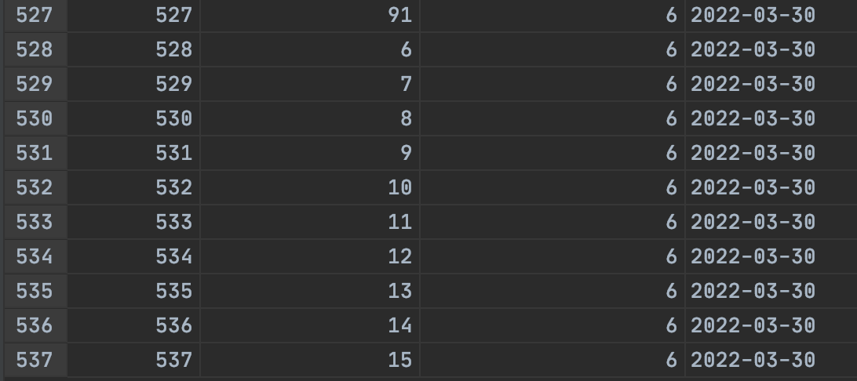

The last section is the Upcoming Training, which works largely in the same way as the Incomplete Training Section.

As I have done previously, I will show all the code for this section, followed by the tests.

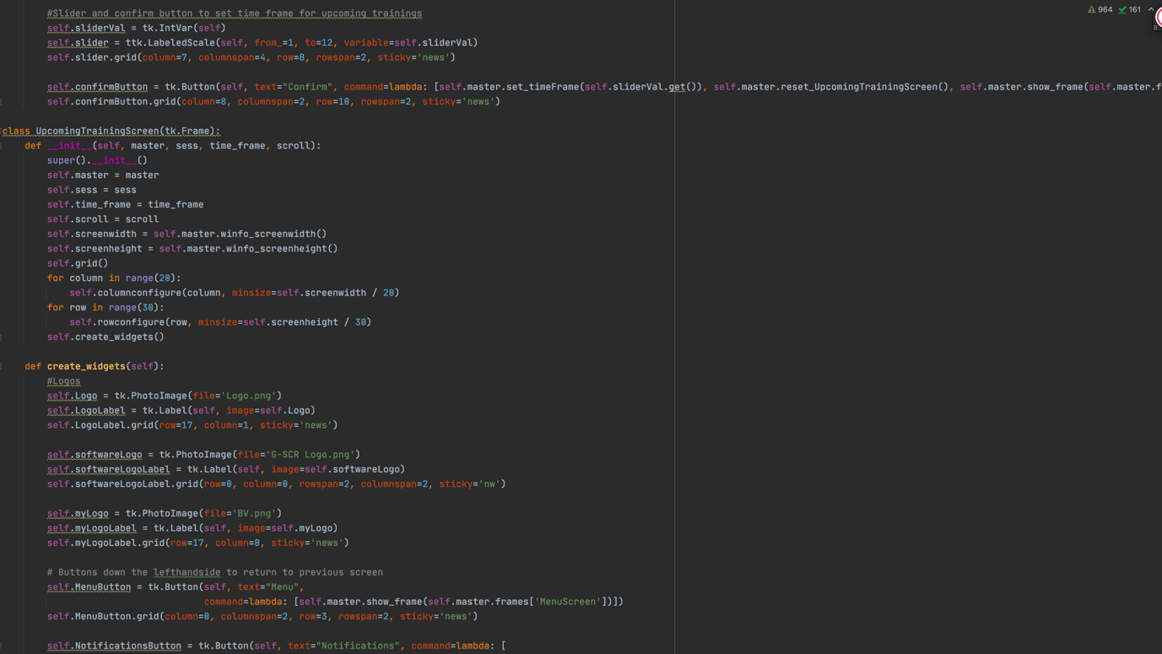

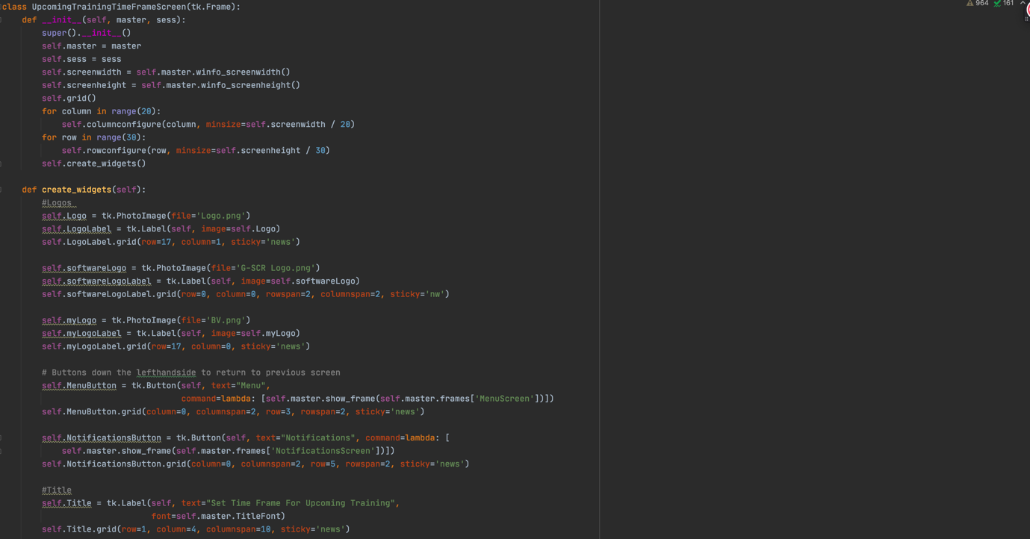

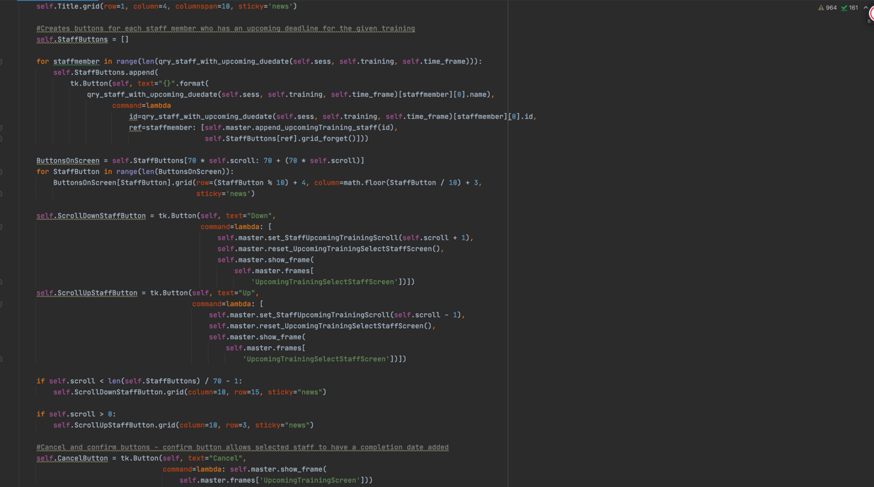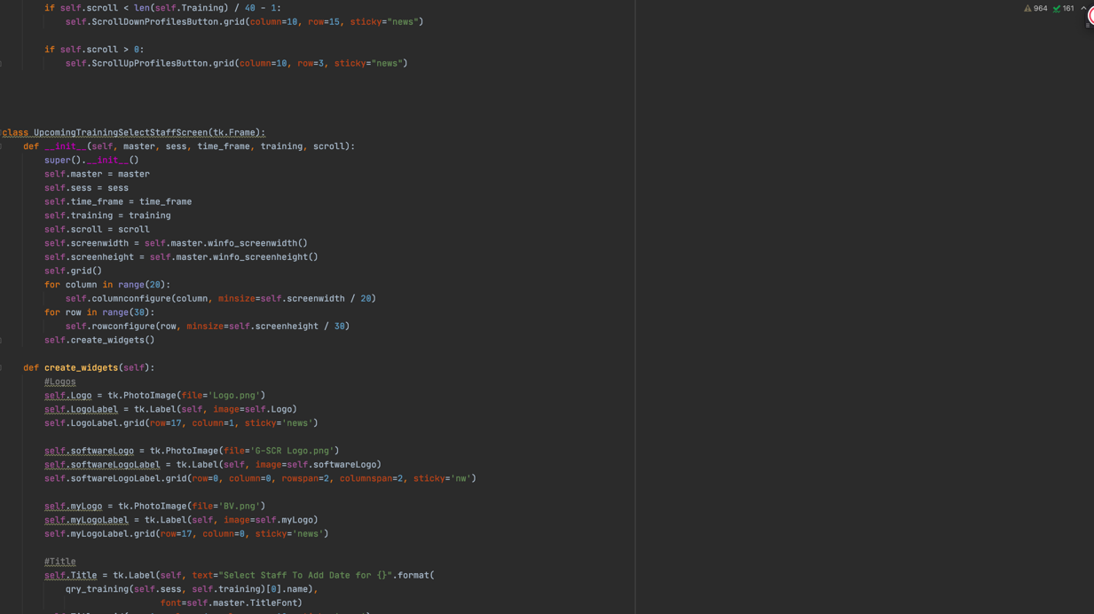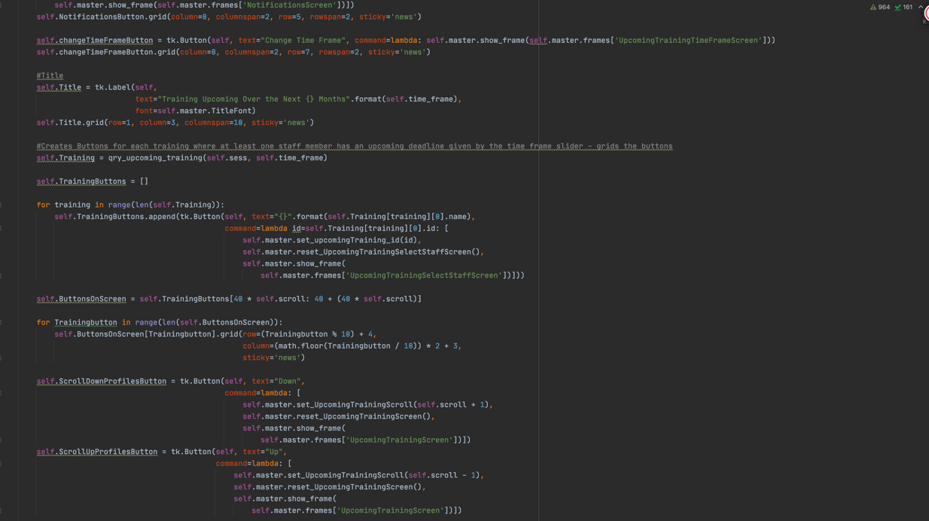

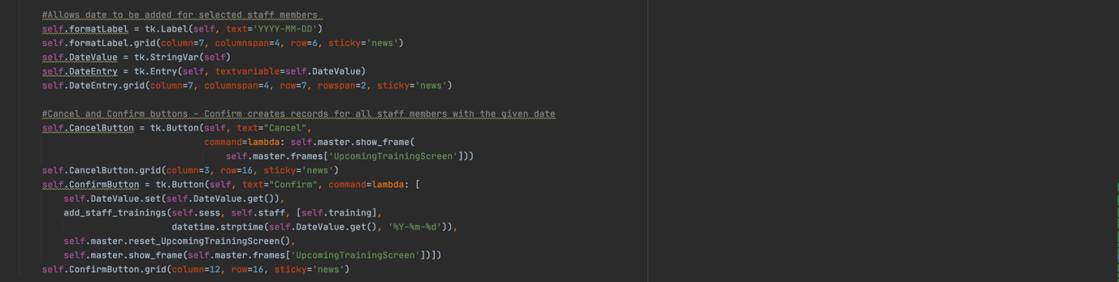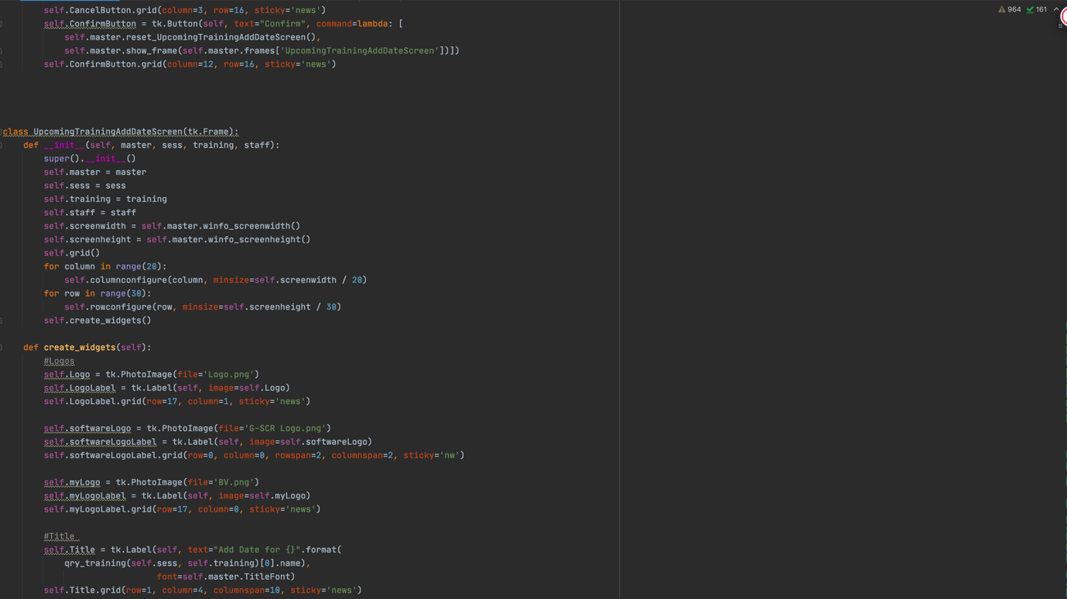

Here is the screen that allows the time frame to be set for upcoming trainings.

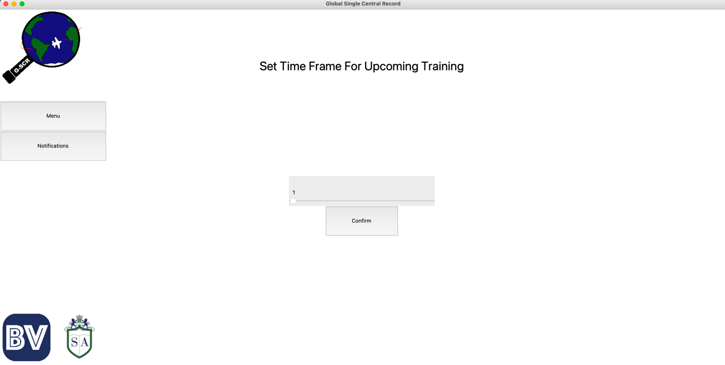

I will show how different time frames will show a different number of Trainings. For example, 3 months:

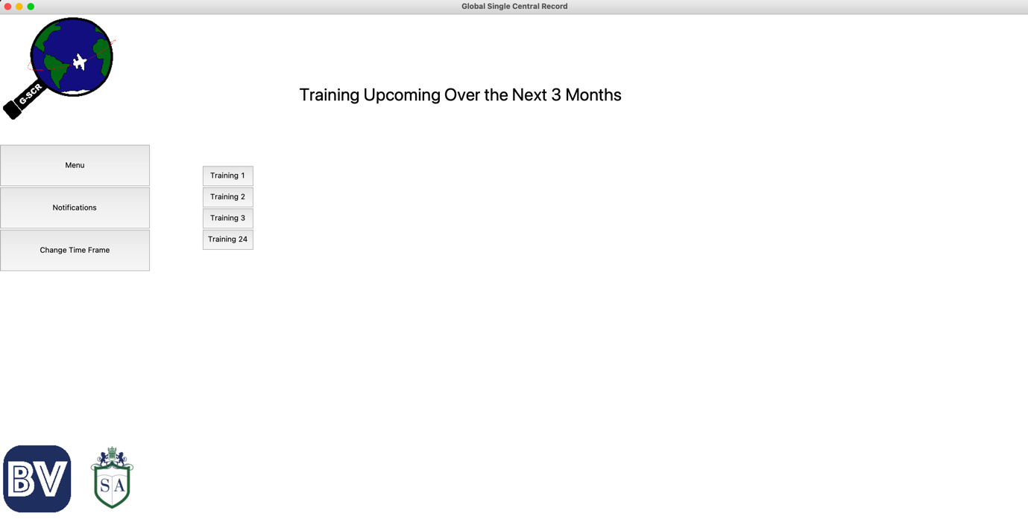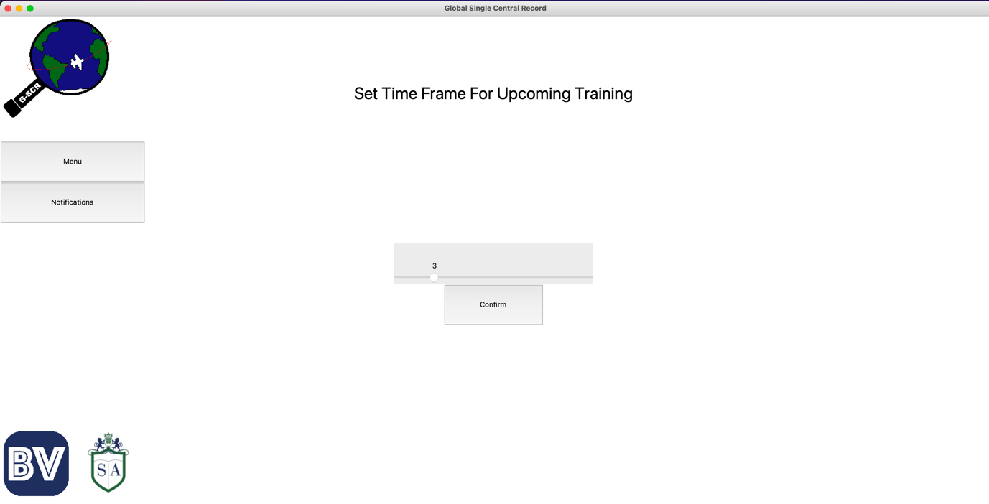Displays 4 Trainings.

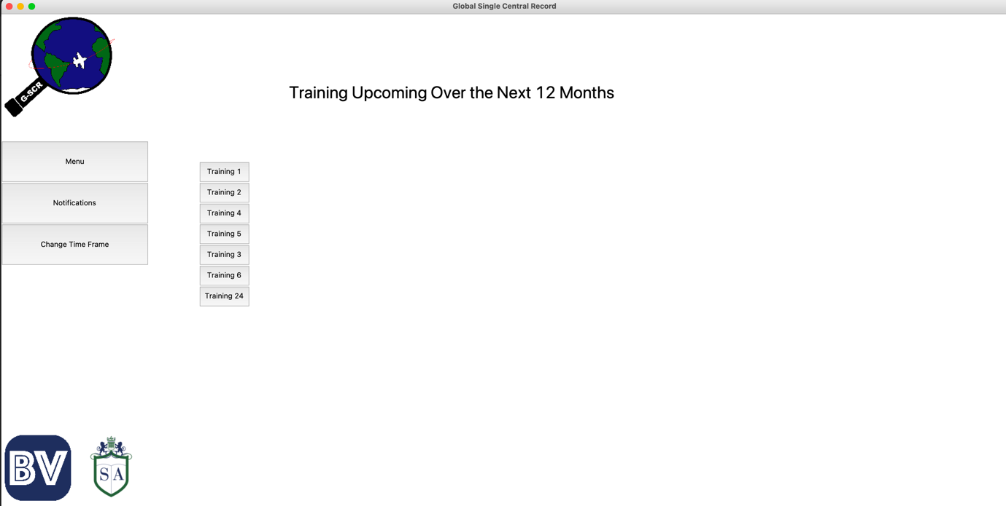However 12 months: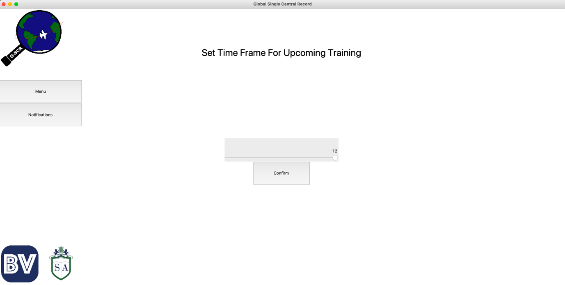

Displays 7 trainings. This makes sense as, the larger the time frame, the more trainings will have expired, and so will need to be completed.

Since the code is the same for the Incomplete Trainings section, I’m only going to test that when training dates are added, they appear in one time frame but not the one before. For example, I will add dates for Training 1 so that it appears in a time frame of 6 months but not 5 months (or 4 months, 3 months, etc.)

After setting the dates for Training 1 so that all deadlines are between 5 and 6 months, this is how the screen looks with a time frame of 5 months.

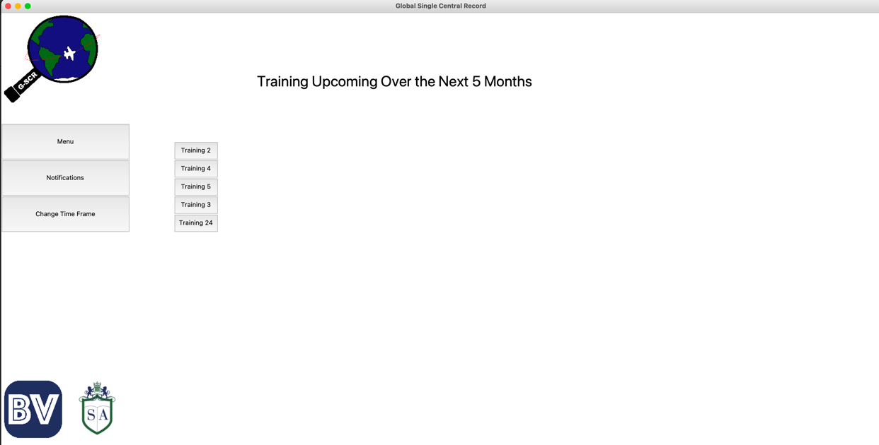

And this is how it looks with a time frame of 6 months, which should now include training 1 since the staff’s qualification for this training should have expired by this time.

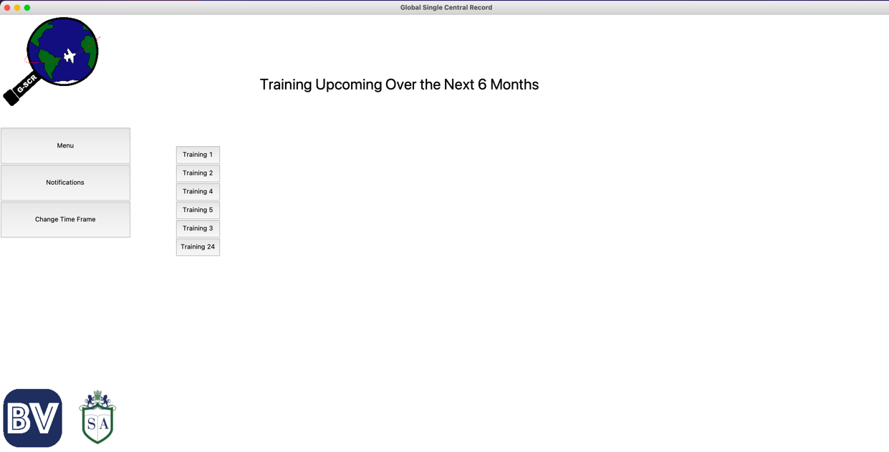

And there Training 1 is.

I will do my last test using Training 2. For this, I will add a date of completion for only some of the staff members so that, while the training should appear both before and after this new date of completion, only the staff I did not add the date for should show up where the time frame is before the deadline for the staff I added a new date of completion to.

This is what happens when I set the timeframe to 10 months.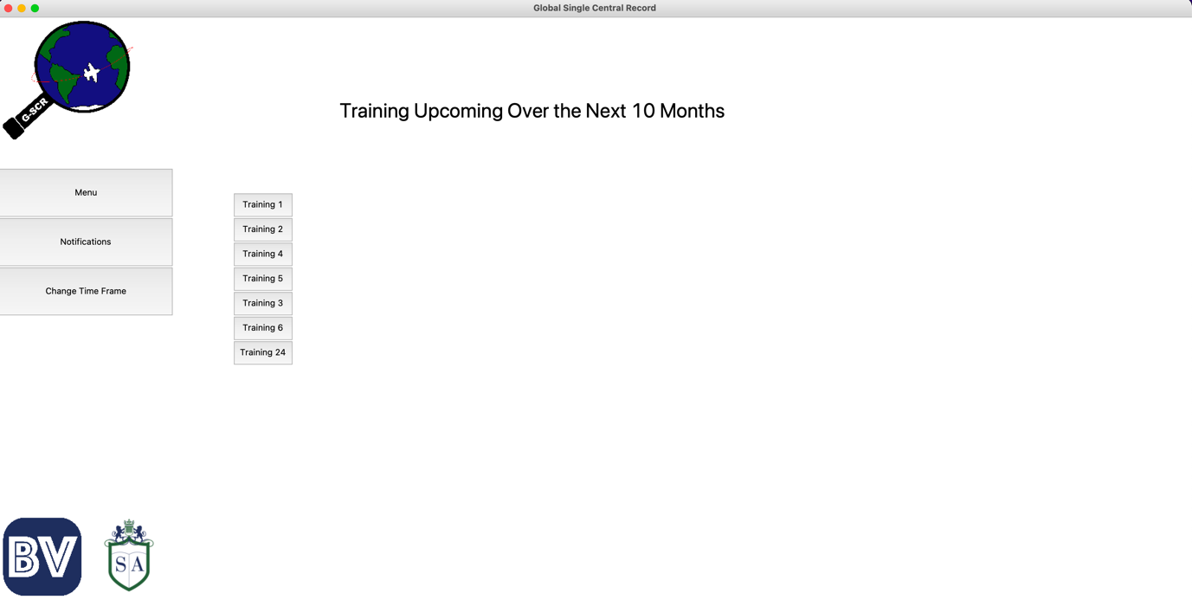

And here are the staff that come up once the Training 2 button on this screen is clicked.

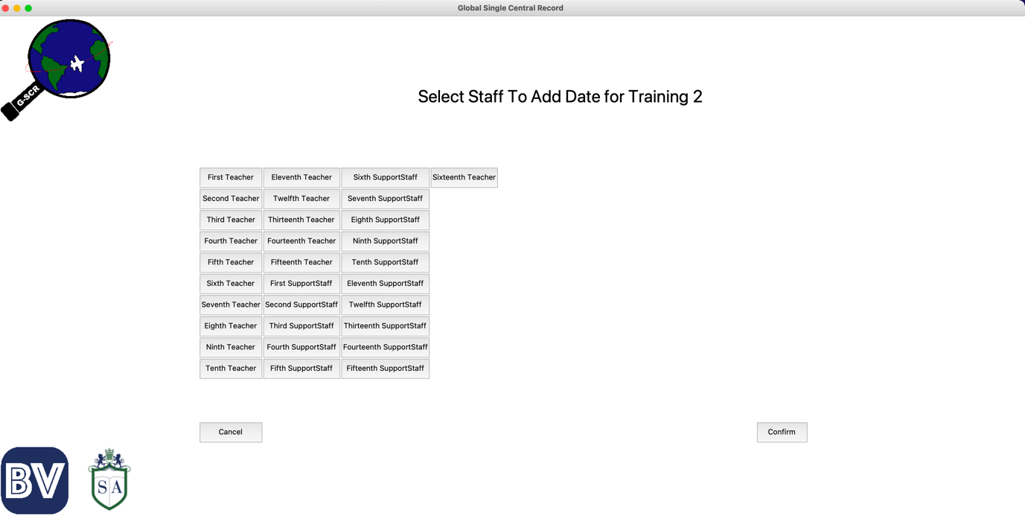

And now, I will show what happens when the time frame is set to 11 months.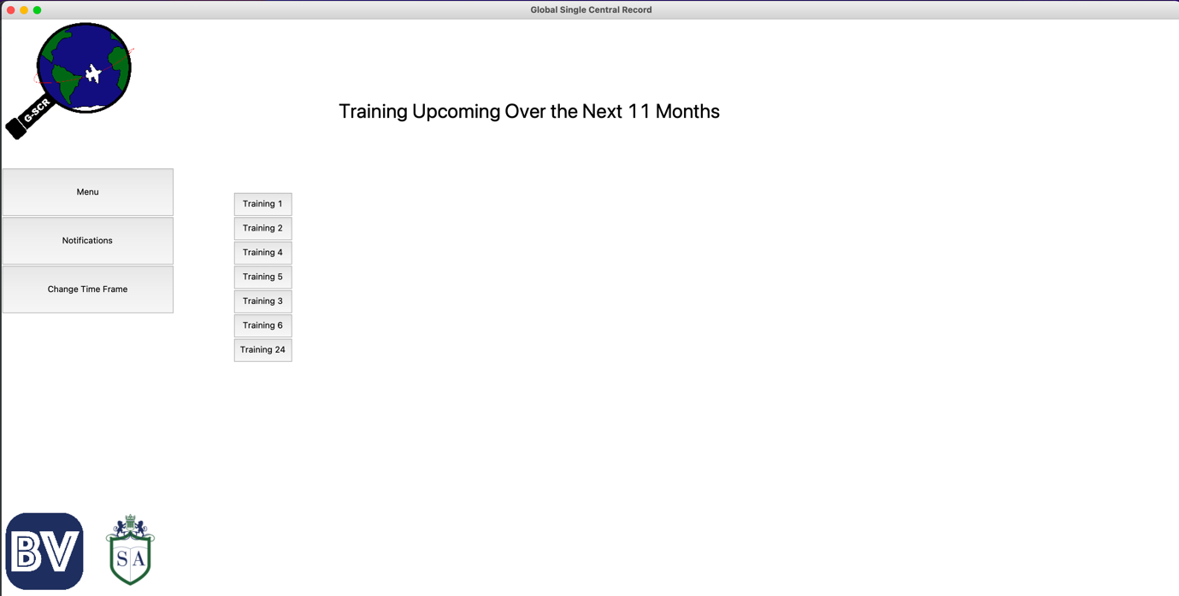

However, there should be more staff members when Training 2 is clicked as there should be more staff members whose qualification should have expired by this time.

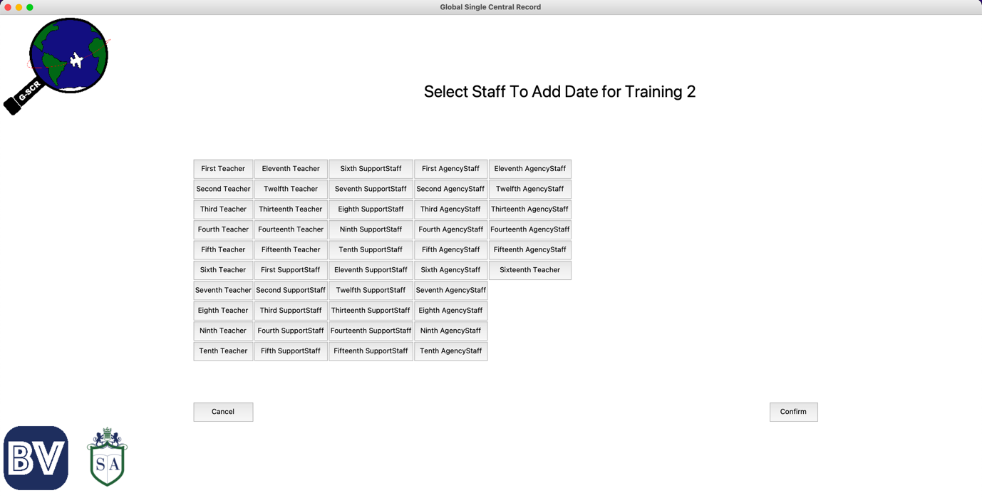Which there is.

## Final Update on Testing Checklist

Now that the GUI is finally completed and tested, it is time to show how my testing checklist is looking.

|  |  |
| --- | --- |
| **Action to test** | **Working?** |
| Buttons on the Home screen take you to the relevant page | ☑ |
| Buttons on the Staff Profiles screen take you to the relevant staff type section, and the Home takes you to the home screen | ☑ |
| Profile (and training) buttons can be scrolled through and pressing one takes you to the correct profile. Directory buttons work | ☑ |
| Create [staff type] button takes you to the relevant staff creation screen | ☑ |
| Profiles only created when inputted data passes validation |  |
| Creating a staff profile (or training) will add all necessary records to the database | ☑ |
| Search Bar works by showing only profiles (or training) with a name similar to the input | ☑ |
| Buttons on a profile page bring you to the correct page for the correct staff member. Directory buttons work | ☑ |
| Information displayed on profile (and training) info pages are correct | ☑ |
| Prerequisites can be marked as done and have the information stored on them | ☑ |
| Training can be added to a staff profile from the profile’s training screen | ☑ |
| Dates can be added for when staff complete a training | ☑ |
| Staff can be added to a training from the training attendees page | ☑ |
| Dates for one or many staff can be added via the training profile | ☑ |
| Contacts can be created | ☑ |
| Contacts can be added to training | ☑ |
| Training can be added to contacts | ☑ |
| Contact creation works and creates correct records in the database | ☑ |
| Upcoming training can have time frame changed | ☑ |
| Query finds all profiles with incomplete prerequisites | ☑ |
| Query finds all incomplete prerequisites given the profile | ☑ |
| Query finds all trainings with staff members who have missed their deadline for it | ☑ |
| Query finds all staff members who have missed the training deadline given the training | ☑ |
| Query finds all trainings with staff members who need to have it done within the time frame selected | ☑ |
| Query finds all the staff members who need to have training redone within the time frame given the training | ☑ |

Unfortunately, I did not have time to add validation for inputted data. However, this is something I will definitely add in the future.

## Stage 7 - Stakeholder Testing

For the stakeholder testing, I will give each stakeholder a copy of the software and then ask them to fill in a questionnaire to get their feedback.

I should mention here that when the software is fully completed and ready for commercial use, an instructional video will be used to train users on how the system is operated. An instructional video like this was not sent to the stakeholders and so they will be using the system based off intuition alone.

### Questionnaire

These are the questions that I asked my stake holders.

**On a scale from 1-10 (10 being the best), how easy did you find it to navigate the software? Please provide an explanation as to why.**

**On a scale from 1-10, how does this software compare to other software/ methods you have seen previously? Please Provide an explanation as to why.**

**What features did you like about the software?**

**What features do you think need to be added/ improved?**

**With the suggested improvements incorporated, would you suggest schools to use this software? Please provide an explanation as to why.**

I received the following responses:

**On a scale from 1-10 (10 being the best), how easy did you find it to navigate the software? Please provide an explanation as to why.**

Emily:

“9/10. Initially, it took some time to understand how everything connected and how to find what I was looking for. However, after some time using it, screens became much clearer in their purposes and I was quickly able to figure it all out.”

Alice:

“Probably an 8. I have seen systems where navigating them is beyond complicated. Relatively speaking, this software is much simpler and finding the information you are looking for is quite intuitive.”

Jonathan:

“8/10. With the big, labelled buttons and the titles on all the screens, it’s pretty clear where you are and where the buttons will take you. There was a slight grace period in figuring out how the system worked but this was short and not too complicated.

**On a scale from 1-10, how does this software compare to other software/ methods you have seen previously? Please Provide an explanation as to why.**

Emily:

“8/10. I have seen some more advanced systems, but this does the job well. While these systems do exist, most methods I see school’s use are complicated, inefficient, and ineffective. Relative to these, your software is great.”

Alice:

“7. The only school I have worked at is [My School], and so their system is the only one I’ve seen. Their system is a bit more advanced but I do still think that yours is decently effective and could be very useful to many people/ schools.”

Jonathan:

“7.5/10. I haven’t actually seen many systems that do this job and so there is not much for me to compare it to. However, yours does do the job well and has some good functionality so I’m sure it compares well against other methods.”

**What features did you like about the software?**

Emily:

“I like that everything is straight forward and easy to use. I especially like the notifications section as it makes it much easier to keep track of what actions need to be taken. I also really like the logos!”

Alice:

“I like many things but especially the Notifications section. Usually, I must meticulously go through rows in excel spreadsheets to figure out when I need to book training sessions and how many people will be attending, this makes that significantly easier.”

Jonathan:

“I like that everything is very simple and well structured. I see great use especially in the upcoming training section as this will be very helpful in allowing the HR department to keep on top of booking training.”

**What features do you think need to be added/ improved?**

Emily:

“I think there needs to be a way to create multiple profiles at a time, perhaps by uploading a spreadsheet? Also, I would like to see a more polished design in the final product.”

Alice:

“It would be good if there was a way to export the information as an Excel document or something similar. Maybe also adding multiple staff members at the same time by uploading a spreadsheet. The design could also do with a slight touch-up.”

Jonathan:

“Since the system knows which staff members need to have certain trainings and already stores their emails, it would be great if you could send out a mass email to let the staff know that they need to attend a training from within the software. Also, I would like a back button on the profile creations screens so that if I make an input error I do not need to go all the way back and re-input everything.”

**With the suggested improvements incorporated, would you suggest schools to use this software? Please provide an explanation as to why.**

Emily:

“Absolutely, I think this would really improve things for a lot of schools. With some further development I believe that this would be a great tool.”

Alice:

“Yes. This system has some great utility and functionality. Schools should definitely consider this as an option when looking for administrative systems.”

Jonathan:

“Yes I would. I think that with some work this system could prove very useful to many schools.”

### Review

I think overall that there was a great deal of positive feedback. However, I do think that there was some great recommendations for how I could make the system even better. Firstly, I think that Tkinter will not suffice as my interface method. Instead, I will try using something more advanced such as Django.

Batch profile creation was something I was always hoping to add eventually, but I liked Alice’s idea for being able to also export the information. This is something I will definitely add in the future.

Jonathan raised a good point about back buttons, particularly with the profiles creation. This is something I hope to add in the future as restarting the creation process seems somewhat inefficient.

Jonathan also had a very good idea about sending emails about training to the relevant staff members. It seems to do this I may have to use some sort of API. This particularly will require some extra research.

# Evaluation

## Success Criteria Met

Here is the Success Criteria table created at the end of the Analysis section. I have added a new column with check marks added for when criteria have been completed and evidenced.

|  |  |  |
| --- | --- | --- |
| **Criteria** | **How to evidence** | **Completed?** |
| Main Window that links to different sections | Screen recording of me using the software | ☑ |
| Window to access each staff type | Screen recording | ☑ |
| Search bar to locate profiles/ trainings | Screen recording | ☑  (Not for training) |
| Adding training requirements to staff profiles | Screen recording | ☑ |
| Saving information on staff that can be viewed in a profile, including personal info and existing training requirements | Screen recording | ☑ |
| Saving information on training that can be viewed, including how frequently it must be renewed | Screen recording | ☑ |
| Adding one or many staff to a training at the same time | Screen recording | ☑ |
| Adding a date of completed training to one or many staff profiles at the same time | Screen recording | ☑ |
| Prerequisites section for staff | Screen recording | ☑ |
| Profile/ training/ contact creation | Screen recording | ☑  (Not for contacts) |
| Batch creation of profiles | Screen recording |  |
| Path down the side that allows you to go back to previous windows | Screen recording | ☑ |
| Store Contacts who training can be booked through | Screen recording | ☑  (This exists in the database but not yet in the GUI) |
| Section to see who has incomplete prerequisites and what they are | Screen recording | ☑ |
| Section to see who has incomplete training requirements and what they are | Screen recording | ☑ |
| Section to see what trainings need to be organised over the next 6 months | Screen recording | ☑  (Time frame can also be specified) |
| Simple, lightweight design | Screen recording of me navigating the software with no screens to clustered. | ☑ |

## Success Criteria Not Met

**No Search Bar in the Training Section**

Due to the time constraint, I was not able to add a search bar in the training section in time. However, I did get one working in the staff profiles section. I prioritised putting one here as it is much more likely that there will be too many staff members than too many types of training.

I do intend on adding another one to the training section, and some other places. This should not be too difficult as I have already figured out the code for this once, which I can mostly reuse.

**No Batch Creation**

Unfortunately, the time constraint meant that I was also unable to create staff profiles in batches by uploading a spreadsheet. This is something that was also requested by some of my stakeholders and so is something I will also definitely add in the future.

This should be relatively easy, I believe that there is a excel library in python and a Tkinter tkFileDialog module which will allow me to select the file with the various staff profiles to create.

**No Contacts Section**

As I was hoping to direct my focus on the main sections of the software, I have not yet added a contacts section. The relationship between contacts and training is even simpler than the relationships between staff and training and so this section will not be too difficult to complete. Additionally, I already have the underlying structure for contacts in the database and so this should be an easy addition to the interface.

## Evidence

### Staff Profiles Video

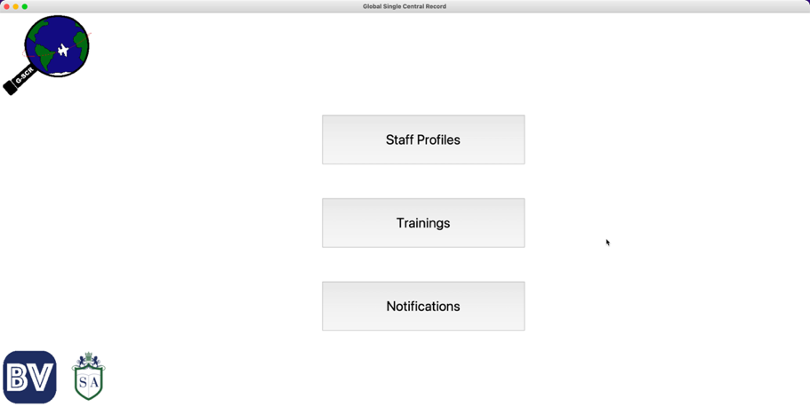

### Trainings Video

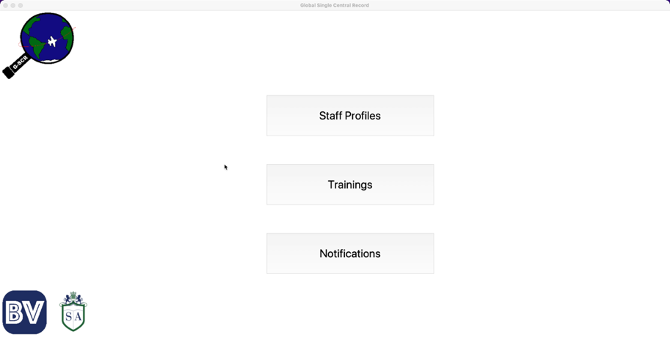

### Notifications Video

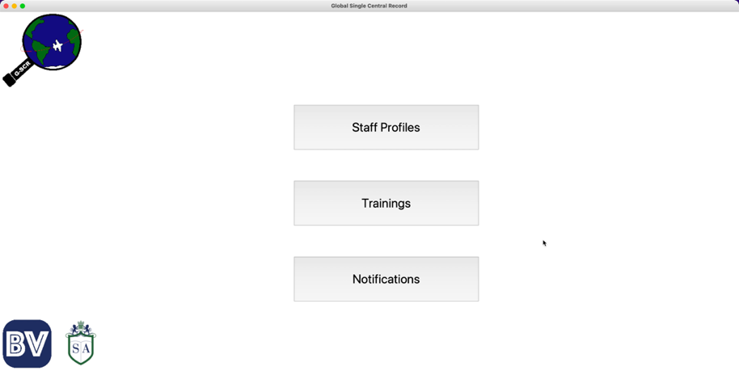

These videos can also be found in the unzipped folder where this document was located.

## Limitations

There are several limitations to this software, some of which I have been aware of from the beginning, some which I have learned about through development and testing, and some which I have been made aware of via my stakeholders.

Below, I will address these limitations and how I intend to make the application better considering these.

1. While I have automated some processes, many things still require a large amount of manual work. For example:
   * Staff profiles and training must be created one at a time, which can be incredibly tedious
   * Staff members must still be notified manually about having to redo training
   * Staff members can be added to trainings/ have dates added to their trainings but this must be done by clicking the button for each staff member

I had and do intend to add a process by which an excel spreadsheet can be uploaded to the system so that batch profile creation can occur.

Eventually, I will create an API to send an email to notify staff members about upcoming training sessions they must attend.

I will also add “Select all” and “Select all [staff type]” buttons that will make adding, for example, all teachers to a training date much more convenient.

1. The software is stored locally and so can only be accessed from the computer it has been set up on.
2. The application is not as aesthetically pleasing as I, and some of my stakeholders, would have liked.

Both of these can be addressed by creating a web app instead of a local application created with TkInter. I may use something like Django to do this or a website builder such as WIX. I am not yet exactly sure how I will do this but intend to research and implement this.

1. Prerequisites can only be filled in/ marked one at a time, which makes filling in many of them in somewhat tedious.
2. Staff/ training information not currently updateable (except for staff prerequisites)

For all areas of staff and training information, I will have one edit button per screen which will allow information to be edited and a confirm button to commit all of the data, as opposed to confirming one thing at a time.

## Maintenance

This system is very portable, due to the limited requirements of python and the modules, this application will be runnable on most or all standard operating systems.

The system will need to be updated. Updating the interface will be relatively straightforward as everything is broken down and labelled very clearly. Additionally, changes to the interface have no impact on the underlying database. This includes adding more search bars, adding edit info screens, select all staff members etc.

Updating the database should also be relatively straightforward but may be slightly more difficult that the interface. This is because information will be stored in there, and I cannot just change the code and make a fresh database. Instead, I will have to essentially transfer the data to the new database after I have made any updates and connect that new database to the interface.

Another update I would like to include is prerequisite information for schools/ staff members in/ from other countries. This will not require extensive changes, only adding the new prerequisites into the database setup and connecting them to the relevant staff members as they are created in the create_staff function of my ‘queries.py’ file.

I would also like the ability to send emails directly to staff members from the software for booked upcoming training sessions etc. for this, I will need to setup an API. This will require some further investigation.

In addition, I want to be able to import and export this information using excel spreadsheets, and so some research into the excel module in python will be required.

In the future, I would like to turn this project from a local application into a web app. To do this, I will either use a web app module such as Django or a website builder such as WIX. If I decide to host the website myself, this will be more difficult as I will need to set up a server and make sure it continues to be operational.